
Free Tools
Step-by-Step for Educators

How To Use AutoCollage

Get AutoCollage
- Visit http://www.microsoft.com/autocollage.
- In the left navigation menu, click Download.
- Click the Download button to download a 30-day trial version of AutoCollage 2008.
- Click Run to run the setup file.
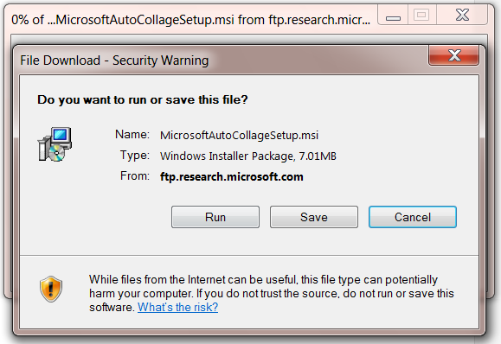
- After the program is installed, open AutoCollage by first clicking on the Start menu and typing AutoCollage in the Search programs and files field. Click on AutoCollage in the list to open the program.
 Note: You can download the full version of AutoCollage 2008 by joining the Partners in Learning Network at http://partnersinlearningnetwork.com.

Make a Collage
- When you first open AutoCollage, it will find your folders of photos in your Photos library and add them to AutoCollage’s Image Browser.
- In the Image Browser, select a folder in the image browser with at least seven images. AutoCollage will preview the photos in that folder.
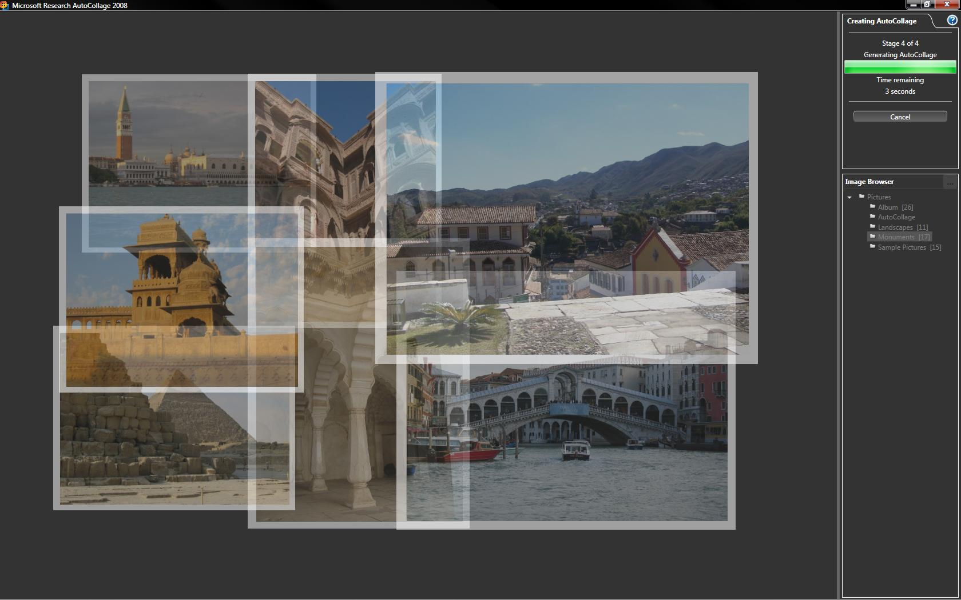

- Under Actions in the upper right corner of the window, click the Create icon. AutoCollage will begin generating the collage.
- After the collage is finished, under Actions, click the Save icon. The default option is to create and save collages as 4-inch by 6-inch landscape .jpg files. You may change this option by clicking on the Options icon.
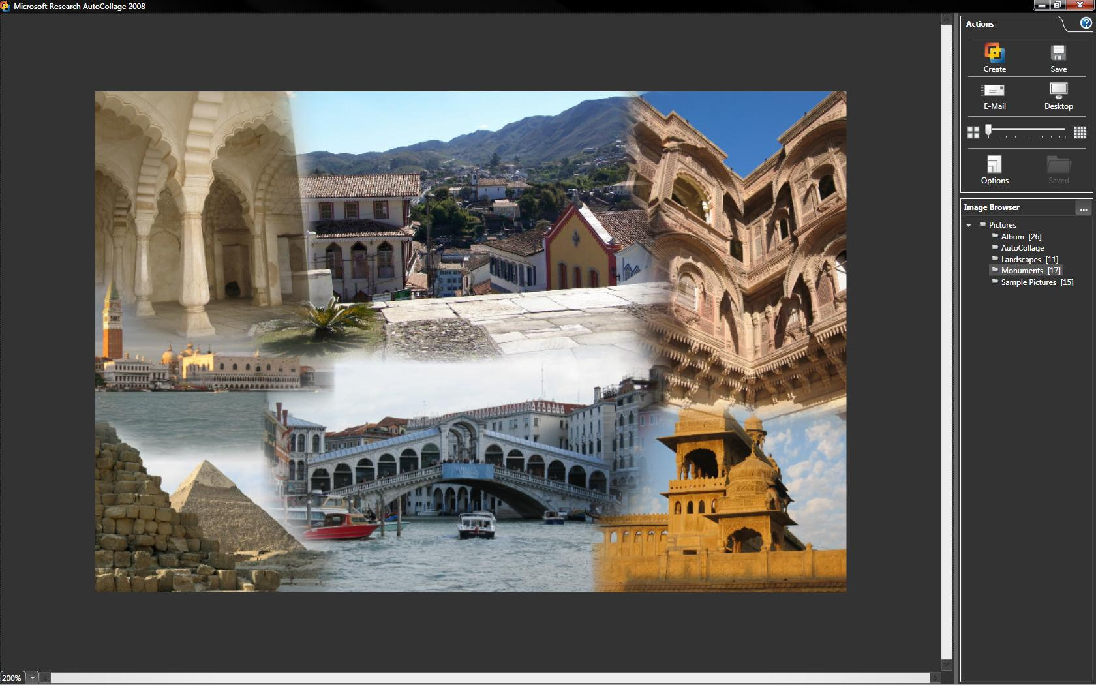

More Information on free tools for educators
For teachers:
www.microsoft.com/education/freetools
For faculty:
www.microsoft.com/freetools

For more information about Microsoft AutoCollage, visit www.microsoft.com/autocollage.

© 2009 Microsoft Corporation. All rights reserved.
This document is for informational purposes only. MICROSOFT MAKES NO WARRANTIES, EXPRESS, IMPLIED OR STATUTORY, AS TO THE INFORMATION IN THIS DOCUMENT.
Microsoft, Windows, Aero, BitLocker, BitLocker To Go, DirectX, Internet Explorer, OneNote, PowerPoint, SmartScreen, and Windows Live are trademarks of the Microsoft group of companies. The names of actual companies and products mentioned herein may be the trademarks of their respective owners.

