
Free Tools
Step-by-Step for Educators

Bing Image Search

Find Images
- Go to Bing.com and click Images, or go directly to Bing.com/images.
- Type your search query and press enter or click the magnifying glass .
- Point to some of the images to reveal the image’s size and the website that hosts it. You may also find the same image in more sizes, or show similar images.
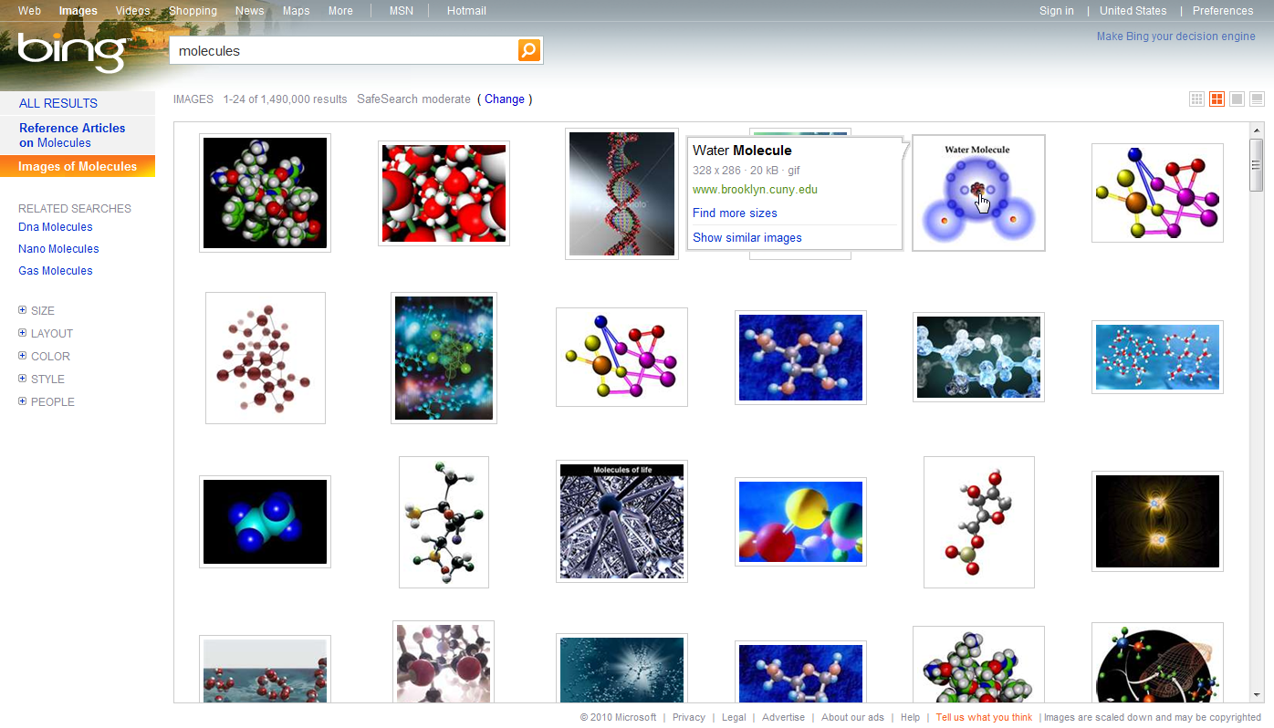

 | About SafeSearch  Note that just under the search field, you may choose how you want to filter your results by clicking Change next to your current SafeSearch setting. Setting options include: strict, moderate, or off.
- Click the image you want. From here, you can click on the full size image, find more sizes, or go to the page where the image is from.
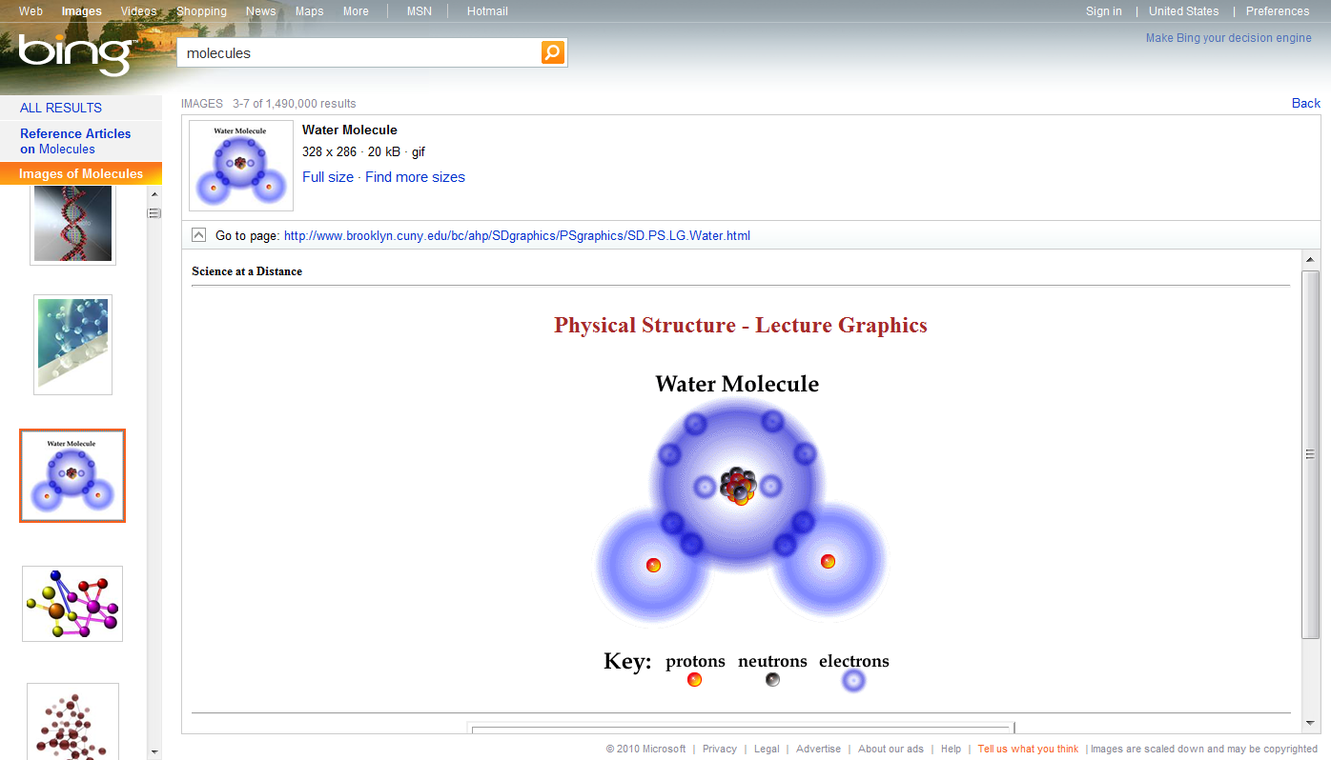

Save an Image
- Right-click the image you want, and select Save Picture As… in the shortcut menu. Locate the appropriate folder, and click Save to save the image to that folder. If using the image for public purposes, be sure to cite the website where you found it.
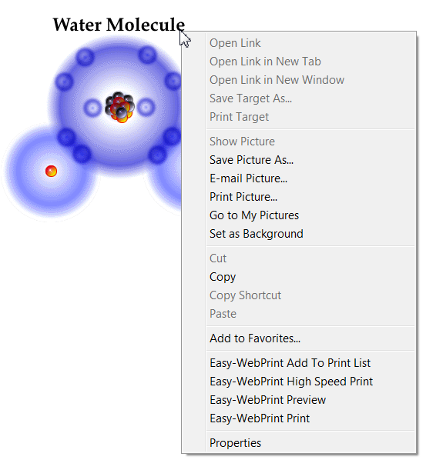

Keep Bing at Your Fingertips
- Go to www.microsoft.com/IE to download Internet Explorer 8. If you already have Internet Explorer 8 installed, go to step 2.
- Go to the Add-ons Gallery at http://IEaddons.com.
- On the left side, click Search. Find Bing Search and click Add to Internet Explorer.
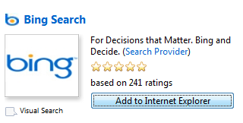
- In the pop-up window, select Make this my default search provider to set Bing as your IE search default, then click Add. (Note, if you already have Internet Explorer 8 installed, click Updgrade.)
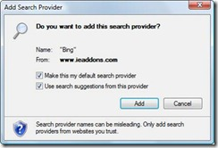

Student-Optimized Browser
As an option, you may install the student browser add-on. Go to . http://IEaddons.com. On the left side, click Optimized Browsers. Find Student Browser and click Add to Internet Explorer.
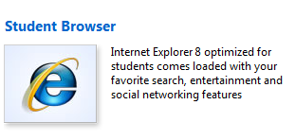

More Information on free tools for educators
For teachers: www.microsoft.com/education/freetools
For faculty: www.microsoft.com/freetools
For more information about Bing, visit bing.com.

For more information about the ethical use of digital files, including images, visit Digital Citizenship and Creative Content: A Teacher’s Guide at www.DigitalCitizenshipEd.com.

© 2009 Microsoft Corporation. All rights reserved.
This document is for informational purposes only. MICROSOFT MAKES NO WARRANTIES, EXPRESS, IMPLIED OR STATUTORY, AS TO THE INFORMATION IN THIS DOCUMENT.
Microsoft, Windows, Aero, BitLocker, BitLocker To Go, DirectX, Internet Explorer, OneNote, PowerPoint, SmartScreen, and Windows Live are trademarks of the Microsoft group of companies. The names of actual companies and products mentioned herein may be the trademarks of their respective owners.

