
Free Tools
Step-by-Step for Educators

Research Using Bing
Bing is a decision engine that provides more organized search results, so you can quickly make more informed choices.

The Home Page

- Go to Bing.com.

 | Note: With learning in mind, the Bing home page features an engaging photo with hidden hyperlinks to learn more about the subject. Point to different areas of the photo to reveal intriguing facts, with links to more information. In the lower right corner, click the arrows to see more photos.  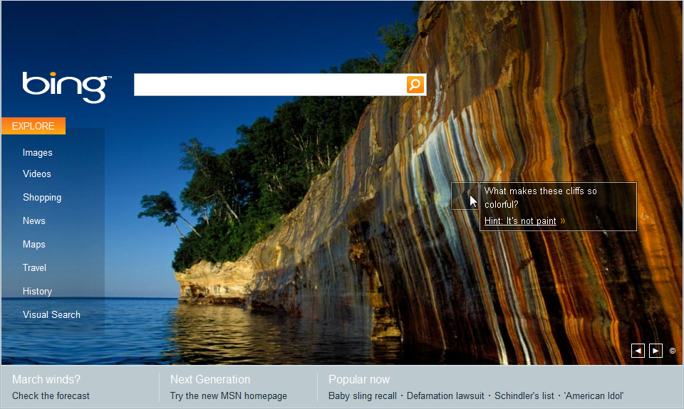

- Enter your search term. Bing automatically fills in terms you may want for easy selection. Simply press the down arrow on your keyboard to access the term you want.
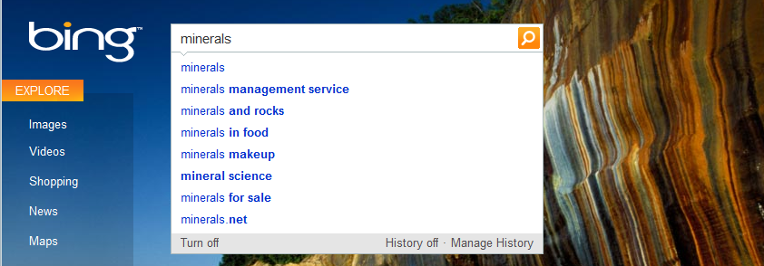
- Notice the search results include a handy list on the left to news, images, local listings, and related searches. It also includes your personal search history.
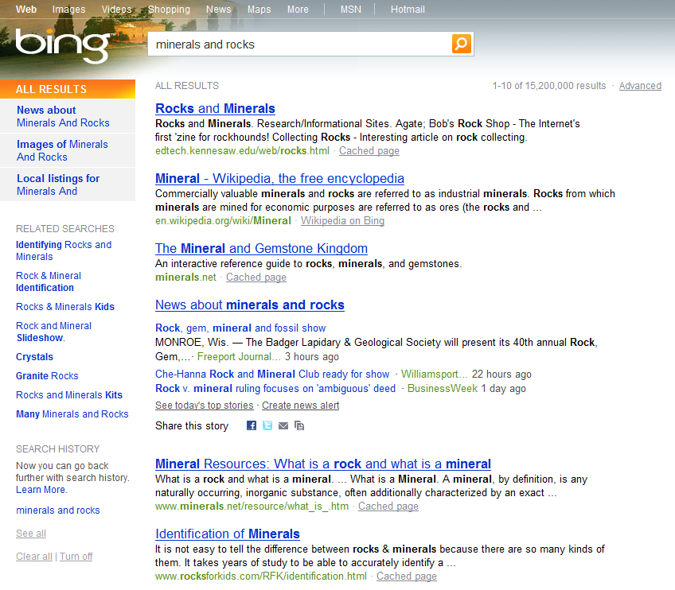

The Explore Page
- On the Bing home page, Bing.com, click Explore just under the Bing logo.
- The Bing Explore page reveals many ways to enhance your search.
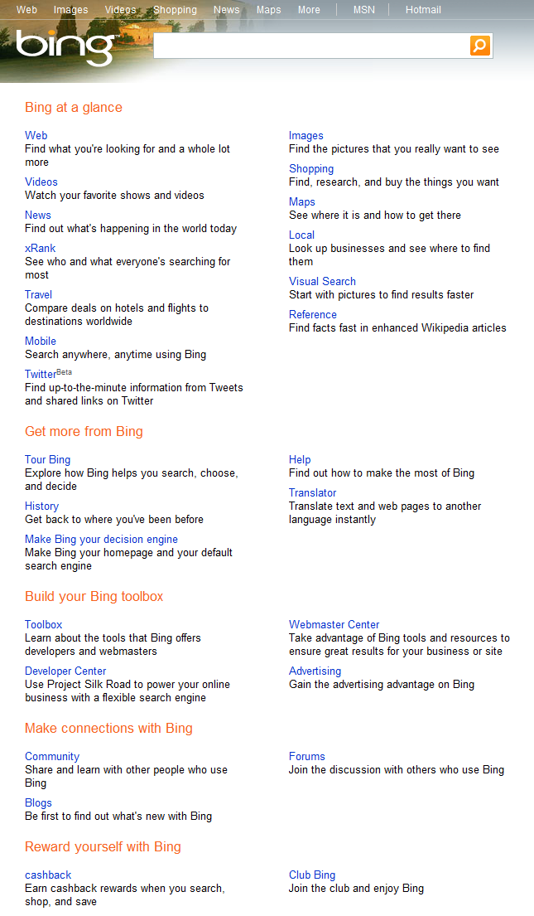

Visual Search
- From the Bing home page or explore page, click Visual Search. Or go directly to Bing.com/visualsearch. There are more than 100 visual galleries ranging from movies, books, and cars to animals, geography, and chemical elements. The sorting categories available change for each topic.
- In the options on the left, click Reference, then click Periodic Table.
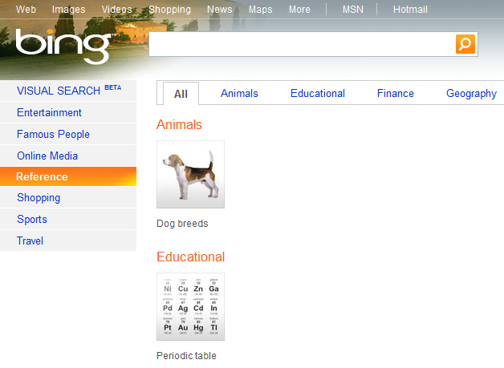

- Chemical elements can be sorted visually by name, atomic number, year discovered, the amount in humans, or amount in the earth’s crust. Point to a visual to reveal its data. Use the scroll bar to the right to reveal more chemical elements.
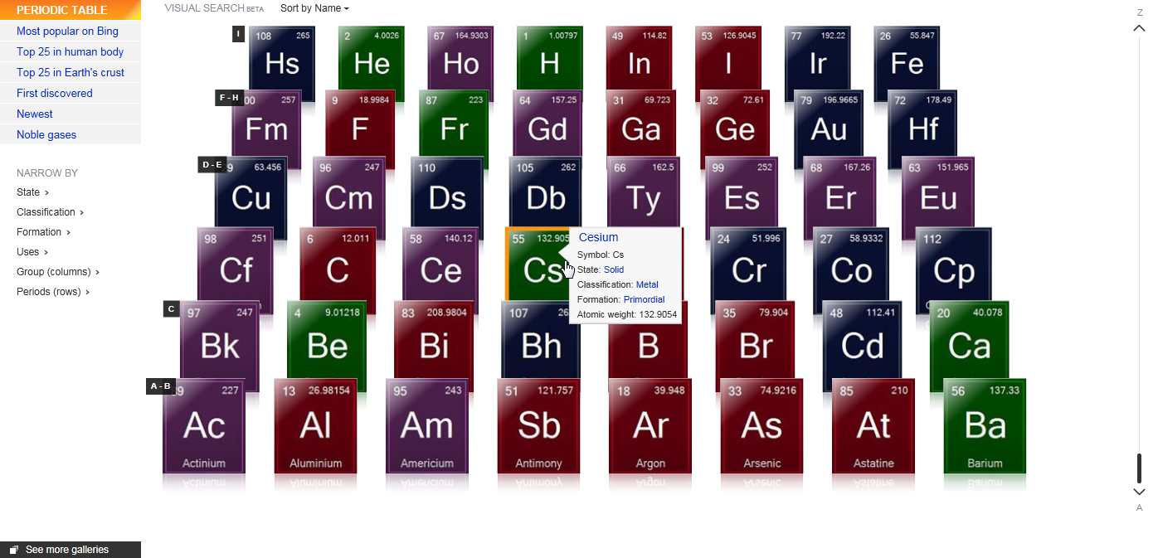

Bing Translator
- Go to the Bing Explore page, Bing.com/explore, and in the Get more from Bing section, click Translator. Or go directly to MicrosoftTranslator.com.
- Using the drop-down lists, adjust the languages from and to which you want translate.
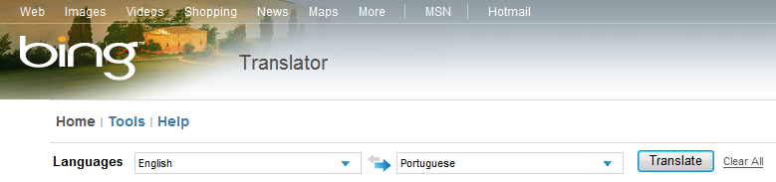
- Type the word(s) you want to translate in the first box, then press Enter or click the Translate button.
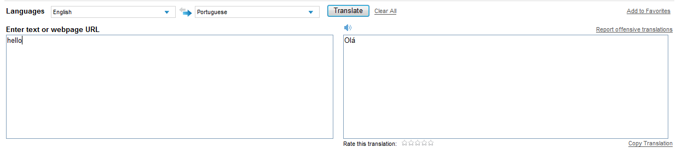

Keep Bing at Your Fingertips
- Go to www.microsoft.com/IE to download Internet Explorer 8. If you already have Internet Explorer 8 installed, go to step 2.
- Go to the Add-ons Gallery at http://IEaddons.com.
- On the left side, click Search. Find Bing Search and click Add to Internet Explorer.
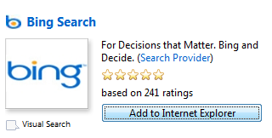
- In the pop-up window, select Make this my default search provider to set Bing as your IE search default, then click Add. (Note, if you already have Internet Explorer 8 installed, click Updgrade.)
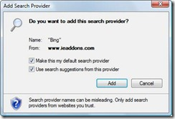

 | Student-Optimized Browser  As an option, you may install the student browser add-on. Go to . http://IEaddons.com. On the left side, click Optimized Browsers. Find Student Browser and click Add to Internet Explorer.  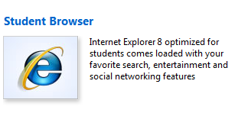

More Information on free tools for educators
For teachers: www.microsoft.com/education/freetools
For faculty: www.microsoft.com/freetools
For more information about Bing, visit bing.com.

© 2009 Microsoft Corporation. All rights reserved.
This document is for informational purposes only. MICROSOFT MAKES NO WARRANTIES, EXPRESS, IMPLIED OR STATUTORY, AS TO THE INFORMATION IN THIS DOCUMENT.
Microsoft, Windows, Aero, BitLocker, BitLocker To Go, DirectX, Internet Explorer, OneNote, PowerPoint, SmartScreen, and Windows Live are trademarks of the Microsoft group of companies. The names of actual companies and products mentioned herein may be the trademarks of their respective owners.

