
Microsoft® Office® 2007
Step-by-Step for Educators

Create a Graph in Excel 2007
Charts are used to display series of numeric data in a graphical format to make it easier to understand large quantities of data and the relationship between different series of data.

About charts and their elements
A chart has many elements. Some of these elements are displayed by default. Chart elements can be added, removed, moved, resized, or changed.
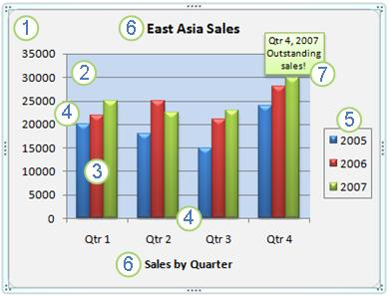
Chart area
Plot area
Data points of the data series
The horizontal (category) and vertical (value) axis
Legend
Chart and axis title
A data label used to identify the details of a data point in a data series

When you click anywhere in the chart area, and then hover the mouse pointer over one of these elements, Excel displays information about that element in a ScreenTip. Clicking anywhere in a chart also makes the Chart Tools available, adding the Design, Layout, and Format tabs.
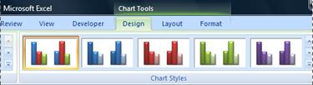

Available chart types
Excel 2007 supports many types of charts to help you display data in ways that are meaningful to your audience. The following are some of the more commonly used chart types available.
Chart Type | Chart Example
Column charts  Data that is arranged in columns or rows on a worksheet can be plotted in a column chart. Column charts are useful for showing data changes over a period of time or for illustrating comparisons among items. | 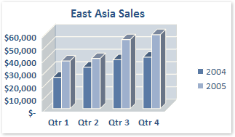
Line charts  Data that is arranged in columns or rows on a worksheet can be plotted in a line chart. Line charts can display continuous data over time, set against a common scale, and are therefore ideal for showing trends in data at equal intervals. In a line chart, category data is distributed evenly along the horizontal axis, and all value data is distributed evenly along the vertical axis. | 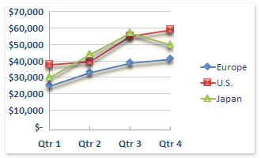
Pie charts  Data that is arranged in one column or row only on a worksheet can be plotted in a pie chart. Pie charts show the size of items in one data series, proportional to the sum of the items. The data points in a pie chart are displayed as a percentage of the whole pie. | 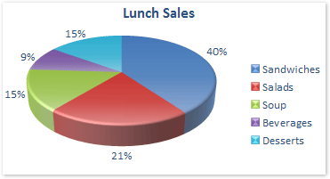
Bar charts  Data that is arranged in columns or rows on a worksheet can be plotted in a bar chart. Bar charts illustrate comparisons among individual items. | 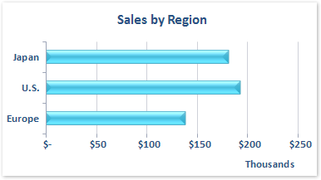
Area charts  Data that is arranged in columns or rows on a worksheet can be plotted in an area chart. Area charts emphasize the magnitude of change over time, and can be used to draw attention to the total value across a trend. For example, data that represents profit over time can be plotted in an area chart to emphasize the total profit. By displaying the sum of the plotted values, an area chart also shows the relationship of parts to a whole. | 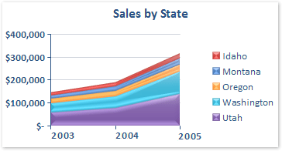
XY (scatter) charts  Data that is arranged in columns and rows on a worksheet can be plotted in an xy (scatter) chart. Scatter charts show the relationships among the numeric values in several data series, or plots two groups of numbers as one series of xy coordinates. | 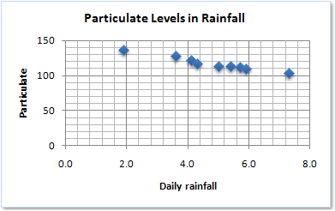
Bubble charts  Data that is arranged in columns on a worksheet so that x values are listed in the first column and corresponding y values and bubble size values are listed in adjacent columns, can be plotted in a bubble chart. | 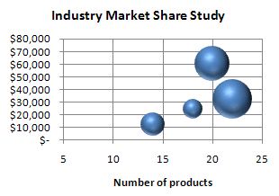

Create a chart
- Enter the numeric data for the chart on a worksheet in Excel. For most charts, you can plot the data that you arrange in rows or columns. However, some chart types (such as pie and bubble charts) require a specific data arrangement.

- Select the cells that contain the data that you want to use for the chart.

- On the Insert tab, in the Charts group, do one of the following:
- Click the chart type, and then click a chart subtype that you want to use.
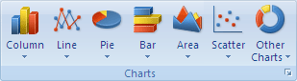
- To see all available chart types, click a chart type, and then click All Chart Types to display the Insert Chart dialog box. Click the one you want to use and select OK.
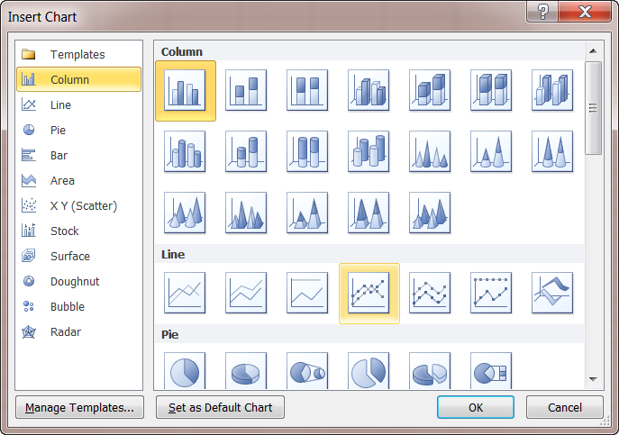
- Excel will automatically create your chart. When you click on the chart you want to format, it displays the Chart Tools, adding the Design, Layout, and Format tabs.

Modifying a basic chart to meet your needs
After you create a chart, you can modify any one of its elements. To modify a chart, you can:
- Change the pre-defined chart style
  - Select the chart you want to format.
  - On the Design tab, in the Chart Styles group, click the chart style you want to use.
- Add titles, axis titles, a legend, or data labels to a chart
  - Select the chart you want to format.
  - On the Layout tab, in the Labels group, select the feature you would like to change, then click the display option that you want.
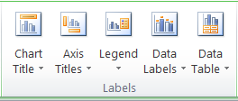
- Show or hide gridlines
  - Select the chart you want to format.
  - On the Layout tab, in the Axes group, click Gridlines and select the horizontal and/or vertical gridlines you would like to show.
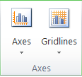

More Information on Office 2007 for educators
For teachers:
www.microsoft.com/education/Office

For faculty:
www.microsoft.com/officeeducation

For more help with Microsoft Office Excel:
http://office.microsoft.com/en-us/excel/FX100646951033.aspx

© 2009 Microsoft Corporation. All rights reserved.
This document is for informational purposes only. MICROSOFT MAKES NO WARRANTIES, EXPRESS, IMPLIED OR STATUTORY, AS TO THE INFORMATION IN THIS DOCUMENT.
Microsoft, Windows, SmartArt, Excel, Internet Explorer, OneNote, PowerPoint, SmartScreen, and Windows Live are trademarks of the Microsoft group of companies. The names of actual companies and products mentioned herein may be the trademarks of their respective owners.

