Create a OneNote Notebook
Microsoft® Office® 2007
Step-by-Step for Educators
OneNote is the program in Microsoft Office that brings everything in your teaching world into one tidy, collaborative space. Think of it as a digital notebook to gather, store and manage materials for teaching. Capture text, photos, video or audio files, Word documents, maps, Web articles, and handwritten notes.

Search the Internet from within OneNote
Using the Research feature in OneNote, you and your students can quickly look up words and phrases in a dictionary, thesaurus or other research source. To use the research feature, on the Tools menu, click Research. In the Research task pane that is displayed on the right side of the window, type the term you’re searching for in the Search box, and select the source to use from the reference list. The results appear in the lower portion of the pane.

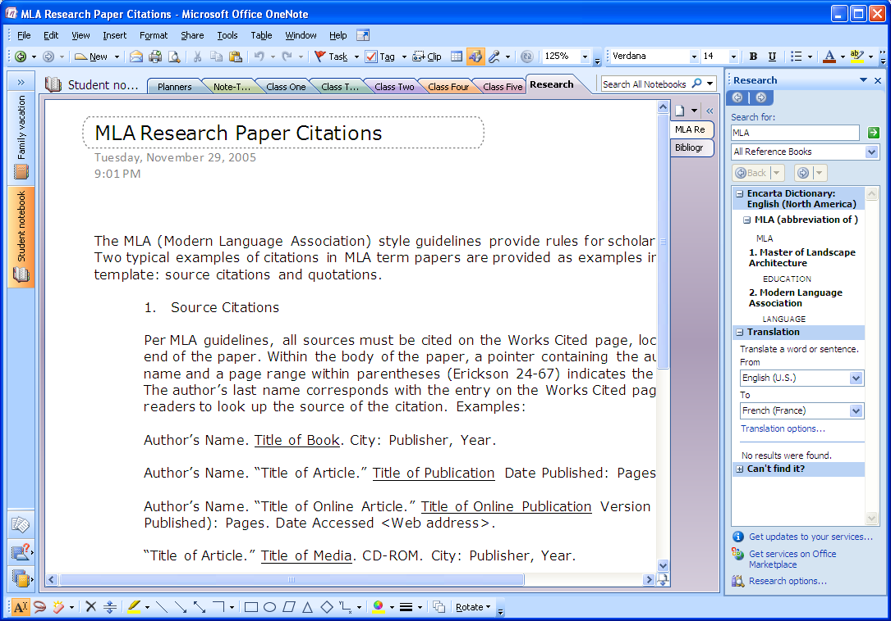
Use the research pane to find information on the Internet

Clip and Save Content from Web Pages
You can use OneNote to take a picture of any part of your computer screen and insert the picture into your notes. Such pictures are called screen clippings, and they can range from a few pixels to the entire height and width of your screen. Anything in the area that you select appears in the image and is automatically pasted into your notes and the Clipboard.

To save a screen clipping from a Web page, in OneNote, click the Clip button on the toolbar. Then switch to the Web page, and use your mouse pointer to drag a rectangle over the area you want to clip. When you release the mouse, the clipping, together with a hyperlink to the Web page, is automatically saved to the OneNote page.

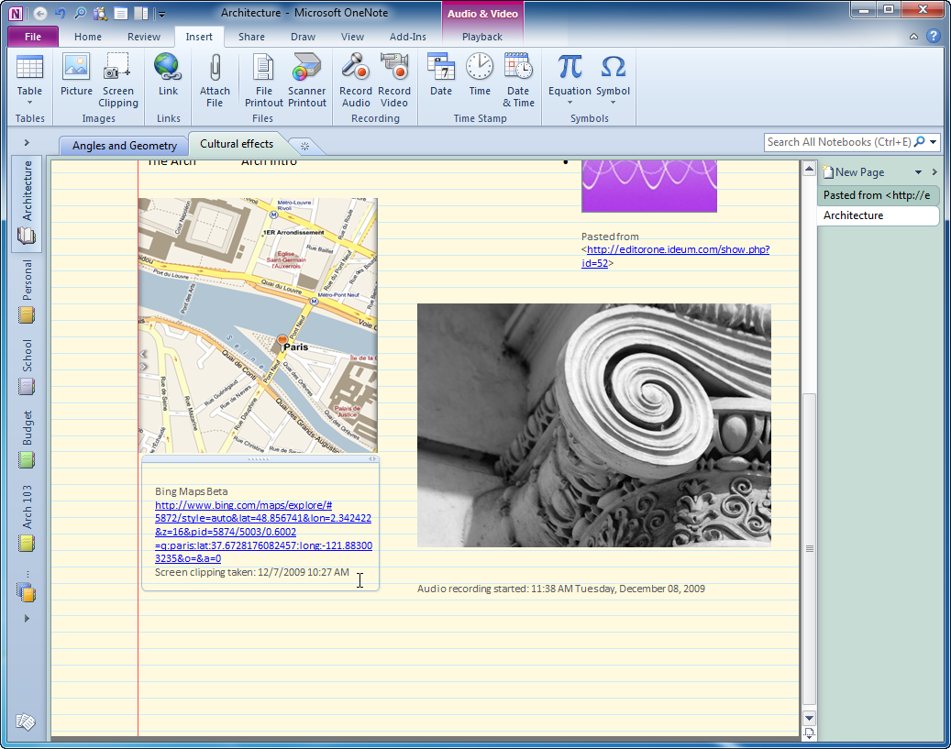
Save a screen clipping of a Web page

Add an Audio Note
OneNote 2007 lets your students record audio and video clips as they take notes. To record audio, you need a microphone. To record video, you need to connect a digital camera capable of recording movie clips, such as a webcam.

Audio and video recordings you make in OneNote are directly linked to any notes you take when the recording is made. Whenever you play back the recording, OneNote shows you the accompanying notes that you took.

To make an audio recording, on the toolbar click the Recording Audio Only button. Use the mini toolbar that appears to make your recording.
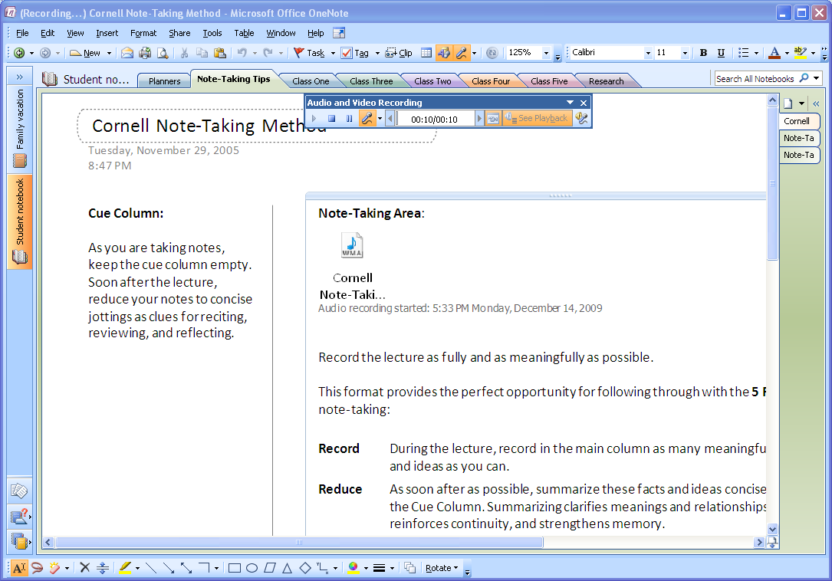
Insert audio recordings with your notes
Note: To record audio or video clips in OneNote,
Microsoft DirectX 9.0a or later and
Microsoft Windows Media Player 9 or later are required.

Set Up a Shared Notebook
OneNote lets you store and maintain shared notebooks on a network server or file share, so that your students can simultaneously access shared notes and contribute to them on an ongoing basis.

Taking notes as a group is a collaborative process that encourages teamwork. OneNote lets everyone access a shared set of notes at once, and it automatically synchronizes everyone's changes to the notebook. The result is a notebook that is always up-to-date and that literally keeps everyone on the same page.

Setting up a shared notebook is easy. On the File menu, point to New, and then click Notebook.

The New Notebook Wizard guides you through the steps for creating a shared notebook in a network location that you and your whole class has access to.
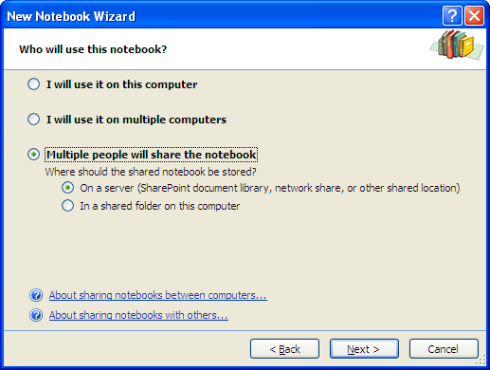
Teach your students to collaborate using shared notebooks

Find Content in OneNote
One of the main advantages of using OneNote instead of traditional notebooks is its ability to quickly search through all of the information you've collected and retrieve important notes based on criteria that you specify. Instead of having to flip and skim through paper pages, you can quickly retrieve anything you've jotted down. OneNote also makes it easy to browse through your most recent notes and search for spoken words in recorded audio notes.

To search for words in OneNote, even words that are inside graphics, type the search term in the Search box in the upper right corner of the window and click the Search button. OneNote highlights the search results where they are found on the pages of the notebook.

If one or more instances of the text are found, the total number of pages appears in the toolbar area.

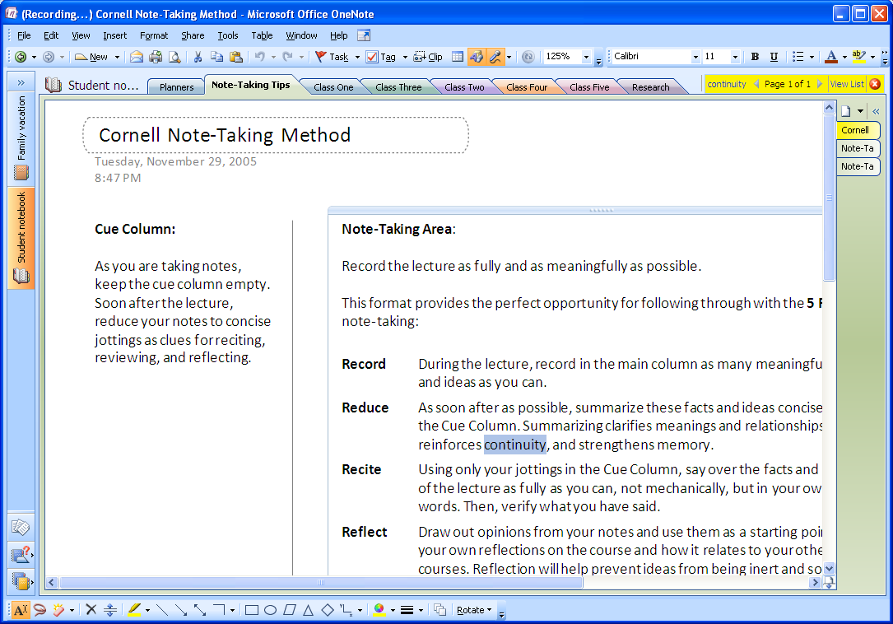
Search results are highlighted on pages

Automatic Save
You never need to save your notes. OneNote automatically saves them as you are working and whenever you close the program or a section.

By default, OneNote automatically backs up your notes at regular intervals. You can change how often automatic backup files are created, and you can turn the automatic backup feature on or off at any time.

To set your backup options, on the Tools menu, click Options. In the Options dialog box, in the Category list, click Backup and select your backup preferences.

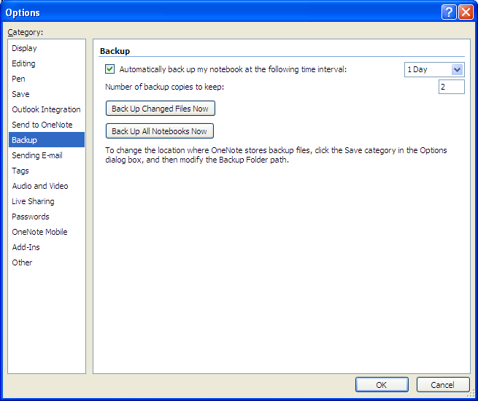
Select backup options

Note: The names of backup files include the date they are created. For example, a backup file for a notebook section called Lectures that is created on January 14, 2010, is automatically named "Lectures.one (On 1-14-2010).one".
More Information on Office 2007 for educators
For teachers:
www.microsoft.com/education/Office

For faculty:
www.microsoft.com/officeeducation

For more help with Office products, visit http://office.microsoft.com/help.

© 2009 Microsoft Corporation. All rights reserved.
This document is for informational purposes only. MICROSOFT MAKES NO WARRANTIES, EXPRESS, IMPLIED OR STATUTORY, AS TO THE INFORMATION IN THIS DOCUMENT.
Microsoft, Windows, SmartArt, Excel, Internet Explorer, OneNote, PowerPoint, SmartScreen, and Windows Live are trademarks of the Microsoft group of companies. The names of actual companies and products mentioned herein may be the trademarks of their respective owners.

