
Join the Partners in Learning Network
Free Tools
Step-by-Step for Educators
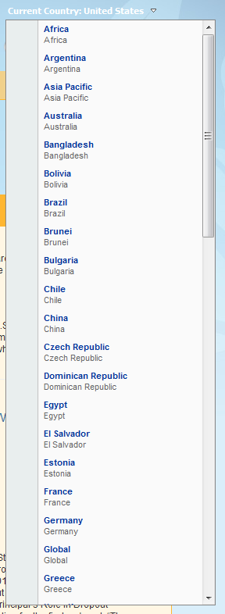
The Partners in Learning Network is a global online community of educators who value innovative uses of information & communication technology (ICT) to improve learning outcomes. By joining the Partners in Learning Network, you can:
- Create or join communities & discussions
- Find lesson plans and activities, as well as share your own resources
- Access free tools and learning programs for your classroom and school
- Collaborate with like-minded colleagues, improve education in your own classroom and community, and ultimately help improve the quality of education globally

Join
- Visit http://partnersinlearningnetwork.com.
- Click Join Today. Sign up requires a Windows Live ID.
- Create your profile. When you identify the country in which you reside, the network will always initiate your experience within that country’s network. If you would like to explore another country’s network, or the global network, choose from the drop-down list in the upper-right corner. See the screen capture to the right.

Download AutoCollage and Songsmith
As a member of the Partners in Learning Network, you can download the full versions of AutoCollage and Songsmith software. Here’s how:
- When you are logged into the network, click Resources in the navigation at the top of the page.
- In the Resources box on the right, click Tools & Programs.
- In the Resources box on the right, click Tools underneath Tools & Programs.
- Click one of the following Featured Tools articles:
  - Songsmith free software download just for educators
  - AutoCollage free software download just for educators

More Information on free tools for educators
For teachers:
www.microsoft.com/education/freetools
For faculty:
www.microsoft.com/freetools

For more information about AutoCollage, visit Microsoft.com/AutoCollage.

For more information about Songsmith, visit Microsoft.com/Songsmith.

© 2009 Microsoft Corporation. All rights reserved.
This document is for informational purposes only. MICROSOFT MAKES NO WARRANTIES, EXPRESS, IMPLIED OR STATUTORY, AS TO THE INFORMATION IN THIS DOCUMENT.
Microsoft, Windows, Aero, BitLocker, BitLocker To Go, DirectX, Internet Explorer, OneNote, PowerPoint, SmartScreen, and Windows Live are trademarks of the Microsoft group of companies. The names of actual companies and products mentioned herein may be the trademarks of their respective owners.

