
Photo Story for Educators
Step-by-step

Create digital stories with Photo Story 3

Download
Download Photo Story 3 at http://microsoft.com/photostory.

Tell your story

Open Photo Story
- After the program is finished downloading, click Start in the lower-left corner of your screen. Type “Photo Story” in the Search programs and files field. Photo Story 3 for Windows will appear at the top of the list under Programs. Click it to run the program.
- On the Welcome page, click Begin a new story, and then click Next.
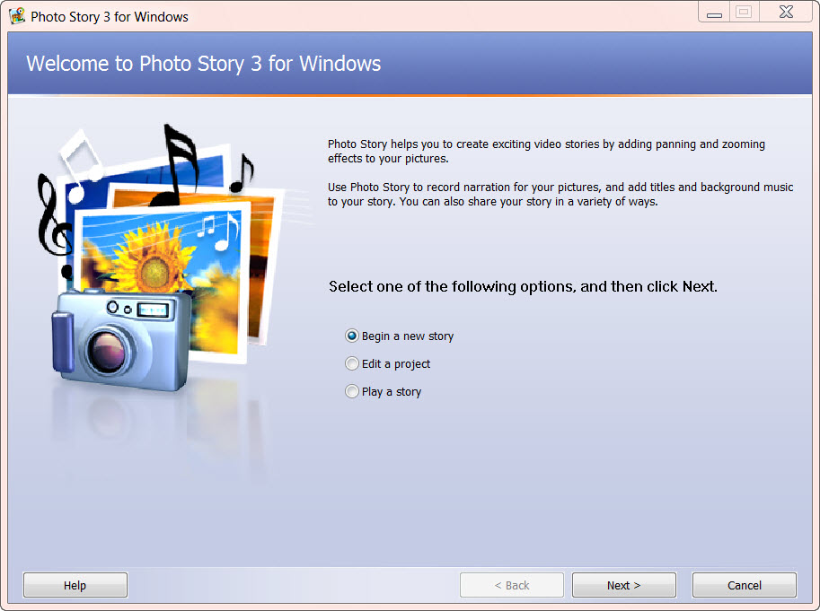

Add pictures to your photo story
- On the Import and arrange your pictures page, click Import Pictures.
- In the file browser dialog box, select the photos you would like to use in your photo story. To add more than one picture at a time, press and hold the CTRL key and click on the pictures you want to add, and then click OK.
- Your selected pictures will be shown in a filmstrip, similar to the following:
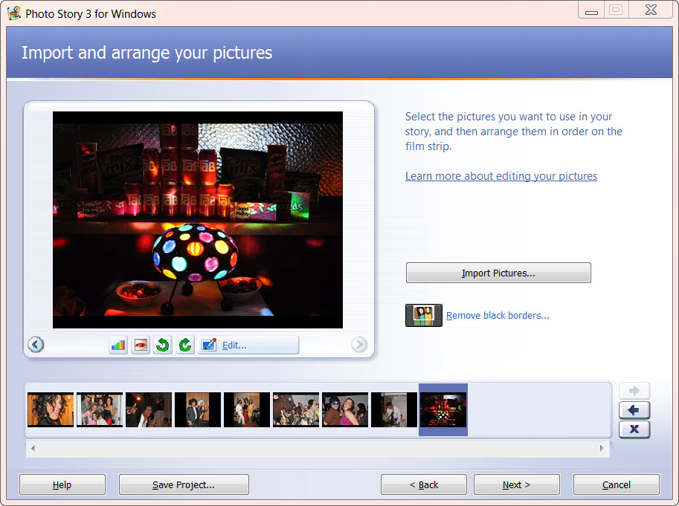
- In the filmstrip, you can:
  - Rearrange photos by clicking and dragging a picture from one location to another
  - Edit photos by selecting a picture and then clicking Edit. You can then rotate it, adjust the color, fix red eye, or add effects. You can also right-click a picture in the filmstrip to perform these actions.
- When you are finished making changes to your pictures, click Next to continue.

Add text to your pictures
- On the Add a title to your pictures page, type text for a photo.
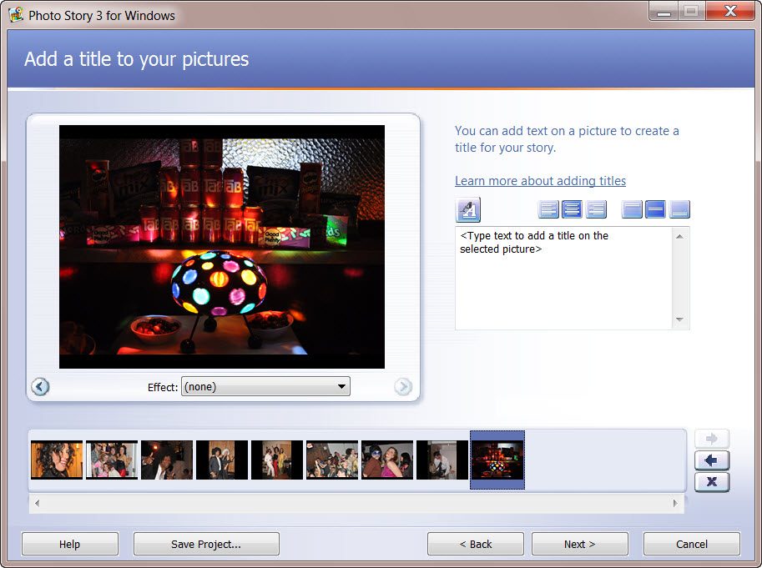
- Click the Select Font button. 
- In the dialog box, under Font style, click Bold, and then click OK.
- Use the alignment buttons to move the title to where you want it.
- Repeat steps 1-4 to add text to additional pictures.
- When you are finished adding text to your pictures, click Next.

Add narration
To add narration to your story you will need a microphone attached to your computer. A wizard will help you set up your microphone to record narration. There is also a text input area to create cue cards which can be a helpful memory aid when narrating your pictures.
- On the Narrate your pictures and customize motion page, click the Microphone button.
- This will launch the Sound Hardware Test Wizard. Complete the wizard by following the onscreen instructions. Once you have completed the wizard, your microphone will be ready to record narration.
- Click a picture in the filmstrip.
- Add any desired text in the cue card area.
- Click the Record Narration  button to start recording narration.
- The red dot in the record button will flash indicating recording is taking place. A timer is provided to help you keep track of your narration length.
- When you have finished narrating the picture, click the Stop Recording  button.
- Repeat steps 2 thru 4 for each picture for which you want to add narration. Note: Narration for each picture cannot exceed 5 minutes.
- Once you have added narration, click the first picture in the filmstrip, and then click Preview to see how your story looks and sounds.
- Close the preview window, and click Next to continue to the next step.

Add background music

To add pre-recorded music
- On the Add background music page, click a picture in the filmstrip and then click Select Music.
- In the dialog box, browse and select the music you want to add (WMA, MP3, or WAV files), and then click Open.
- The music is shown as a colored bar above the picture in the filmstrip. This helps you determine which pictures will be shown for each piece of music you add. This is particularly helpful when you add more than one song to your story.
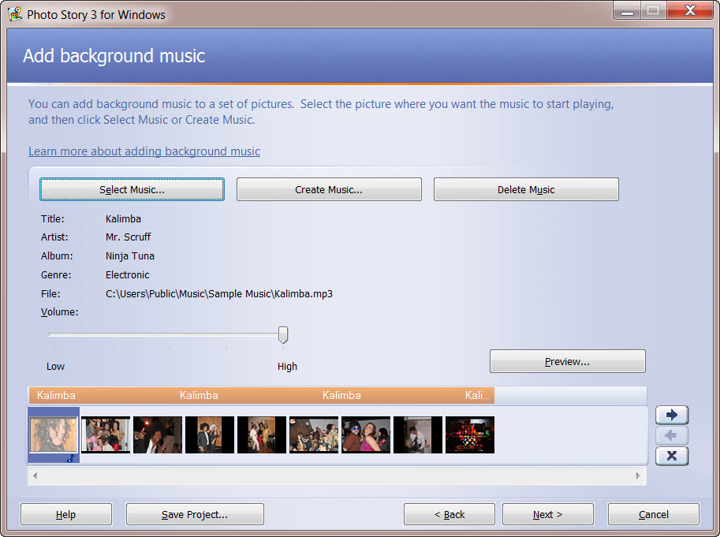

To create custom music
- Click a picture in the film strip, and then click Create Music.
- In the Create Music dialog box, in the Genre drop-down list, scroll down and select Soundtrack.
- In the Style drop-down list, select Soundtrack: Mysterious Cave.
- You may leave the default Bands and Moods, or choose different ones.
- Click Play to hear what the music will sound like.
- When the music has finished playing, click OK to close the Create Music dialog box.
- There are now two different pieces of music shown as colored bars above the pictures in the filmstrip.
- Click the first picture in the filmstrip, and click Preview, to see how well your music fits the story.
- You may need to adjust the music volume levels to accommodate your narration. To do this, simply click the picture in the filmstrip and then adjust the music volume using the volume slider bar. You may need to adjust the volume and preview your story a few times to get it just right.
- Click Next, to move on to the final steps.

Save your story
- On the Save your story page, verify that Save your story for playback on your computer is selected in the activities list.
- Click Browse to specify the location your story.
- In the Filename text box, type the name of your photo story.
- Click Save, and then click Next.
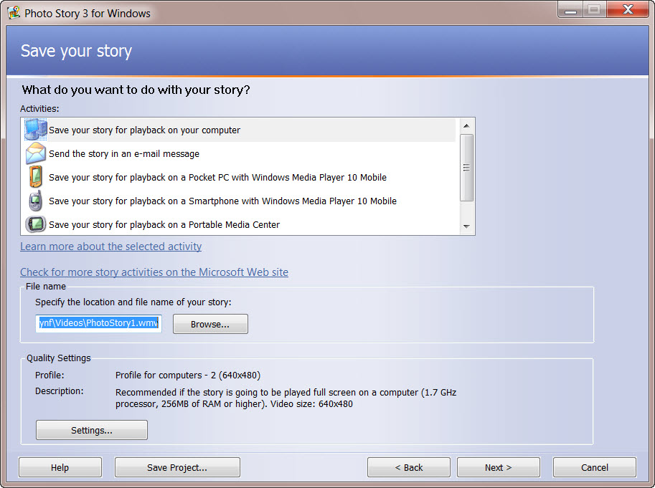

View your story
When your story is built and saved, the Completing Photo Story 3 for Windows page will appear. You can view your newly created story or begin a new story from here. To see what you have created, click View your story. Windows Media Player will open and play your story.
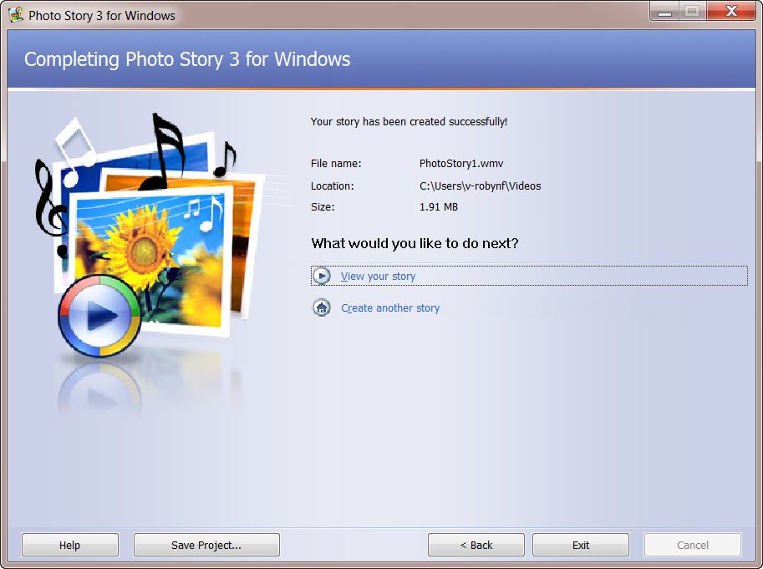
More information
For teachers, visit http://www.microosft.com/teachers.
For more information about Photo Story 3, visit http://www.microsoft.com/photostory.

© 2009 Microsoft Corporation. All rights reserved.
This document is for informational purposes only. MICROSOFT MAKES NO WARRANTIES, EXPRESS, IMPLIED OR STATUTORY, AS TO THE INFORMATION IN THIS DOCUMENT. Microsoft, Bing, DirectX, Internet Explorer, Windows, Windows Live, Windows Server, and Windows Vista are trademarks of the Microsoft group of companies. All other trademarks are property of their respective owners.

