
Free Tools
Step-by-Step for Educators

How To Use Photosynth
Creating the best synth starts with the right photos. This guide will help you understand how to take photos that Photosynth can use to best advantage. Reading it could save you from taking a few hundred pictures only to find out later that Photosynth won’t put them together the way you imagined.

 Watch a video on the Photosynth process at http://photosynth.net/howtosynth.aspx.
A few things you should be aware of:
- All synths are uploaded to the web. They're big, so you need to use a broadband Internet connection.
- Synths are by default public and will be visible to everyone on the Internet. You can set the display preference to unlisted if you do not want your synth to be public.
- Currently the "synther" only runs on Windows
- You'll need to Sign Up for a Photosynth account. It uses Windows Live ID.

Photosynth Photography Guide

Quick tips
- Start small. Pick a simple subject first, such as a piece of furniture or a single painting. You should be able to make a great 10-photo synth in just a few minutes if you follow the tips below. Then move on to something more ambitious.
- Remember the “Rule of 3”. Each part of the scene you’re shooting should appear in at least three separate photos taken from different locations. This rule means that you are going to shoot a lot more photos for a synth than you would for any other purpose.
- Panorama first, then move around. Start by taking a panorama of your scene, then move around and take more photos from different angles and positions. If you just do a panorama you won’t end up with a good 3-D experience.
- Have lots of overlap when shooting panoramas. Try for at least 50% overlap between photos.
- Limit the angles between photos. When moving around objects, try to get one photo every 25 degrees or so. That will make the synth work better. Larger angle differences on a subject won’t match up.
- Shoot scenes with lots of detail and texture. The visual texture in the photos is what ties them together. A blank wall won’t synth. One with lots of art or posters will work well.
- Don’t crop images. It confuses Photosynth.
- Shoot wide shots. Wide angle shots (photos taken from farther away, or with your camera’s lens zoomed all the way out) reconstruct more reliably than closer shots. It’s good to have close-ups, too, but you’ll want to have good coverage of your subject with lots of nice overlapping wide shots.
- Orientation. Make sure your photos are all right-side-up before you start synthing.
- Shoot for Highlights. Since you can call out your ‘best’ shots when you’re done synthing, think about specific areas of interest you’d want to highlight.

Got more time?
- Read the rest of this guide. You’ll find detailed advice about how to shoot all the common situations.
- Study the masters. Take the time to examine the photos that were used to create any synth that catches your eye. To see all the photos at once, switch to grid view: 
- Learn the keyboard commands. The last section of this document explains the keyboard shortcuts, including the powerful control key.

Shooting interiors
Start by standing in the center of the room with your camera zoomed wide. Spin around, taking overlapping shots as you go. Make sure successive photos are overlapped by at least 50%. Depending on how wide your lens goes, you’ll probably need to take 15-30 photos to go all the way around.
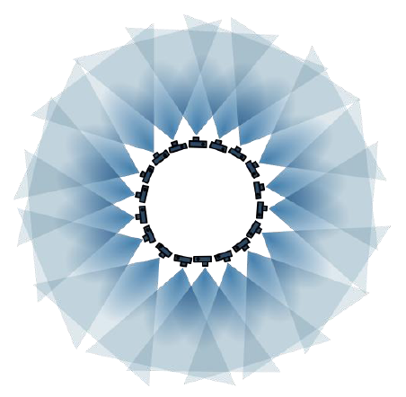
To give the room a good 3D model, you should next shoot overlapped shots from each of the corners. For saturation coverage and the most reliable reconstructions, shoot from the centers of each wall as well.
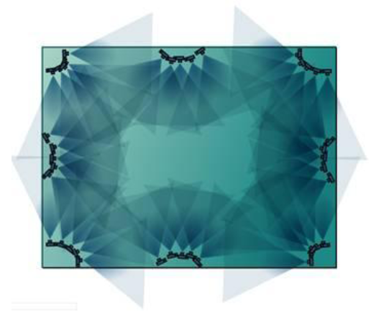
Finally, walk around the room shooting the interesting details. Make sure that all your close-ups have “approach shots” providing intermediate sizes of the object you’re closing in on. For example, if you’re photographing a wall of paintings, and you want to zoom in on a single painting, you’ll need to have a few intermediate images to help Photosynth put the whole thing together. See the photos below.

A good rule of thumb is to never move more than half the distance to your subject without taking an additional shot. Similarly, never increase your focal length by more than a factor of 2 without taking an additional shot.

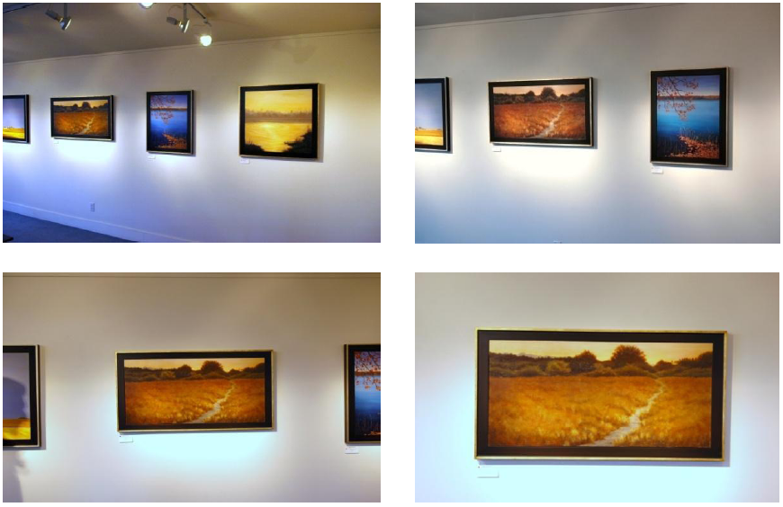

Move in on the subjects that interest you, but make sure you don’t move more than 50% of the way in without taking an additional shot. Copyright Christine Gedye 2008. Used with permission of the artist.

So, remember to:
- Start by standing in the center of the room and turning in a circle, creating a panorama with lots of overlap in each shot.
- Then shoot from the corners.
- Shoot a mix of wide, medium and closer shots—more variety is better.
- Remember the ‘rule of 3’: each part of your scene should appear in at least three separate photos.

2D Synths
If you take overlapping shots of a 2D surface at different scales, Photosynth will create a detailed synth of the result. Move the camera so that it’s always facing the subject head on. You don’t need to shoot it from different angles, although it doesn’t hurt if you do.
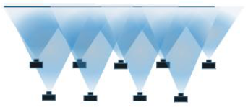
Shooting a two dimensional object

Shooting a 3-D Object
It’s important to get lots of overlap around an object and to walk around it. To get a great synth around a convex object (such as a vase), you’ll want to take a photo approximately every 15 degrees, so it takes at least 24 photos to get around a vase perfectly. If your object is not completely convex, you’ll need even more.
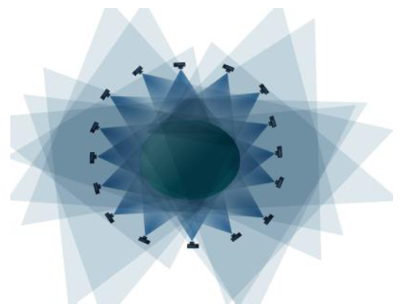
Shooting a 3-D object

Make sure that the center of the object is in the middle of the picture, and that the picture frames the entire object. Be sure to include close-ups. This technique can be used for a full circle around an object, a small arc or anything in between.

Shooting for Highlights
The best synths will have highlights so plan to add them after your synth is completed.

Because Photosynth rewards quantity over quality, it’s easy to get caught up in taking coverage shots and just shoot wildly. We added the Highlights feature so you, as the creator, can point viewers to the best shots or the most interesting bits in your synth. Some tips for good highlights are:
- Whenever possible make sure the most interesting parts of the synth can be completely seen in at least one image. ex. If you're shooting a car make sure there's at least one photo that shows the whole car. The synther doesn't need that shot but users will appreciate the context. then they can click on the close up shots.
- Take some shots with highlights in mind; think about what you might share with friends in a gallery or slideshow.
- Be sure to include interesting details like close ups, information plaques, etc
- Other good highlights are wide angle shots that show the whole scene and give a reference point and photos with interesting stories (ex. "this is where i met my wife")

Want to Use a Turntable?
If you have an object that is small enough to be rotated in front of the camera on a turntable, you should be able to make a fantastic synth with a beautiful navigational “halo”. If you don’t have a photographic turntable, get creative – a plastic kitchen turntable (also known as a ‘Lazy Susan’) works just fine. Here are the rules for using a turntable:
  - Put your camera on a tripod.
  - Put the object as close to the exact middle of the turntable as possible.
  - Position your camera so that the object is in the center of the viewfinder, and rotate the turntable to check whether the object stays in frame as you spin the table.
  - Very important – make sure that there is little or no visible texture behind the object as seen from the camera. Visible texture that doesn’t move when the object rotates on the turntable will confuse Photosynth. Best to use a plain drop cloth or piece of cardboard behind your turntable.
  - Don’t be afraid to use lights or a flash if you want to. Photosynth is fairly tolerant of different lighting conditions so you don’t need to worry that different parts of the object will be illuminated differently as the object turns.

Now comes the easy part. Take a photo, then rotate the object no more than 15 degrees, then take another photo. Repeat until you have rotated the object through 360 degrees. There is no need to be exact in the amount of rotation between shots, but you should be aware that the 15 degree rule assumes fairly convex shapes. If you have an object with lots of deep narrow cavities, or has lots of complex overlaps, you’ll want to shoot with less than 15 degrees of separation.

Going Around Corners
To be safe, you need at least 9 images to go around an exterior corner. In the example below there are solid matches between adjacent images (e.g.: Images 1/2), average matches between pairs that are 2 apart (e.g.: 4/6) and not many between images that are 3 apart (e.g.: 4/7).
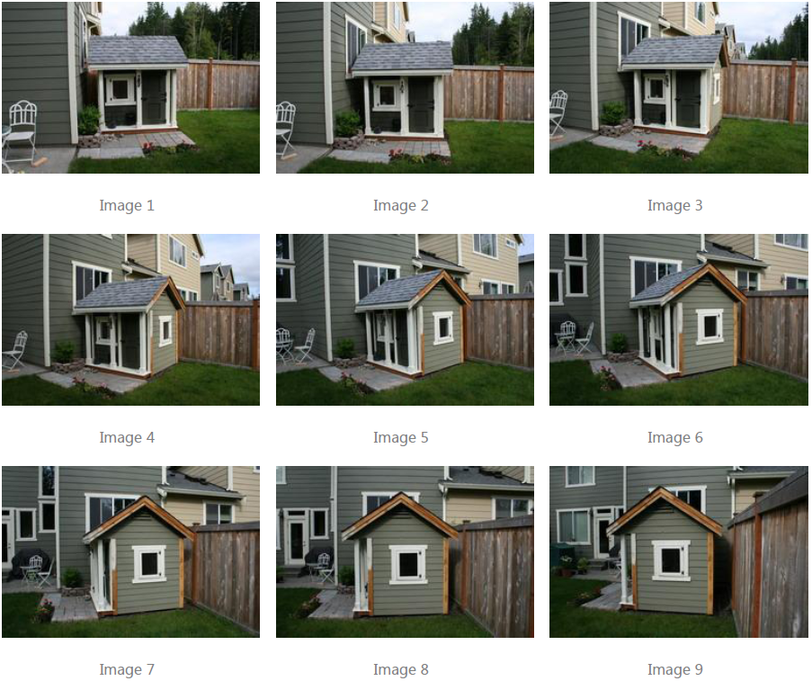

Like to process your photos?
If you’re the kind of photographer who likes to adjust color or contrast before you share your work, go for it. Photosynth is remarkably resilient to different color casts, and dynamic ranges. If you want to remove red-eye or fix other imperfections in a part of a photo, don’t hesitate.

On the other hand, the following operations will confuse Photosynth, and should be avoided if you want a decent reconstruction.
- Don’t crop your photos
- Don’t do any geometric transforms on your photos except rotation. (E.g. flips and perspective transforms will cause strange results.)
- Don’t mess with the visual texture of the image with filters. De-noising may be reasonably safe, but blurring or any of the artistic filters will almost certainly affect your results.
- Be very careful with watermarks, or any other action that adds the same overlay to all your photos. If you want to make sure that your copyright is displayed use the type-in fields in the Photosynth application, or search our support site for the “copyright” FAQ.

What NOT to do
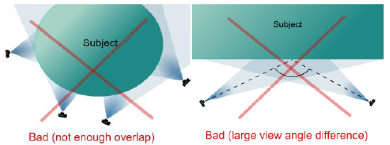
Avoid drastic angle and scale changes – a close-up of a sign may not stitch in if the only other photo of it is 100 feet away.

What NOT to shoot
There are some subjects that Photosynth just doesn’t like. Here are some examples of what works well (‘Synthy’) and what doesn’t:
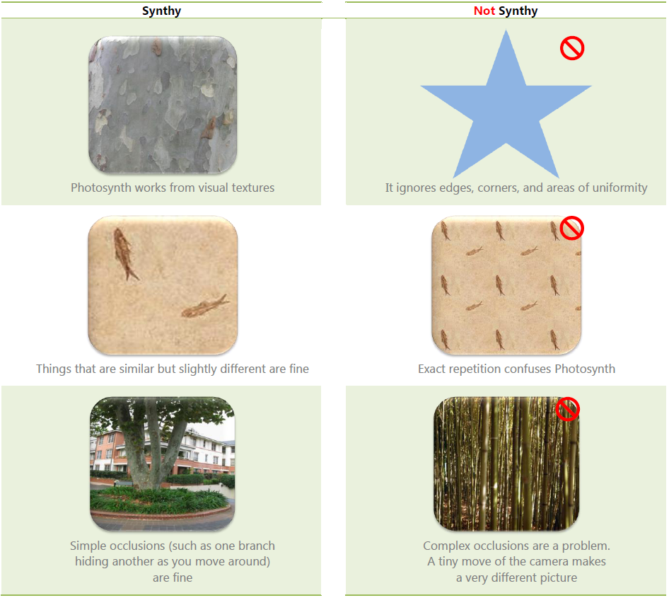
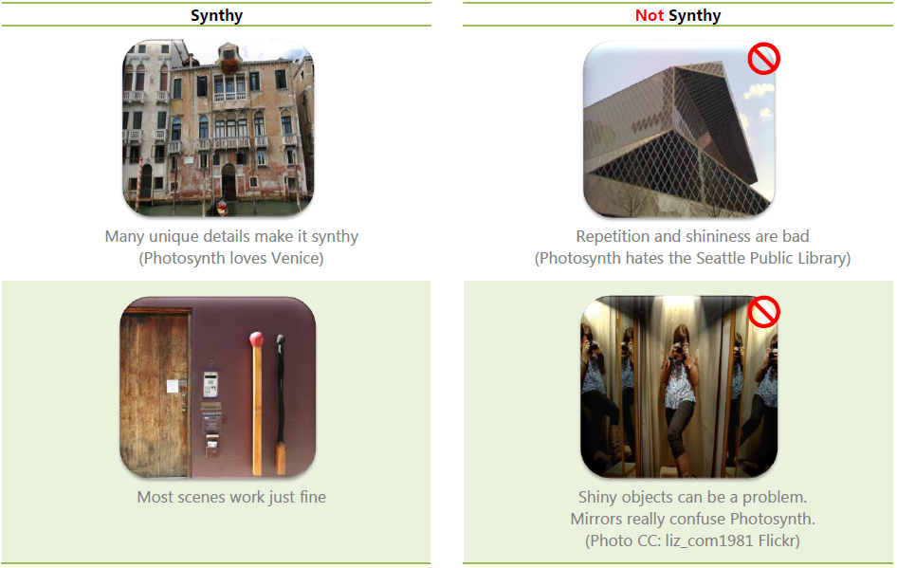

Create a Synth
Now that you know what works and what doesn’t, you’re ready to get started. Don’t be discouraged if your first synth doesn’t come out as well as you’d hoped. Before long you’ll get a feel for the variety of photos that will make the best synth. The most important thing to remember is: have fun!
- Visit http://photosynth.net/create.aspx and click Create a Synth.
- This will open the “synther.”
- Click Add Photos and add your photos.
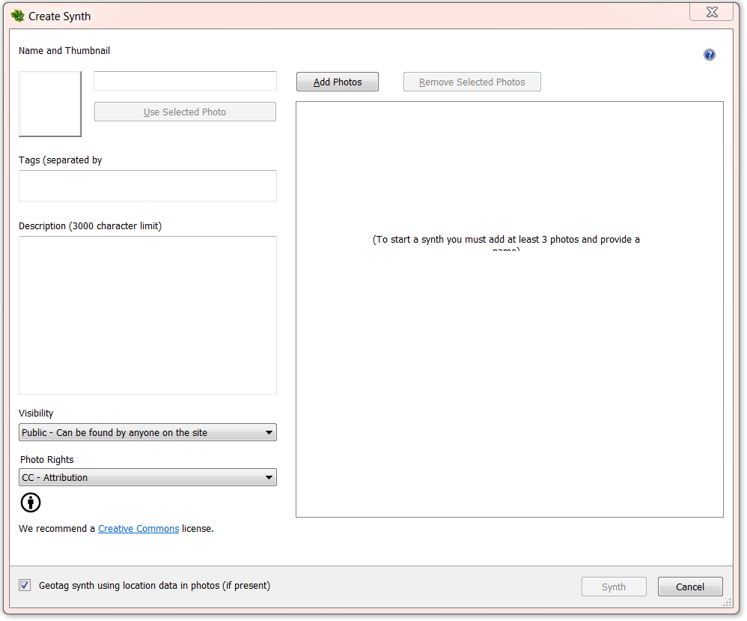

Viewer keyboard shortcuts
Try these keystrokes and mouse actions to get the most out of the Photosynth viewing experience.
Zooming and Neighbors
Scroll wheel | Scrolling the mouse wheel zooms you in or out. The zooming is centered around your current mouse position.
+ or - | Zoom in or out around the center of the window.
← or → | Move left or right to a neighboring photo, when one is available
↑or ↓ | Move up or down to a neighboring photo, when one is available
i or o | Move inwards or outwards to a neighboring photo, when one is available

Tours and History
Spacebar | Go to next photo in the spatial tour.
Shift-spacebar | Go to previous photo in the spatial tour.
. (period) | Go to next photo in alphabetical order by filename. (Depending on your camera, this is usually shooting order.)
, (comma) | Go to previous photo in alphabetical order by filename.
z | Go to the last image you were on. (Like Back in a Web browser.)
Shift-z | Undo z. (Like Forward in a Web browser.)

Fun with the Point Cloud
Ctrl | Holding the control key down temporarily hides all photos allowing you to see the point cloud in all its glory. Dragging a halo with the control button down lets you spin around the entire point cloud. Try it!
p | Switches among three modes: points, images, both

Useful Shortcuts
Enter | Center the current image
F | Toggle full-screen
~ | Toggle between 2D and 3D
M | Go to the ‘home’ starting image
1 | Starts the slideshow

Free Navigation (Only in 3D view)
A | Strafe left
D | Strafe right
W | Move forward
S | Move backward
E | Move up
C | Move down
L | Rotate left
‘ | Rotate right
[ | Rotate up
; | Rotate down

More Information on free tools for educators
For teachers:
www.microsoft.com/education/freetools
For faculty:
www.microsoft.com/freetools

For more information about Microsoft Photosynth, visit photosynth.net.

© 2009 Microsoft Corporation. All rights reserved.
This document is for informational purposes only. MICROSOFT MAKES NO WARRANTIES, EXPRESS, IMPLIED OR STATUTORY, AS TO THE INFORMATION IN THIS DOCUMENT.
Microsoft, Windows, Aero, BitLocker, BitLocker To Go, DirectX, Internet Explorer, OneNote, PowerPoint, SmartScreen, and Windows Live are trademarks of the Microsoft group of companies. The names of actual companies and products mentioned herein may be the trademarks of their respective owners.

