
Get Windows Live™ SkyDrive™
Free tools for Collaboration
Step-by-Step for Educators
Want to share a project online with students? With shared folders, the whole class can upload, download, and collaborate with you on documents and other files. Windows Live™ SkyDrive™ lets you easily store, access, and share your files—from anywhere. With 25 GB of free online storage, SkyDrive acts like your virtual hard drive on the internet where you can store all your files, photos, documents, etc., confidently.

Download now
- Visit http://WindowsLive.com/online/SkyDrive.
- Click Get SkyDrive.
- If you have a Windows Live ID, log in and it will direct you to SkyDrive. If you do not already have a Windows Live ID, create one now.
- Once you are logged in with your Windows Live ID, you can directly access your own SkyDrive by visiting http://skydrive.live.com.

Like other products in the Windows Live suite, SkyDrive is tightly integrated with the other Windows Live services. And because SkyDrive is the backend to Windows Live™ Photos, the photos that you upload to Windows Live automatically reside there too.
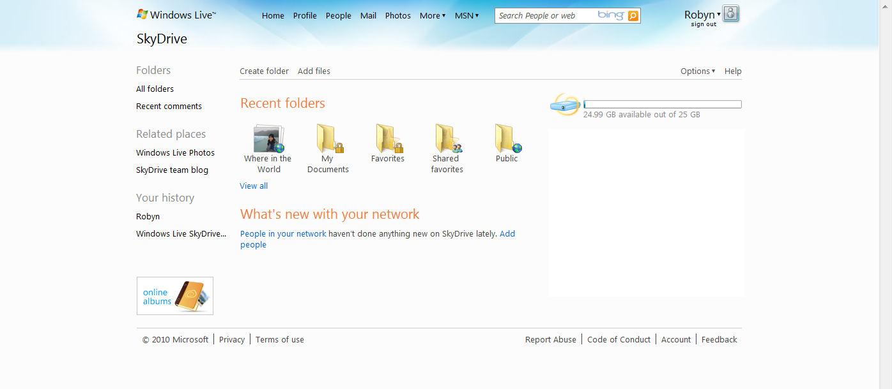
Photos uploaded to Windows Live Photos automatically reside in Windows Live SkyDrive.

Upload Files
Uploading content is as easy as dragging and dropping the files from your computer onto the Web.

- Click on Create Folder.
- Fill in the Name field. Use the drop-down menu to indicate with whom you want to share the folder. Options are: Everyone (public), My network, Just me, and Select people.
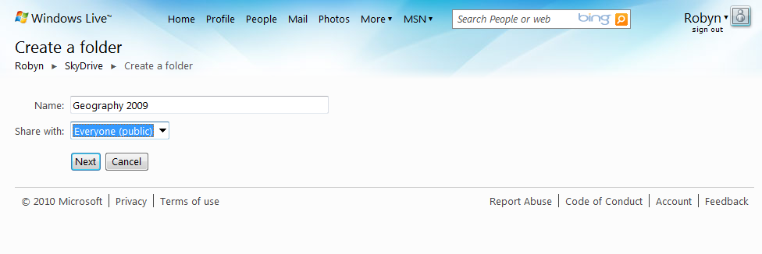
- Click Next.
- Now add files to the folder. Simply drag and drop files into the Drop files here area. Or, you may click on Select files from your computer to browse folders.
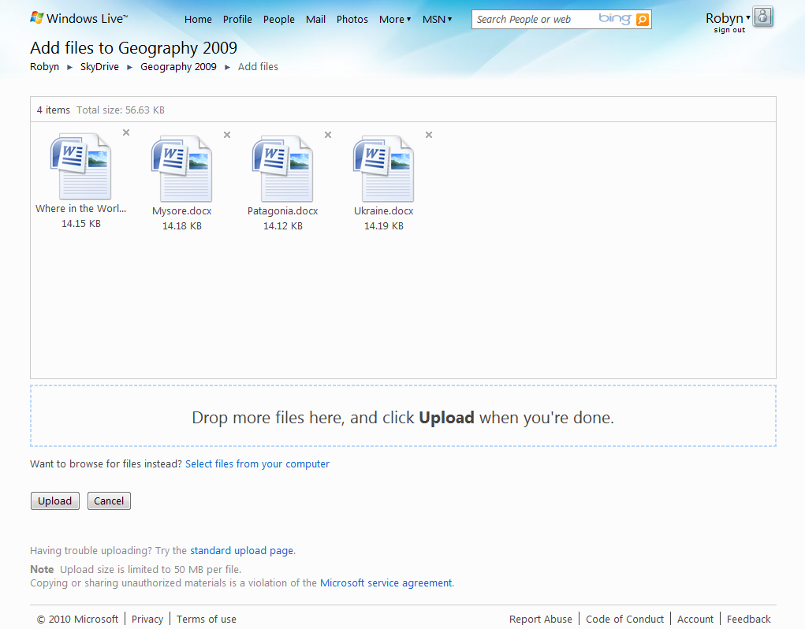
- Click Upload.

Share Files
- Click Send a link.
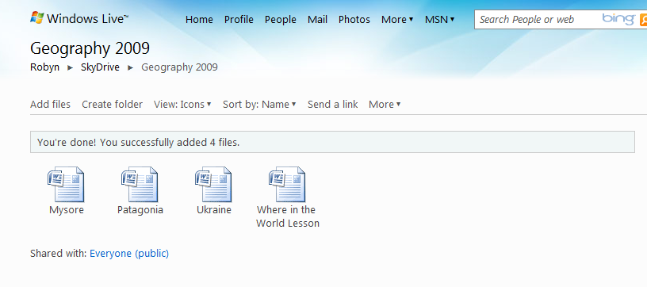
- In the To field, enter the recipients’ email addresses. You can include a message about the files. Check Don’t require recipients to sign in with Windows Live ID so that all of your students can access the files. Then click Send.
*NOTE: You can save all of your students’ contact information in one category to make it easy to send links to SkyDrive to the term. See the next section.
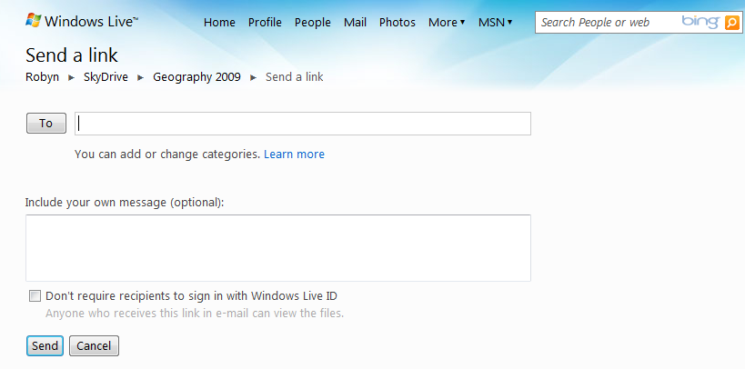
- You will receive a send confirmation.
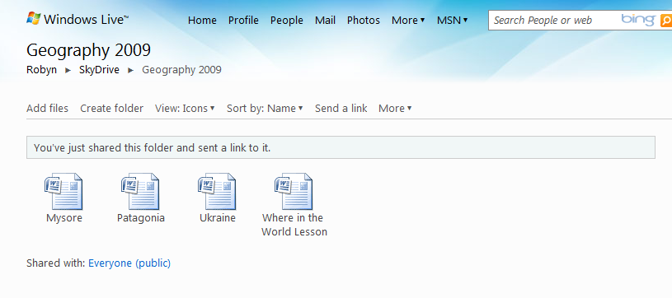

Organize Contacts into Categories
You can organize your contacts in Windows Live into categories to make it easier to communicate with them by sending e-mails or SkyDrive invitations to all the people in a category at once.

Create a New Category
- Click People in the top navigation.
- Click Categories.
- Click New category.
- Next to Name, type a name for the new category.
- Next to Members, type the e-mail addresses that you want to add.
- Click Save.

Edit a Category
- Click People in the top navigation.
- In the left pane, click Manage categories.
- Select a category, and then click Edit.
- Do any of the following:
  - Change Category Name: Next to Name, type a name for the new category.
  - Add People: Under Members, type their e-mail address and then press Enter.
  - Remove People: Next to each person that you want to remove from the category, click the Remove contact icon .
- Click Save.

Delete a Category
- Click People in the top navigation.
- In the left pane, click Manage categories.
- Select the category that you want to delete, and then click Delete.
- In the dialog that opens, click OK.

More Information on free tools for educators
For teachers:
www.microsoft.com/education/freetools
For faculty:
www.microsoft.com/freetools

For more information about Windows Live Services, including additional collaboration tools like Windows Live™ Groups, visit http://windowslive.com/online/Groups and
http://help.live.com

For more information about Microsoft resources for teachers, visit http://www.microsoft.com/education.

© 2009 Microsoft Corporation. All rights reserved.
This document is for informational purposes only. MICROSOFT MAKES NO WARRANTIES, EXPRESS, IMPLIED OR STATUTORY, AS TO THE INFORMATION IN THIS DOCUMENT.
Microsoft, Windows, Aero, BitLocker, BitLocker To Go, DirectX, Internet Explorer, OneNote, PowerPoint, SmartScreen, and Windows Live are trademarks of the Microsoft group of companies. The names of actual companies and products mentioned herein may be the trademarks of their respective owners.

