

Share your Windows Live Movie Maker Masterpiece

Publish to YouTube
Click the YouTube button in the Sharing section of the Home tab on the ribbon. It will ask you to sign into YouTube with your username and password.
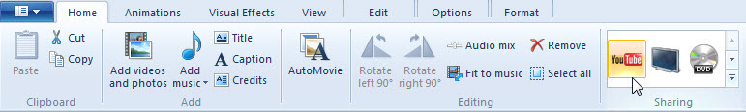
Follow the instructions in the Publish on YouTube pop-up and enter a title, description, tags, category, and permissions for your movie. Click the Publish button. Movie Maker will quickly publish your movie to YouTube. When the progress bar is complete, congratulations! Your movie has been published. Now you can see it online, on your PC, or click the Close button.
Watch a video on how to post your movie to YouTube at http://windowslive.com/Tutorial/MovieMaker/YouTube/Video.
Save the movie as a WMV file and burn to DVD
Click the DVD button in the Sharing section of the Home tab on the ribbon.
It will ask you to name and save the file as a Windows Media Video (WMV) file.
Windows DVD Maker will open automatically with your new movie in the queue for burning. It will also allow you to add multiple files, if you wish. Ensure that you have a blank DVD disc ready in your PC. Click Next and then burn DVD.
Watch a video on how to burn movies to DVD at http://windowslive.com/Tutorial/MovieMaker/BurnToDVD/Video.

More information on Windows Live Movie Maker
For teachers, visit www.microsoft.com/education/moviemaker
For faculty, visit www.microsoft.com/moviemaker
For more videos and information about Windows Live Movie Maker, visit http://windowslive.com/desktop/moviemaker
For more help on Windows Live Movie Maker and other Windows Live products and services, visit http://help.live.com/

© 2009 Microsoft Corporation. All rights reserved.
This document is for informational purposes only. MICROSOFT MAKES NO WARRANTIES, EXPRESS, IMPLIED OR STATUTORY, AS TO THE INFORMATION IN THIS DOCUMENT. Microsoft, Bing, DirectX, Internet Explorer, Windows, Windows Live, Windows Server, and Windows Vista are trademarks of the Microsoft group of companies. All other trademarks are property of their respective owners.

