# :art:WLMM_SBS_Cover.jpgThe Microsoft Office suite can be one of the most useful tools both in and outside of the classroom. Whether a person is presenting with Microsoft® PowerPoint®, writing with Microsoft® Word®, or taking notes with Microsoft® OneNote®—Office is an essential part of teaching and learning. This document covers some helpful Microsoft Office 2007 tips and tricks for teachers.

**Microsoft® Office® 2007**

**Step-by-Step for Educators**

# The Office 2007 User Interface

In Office 2007, we dramatically improved the user interface after thousands of hours of customer research and hundreds of designs. Our goal was to make the programs easier to use, and help you discover new, more efficient ways to get your work done. The result is a very visual and more dynamic interface.

### The Ribbon

The heart of this new interface is the ribbon. The ribbon replaces traditional menus and toolbars with a highly visual layout of commands that helps you find the features you need fast. All the tools for working in your documents have been logically grouped into tabs—each one, organized around a particular set of activities. To keep things simple, some tabs only appear when needed. For instance, the Table Tools tabs only appear when you insert or select a table. Just click on the object you want to edit, and the tools you need will be displayed.

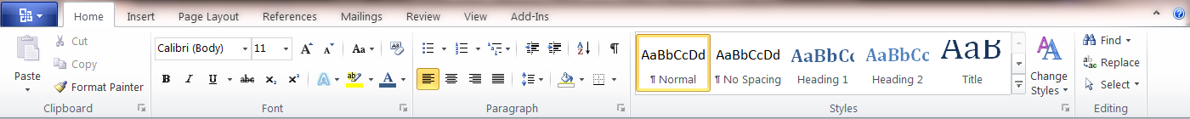

The home tab in the new Office 2007 ribbon: insert or select a table and the Table Tools tabs appear.

### Galleries and Live Preview

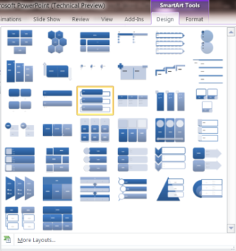Galleries present a selection of the results you can achieve with a feature, such as a selection of designs or formats. As you move your mouse over the options, Live Preview shows you exactly how they would look in your document. When you like what you see, just click on the results you want.

### 

### The Office Button

All the functions for working with your document—like opening, saving, printing, and sharing—are organized into one place.

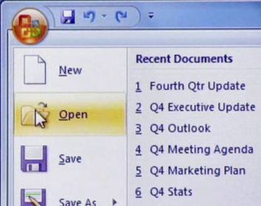

The Office Button

These features span the Office 2007 programs. Now let’s take a closer look at each program.

# OneNote 2007

OneNote is the program in Microsoft Office that brings everything in your teaching world into one tidy, collaborative space. Think of it as a digital notebook to gather, store and manage materials for teaching. Capture text, photos, video or audio files, Word documents, maps, Web articles, and handwritten notes.

## Search the Internet from within OneNote

Using the Research feature in OneNote, you and your students can quickly look up words and phrases in a dictionary, thesaurus or other research source. To use the research feature, on the **Tools** menu, click **Research**. In the **Research** task pane that is displayed on the right side of the window, type the term you’re searching for in the Search box, and select the source to use from the reference list. The results appear in the lower portion of the pane.

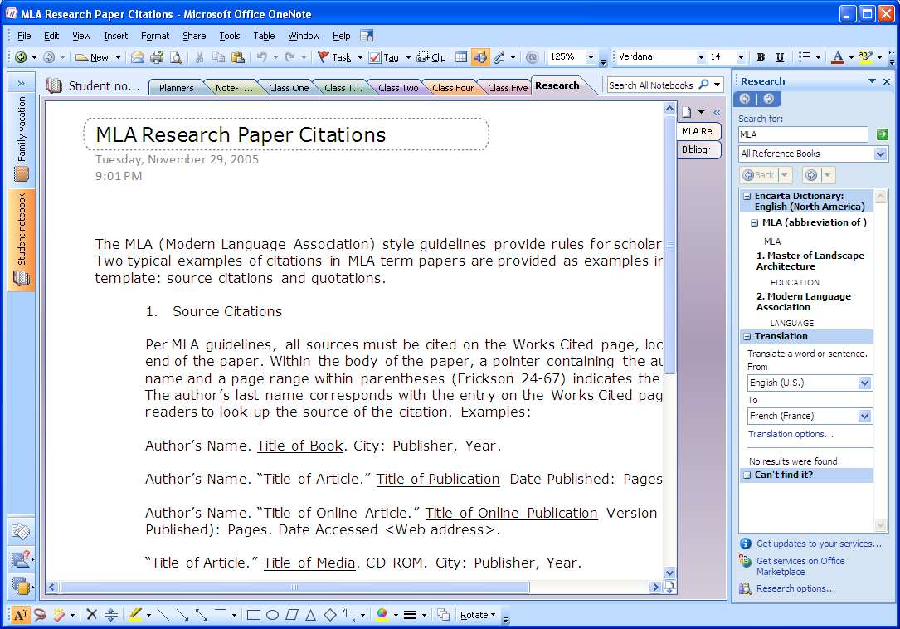

Use the research pane to find information on the Internet

## Clip and Save Content from Web Pages

You can use OneNote to take a picture of any part of your computer screen and insert the picture into your notes. Such pictures are called screen clippings, and they can range from a few pixels to the entire height and width of your screen. Anything in the area that you select appears in the image and is automatically pasted into your notes and the Clipboard.

To save a screen clipping from a Web page, in OneNote, click the **Clip** button on the toolbar. Then switch to the Web page, and use your mouse pointer to drag a rectangle over the area you want to clip. When you release the mouse, the clipping, together with a hyperlink to the Web page, is automatically saved to the OneNote page.

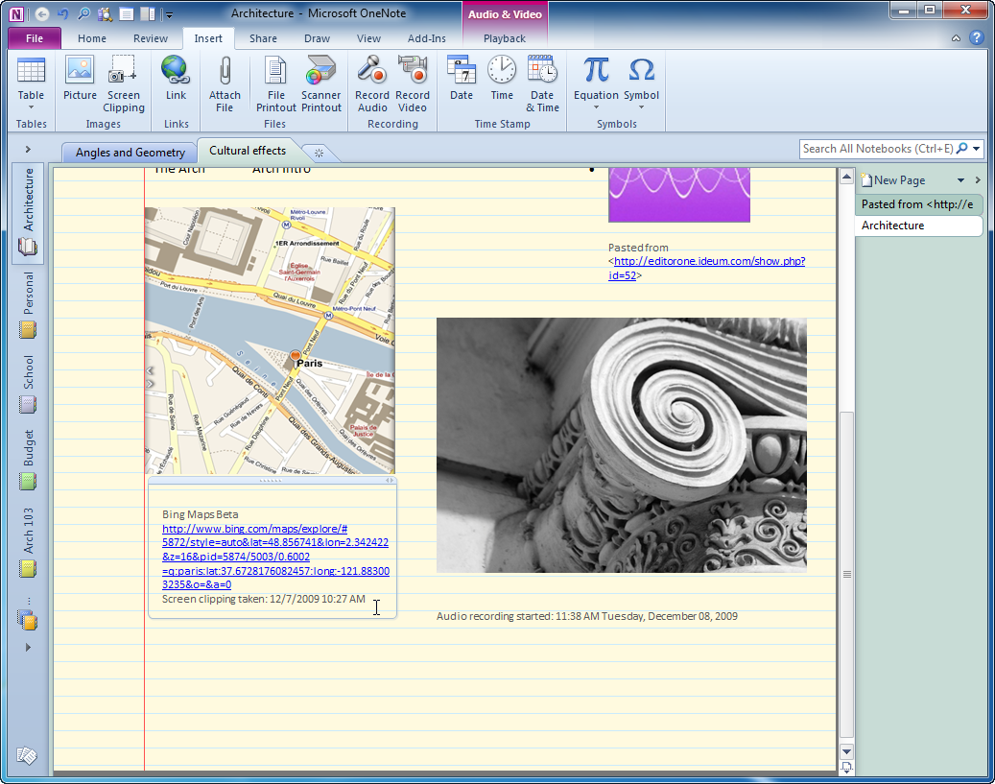

Save a screen clipping of a Web page

## Add an Audio Note

OneNote 2007 lets your students record audio and video clips as they take notes. To record audio, you need a microphone. To record video, you need to connect a digital camera capable of recording movie clips, such as a webcam.

Audio and video recordings you make in OneNote are directly linked to any notes you take when the recording is made. Whenever you play back the recording, OneNote shows you the accompanying notes that you took.

To make an audio recording, on the toolbar click the **Recording Audio Only** button. Use the mini toolbar that appears to make your recording.

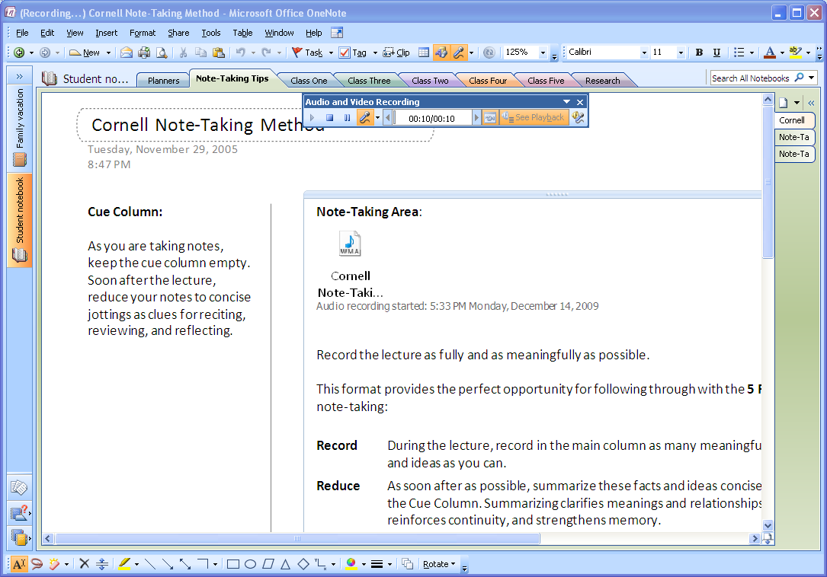

Insert audio recordings with your notes

Note: To record audio or video clips in OneNote, Microsoft DirectX 9.0a or later and Microsoft Windows Media Player 9 or later are required.

## Set Up a Shared Notebook

OneNote lets you store and maintain shared notebooks on a network server or file share, so that your students can simultaneously access shared notes and contribute to them on an ongoing basis.

Taking notes as a group is a collaborative process that encourages teamwork. OneNote lets everyone access a shared set of notes at once, and it automatically synchronizes everyone's changes to the notebook. The result is a notebook that is always up-to-date and that literally keeps everyone on the same page.

Setting up a shared notebook is easy. On the **File** menu, point to **New**, and then click **Notebook**.

The New Notebook Wizard guides you through the steps for creating a shared notebook in a network location that you and your whole class has access to.

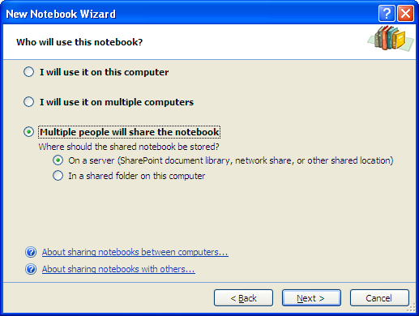

Teach your students to collaborate using shared notebooks

## Find Content in OneNote

One of the main advantages of using OneNote instead of traditional notebooks is its ability to quickly search through all of the information you've collected and retrieve important notes based on criteria that you specify. Instead of having to flip and skim through paper pages, you can quickly retrieve anything you've jotted down. OneNote also makes it easy to browse through your most recent notes and search for spoken words in recorded audio notes.

To search for words in OneNote, even words that are inside graphics, type the search term in the Search box in the upper right corner of the window and click the **Search** button. OneNote highlights the search results where they are found on the pages of the notebook.

If one or more instances of the text are found, the total number of pages appears in the toolbar area.

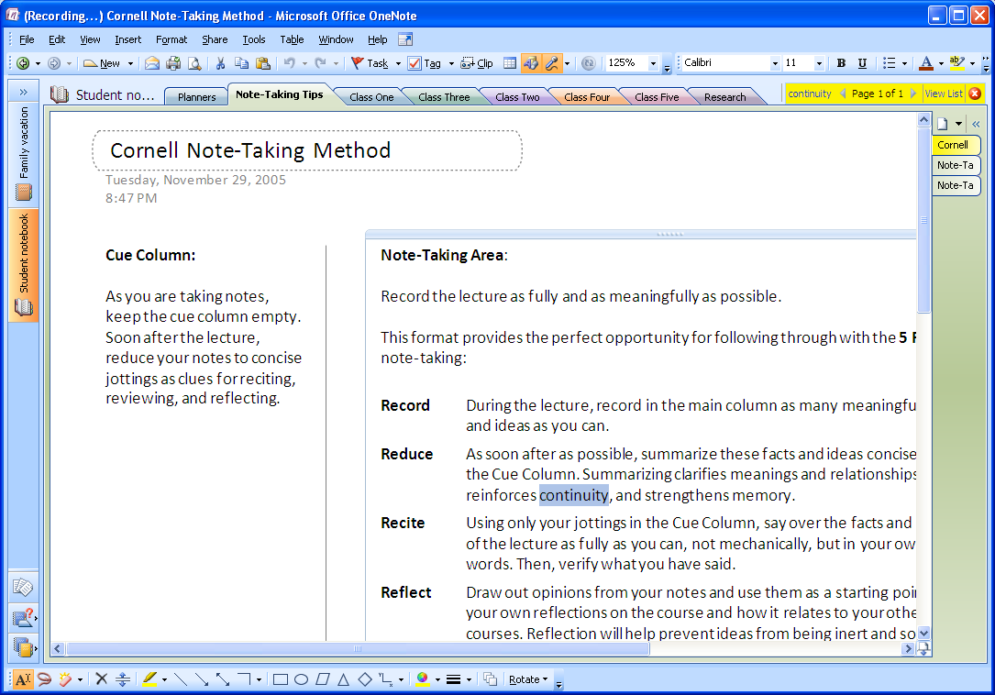

Search results are highlighted on pages

## Automatic Save

You never need to save your notes. OneNote automatically saves them as you are working and whenever you close the program or a section.

By default, OneNote automatically backs up your notes at regular intervals. You can change how often automatic backup files are created, and you can turn the automatic backup feature on or off at any time.

To set your backup options, on the **Tools** menu, click **Options**. In the **Options** dialog box, in the **Category** list, click **Backup** and select your backup preferences.

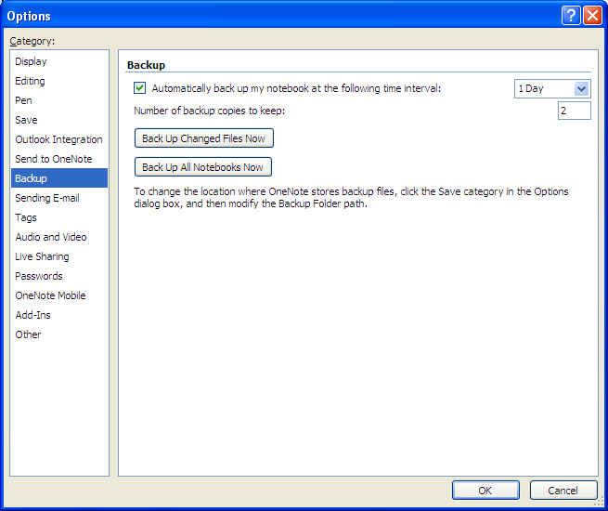

Select backup options

**Note:**The names of backup files include the date they are created. For example, a backup file for a notebook section called Lectures that is created on January 14, 2010, is automatically named "Lectures.one (On 1-14-2010).one".

# PowerPoint 2007

## Apply a Design Theme

In previous versions of PowerPoint, you gave your presentation the look you wanted by applying a design template. In PowerPoint 2007, you can do the same thing by applying a theme. There are lots of great looks now available for your presentations.

Open the presentation. On the ribbon’s **Design** tab, in the **Themes** group, click **More**Button image to see the Themes gallery. Point to the themes to see a preview of how your presentation would look. You can also click on **More Themes in Microsoft Office Online** and search for education-specific templates. Click the thumbnail that you like the best.

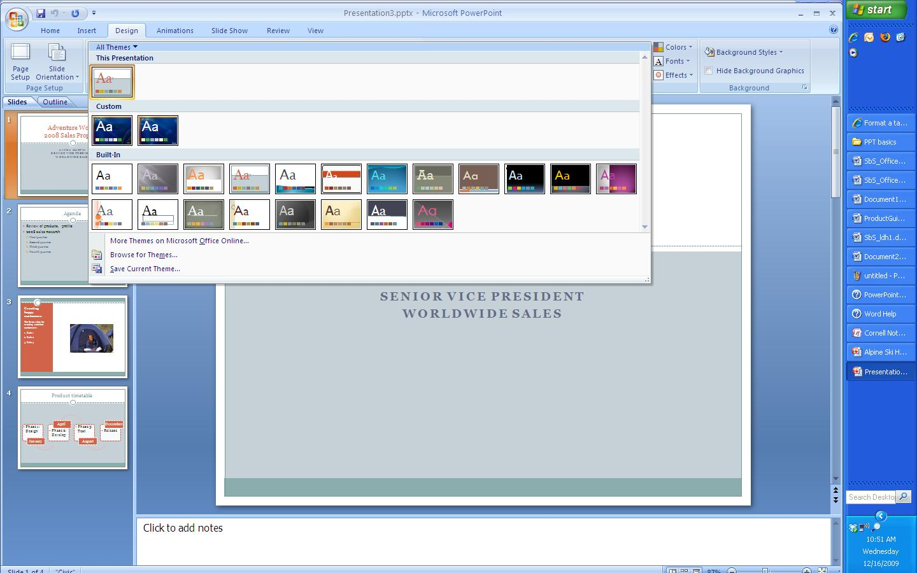

View the Theme gallery

## Add Visual Impact with SmartArt

PowerPoint gives your students an opportunity to convey their ideas to you and their fellow students using graphics as well as words. PowerPoint 2007 includes a feature called SmartArt, which lets you visually represent a variety of concepts and ideas that might not work too well with just text.

Add a SmartArt graphic to a slide in one of two ways:

1. To insert SmartArt into a new slide, click on the **Home** tab on the ribbon, and then click on **New Slide**. The new slide will provide helpful icons to insert specific types of content. Click the SmartArt Graphic icon.  
   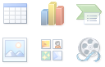

**Insert SmartArt**

1. To insert SmartArt into an existing slide, click on the **Insert** tab on the ribbon. In the **Illustrations** group, click on SmartArt.   
     
   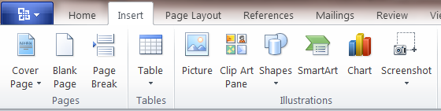

**Insert SmartArt**

The SmartArt gallery will be displayed. Choose the option that most closely resembles the concept you want to convey.

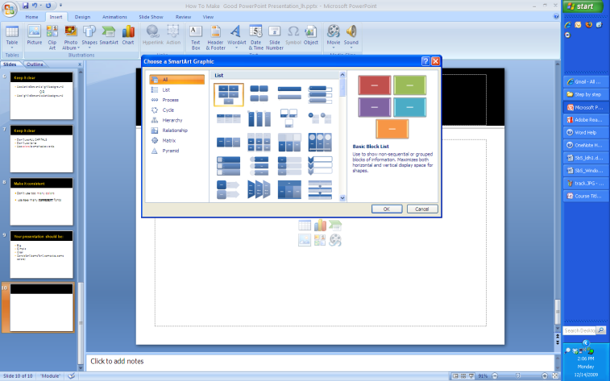

View the SmartArt gallery

## Add an Animation

Animations let you add movement and action to your presentations, emphasize important points, and control the flow of information to your audience.

You can use the built-in animation effects in PowerPoint, or you can create your own custom effects. First select the text box or object you want to animate. Then, on the **Animations** tab, in the **Animations** group, either click the animation you want to use or click **Custom Animation**, to display the **Custom Animation** task pane.

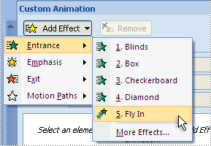

Add a custom animation

Point to the type of animation you want to apply, and then click the animation. PowerPoint shows you a preview of the animation you have selected and adds the animation to the **Custom Animation** task pane.

In addition to animations, transitions can be inserted to move from one slide to the next when you show the presentation.

Since the goal is to draw attention to the information you are trying to convey, it’s best to use animations subtly, rather than draw too much attention to the technology feature.

To apply an animated transition to one or more slides, selected the slides and, on the **Animations** tab, in the **Transition to This Slide** group, point to a transition to see a preview. Then click the one you like.

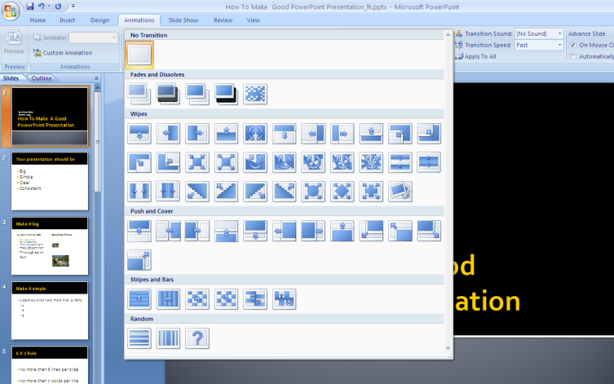

View the slide transition gallery

Notice that PowerPoint displays an animated star under the slide number on the **Slides** tab, for every slide to which a transition has been applied.

## Create an Interactive Story

You or your students can create stories with multiple story endings by using hyperlinks.

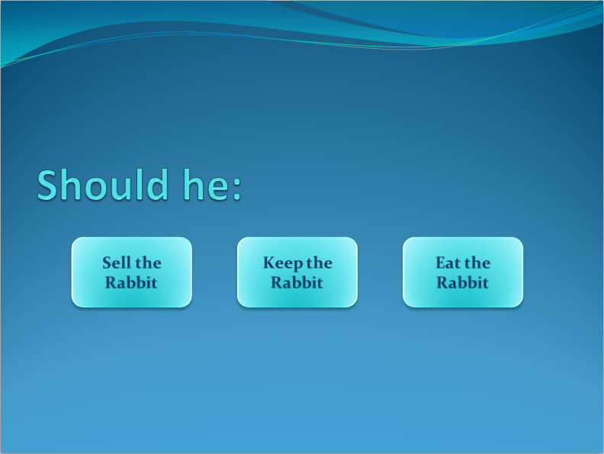

Create an interactive story that allows your audience to choose the ending

Create your story pages, or slides. On the slide where your story branches off, add graphic elements or text boxes to represent different story options (see example above). Select the first option. On the **Insert** tab, click **Hyperlink**. On the left side of the dialog box, select **Place in this Document**, and select the destination slide. Then click **OK**. Repeat for the other story options.

## Embed a Movie

**You can embed a movie clip (or video) on a slide so that it plays within the presentation. This is a good way to add lecture notes or comments to a presentation.**

To insert a video clip on a slide, first select some text or an object on the slide. On the **Insert** ribbon, in the **Media Clips** group, click **Movie** and then click **Movie from File**. Then find the video file on your computer.

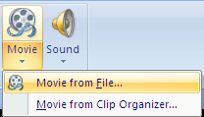

Select a Movie

**If you’re going to be presenting on another computer, note that** PowerPoint stores the movie file as a relative path in the presentation.If PowerPoint cannot find the movie file in the same path, the movie will not be played. **Therefore, it’s a good idea to start out by placing the video** file in the same folder as your presentation, and copy the whole folder **to the other computer.**

In the message box that is displayed, indicate whether you want the video to play automatically or when clicked. If you choose the latter, when you view the slideshow the video will start playing only after you click the movie object in the slide.

# Word 2007

## Reviewing and Editing

The Review features in Word give teachers a great way to comment on students’ writing and suggest changes.

### Track Changes

You can easily make and view tracked changes and comments while you work in a document. By default, Microsoft Office Word 2007 uses balloons to display deletions, comments, formatting changes, and content that has moved. You can change settings so that tracked changes and comments display the way you want. To show changes inline, in the **Tracking** group, click **Balloons**, and then click **Show all revisions inline**.

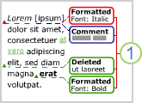

Balloons show formatting changes,   
comments, and deletions

1. To track changes, open the document that you want to revise.
2. On the **Review** tab, in the **Tracking** group, click the **Track Changes** image.
3. Make the changes that you want by inserting, deleting, moving, or formatting text or graphics.
4. To turn off change tracking, on the **Review** tab, in the **Tracking** group, click the **Track Changes** image.

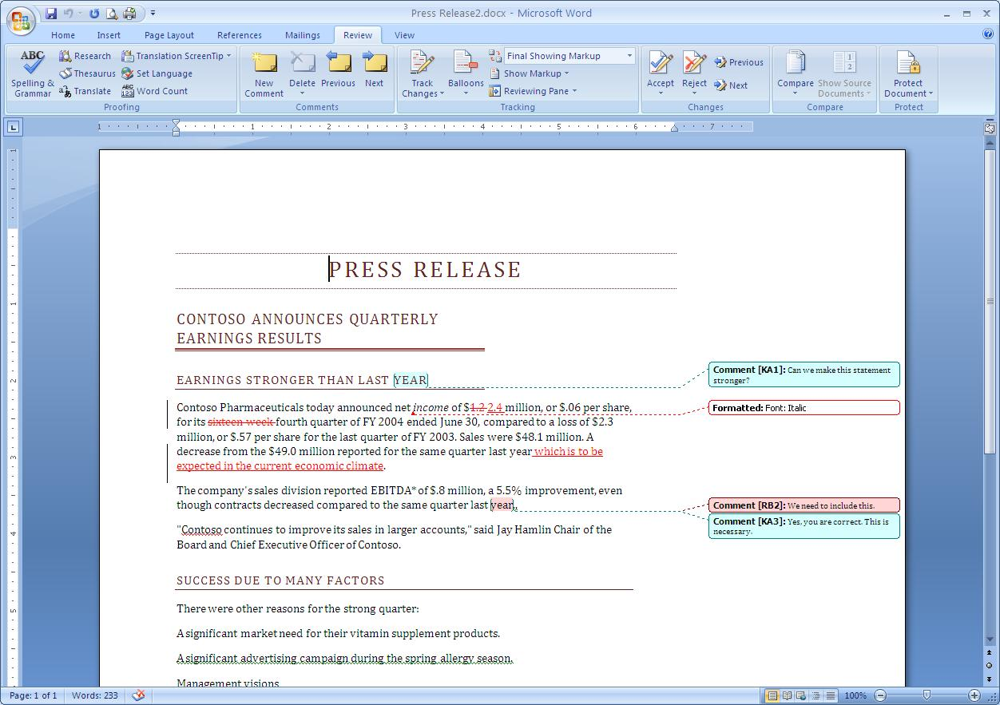

### Comments

To insert a comment (a note or an annotation) in a document, select the text or item that you want to comment on. Then, on the **Review** tab, in the **Comments** group, click **New Comment** and type the comment text in the comment balloon. To respond to a comment, click its balloon, and then click **New Comment** in the **Comments** group. Type your response in the new comment balloon.

### Change the Way the Markup is Displayed

You can change the color and other formatting that Word uses to mark changed text and graphics by clicking the arrow next to **Track Changes** and then clicking **Change Tracking Options.** Note:While you can't assign specific colors for changes made by different reviewers, each reviewer's changes appear as a different color in the document so that you can track multiple reviewers.

In the **Review** tab, in the **Tracking** group, click **Show Markup** to turn on and off markup viewing options such as: comments, ink (if you’re using a Tablet PC), insertions and deletions, and formatting. You can also choose to see changes and comments from only certain reviewers, or all reviewers.

Note that the Show Markup feature only hides tracked changes or comments in the document. It does not eliminate them.

### Review Tracked Changes and Comments

Comments need to be deleted and tracked changes need to be either accepted or rejected to create a publishable version of a document.

1. On the **Review** tab, in the **Changes** group, click **Next** or **Previous**.
2. Do one of the following:
   1. In the **Changes** group, click **Accept**.
   2. In the **Changes** group, click **Reject**.
   3. In the **Comments** group, click **Delete**.
3. Accept or reject changes and delete comments until there are no more tracked changes or comments in your document.

To ensure all tracked changes are accepted or rejected and that all comments are deleted, on the **Review** tab, in the **Tracking** group, click **Reviewing Pane**. The summary section at the top of the **Reviewing Pane** displays the exact number of tracked changes and comments that remain in your document.

To accept all changes at once:

1. On the **Review** tab, in the **Changes** group, click **Next** or **Previous**.
2. Click the arrow below **Accept**, and then click **Accept All Changes in Document**.

## Insert and Design Tables

The quickest way to insert a table in a document in Word 2007 is to first click in the document to indicate where you want the table. Then, on the **Insert** tab, in the **Tables** group, click **Table**, and drag to indicate the number of columns and rows you want in the table.

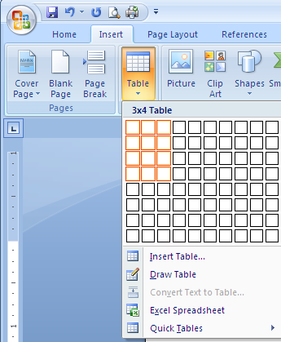 **Drag to indicate the number of columns and rows**

**Table Tools** will display on the ribbon, which include a **Design** and **Layout** tab. Click on the **Design** tab. In the **Table Styles** group, click the **More** button in the lower right corner to display the Design gallery. Mouse over the designs to see Live Preview of the designs applied to your table. Select the design you like and it will automatically be applied.

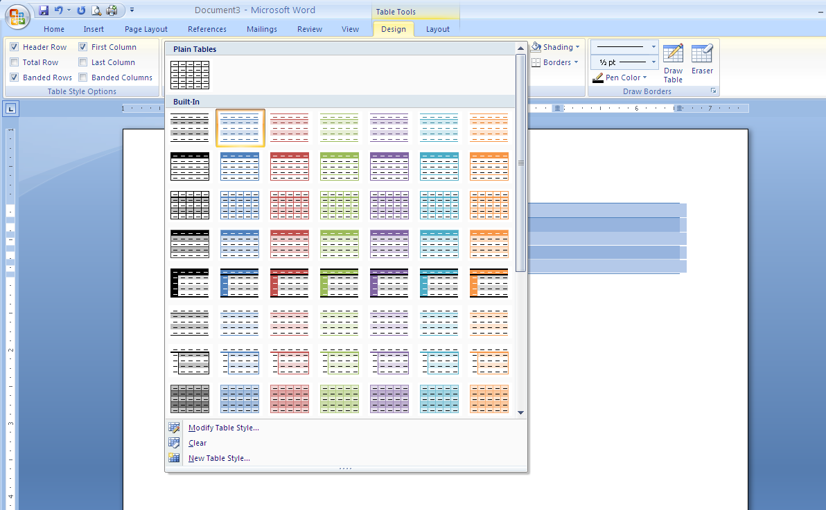

Select a design from the Design gallery

## Headers, Footers, Page Numbers

Headers and footers are areas in the top, bottom, and side of each page in a document. You can insert or change text or graphics in headers and footers. For example, you can add page numbers, the time and date, the document title or file name, or the author's name.

To insert a header or footer in a document, on the **Insert** tab, in the **Header & Footer** group, click **Header** or **Footer**. (You can also double-click in the header or footer area of your document to accomplish the same thing.)

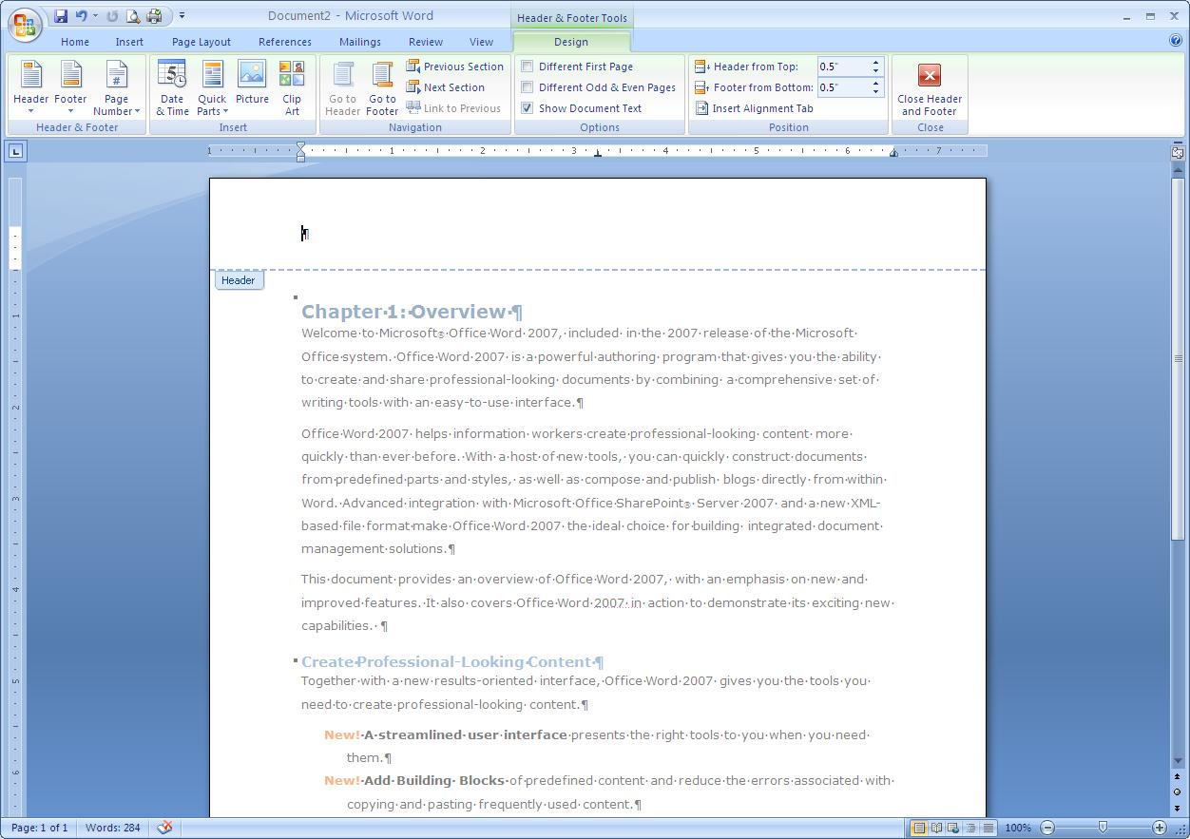

Insert a header

Click the header or footer design that you want. The header or footer is inserted on every page of the document. If necessary, you can format text in the header or footer by selecting the text and using the formatting options on the mini toolbar.

**More Information on Office 2007 for educators**

**For teachers:**

[www.microsoft.com/education/Office](http://www.microsoft.com/education/Office)

**For faculty:**

[www.microsoft.com/officeeducation](http://www.microsoft.com/officeeducation)

© 2009 Microsoft Corporation. All rights reserved.

This document is for informational purposes only. MICROSOFT MAKES NO WARRANTIES, EXPRESS, IMPLIED OR STATUTORY, AS TO THE INFORMATION IN THIS DOCUMENT.

Microsoft, Windows, SmartArt, Excel, Internet Explorer, OneNote, PowerPoint, SmartScreen, and Windows Live are trademarks of the Microsoft group of companies. The names of actual companies and products mentioned herein may be the trademarks of their respective owners.