CURRICULUM VITAE
OF

IHAB FATHI HOSNI OMAR

PERSONAL INFORMATION

Nationality : Jordanian
Date of Birth : 11th of July 1959
Sex : Male
Marital Status : Married with 5 children

Religion : Moslem
Mobile : 00962-797976222 (Jordan)
: E-mail: ihabfho@gmail.com

EXPERIENCE:

- Mar 24 – Up to present Ass. Pro. /Allied medical : JUST

- Mar 21 – Feb 24 Consultant Anesthestist : MOH

- Nov.16 – Dec 20 Consultant Anesthestist : Amman Hospital

- July '10 – Oct. 16 : Consultant Anesthetist: Riyadh Care Hospital
Riyadh K.S.A

- Oct. '03 –July. '10 - Acting Consultant Anesthetist
King.Fahad.Medical.City, Riyadh.K.S.A.

- Nov.'99 –Sept. '03 - Consultant Anesthetist
Malhas Hospital,Amman, Jordan

- Sept.'96 -Oct. '99 - Specialist Anesthetist
Al-Moosa Hospital -Alhasa. K.S.A.

- Oct. '95 -July '96 - Specialist Anesthetist
Malhas Hospital, Amman, Jordan.

- May '95-Sept.'95 - Specialist Anesthetist
Heba Hospital, Amman, Jordan.

- Dec. '90-March '95 - Specialist Anesthetist
Martyr Ibrahim Abu Dayieh Hospital-Amman, Jordan

- Sept. '89-Oct.'90 - Specialist Anesthetist
Al Hammadi Hospital, Riyadh, K.S.A.

- May '88-May '89 - Specialist Anesthetist
Veeny Hospital, Cairo, Egypt

JOB DESCRIPTION
As a member of an academic staff:
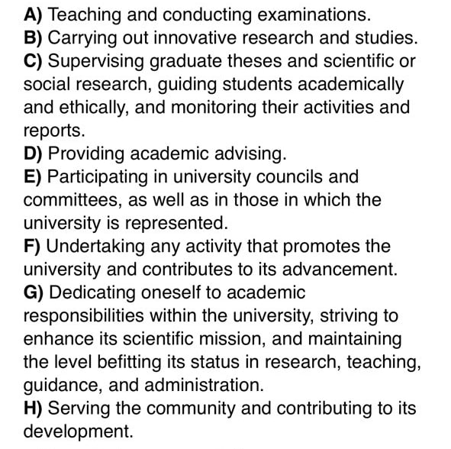
As an anesthesia consultant
- Provide anesthesia with the full range of anesthetic agents, methods and techniques, observing safety standard in the operating room as related to anesthetic agents and equipment (except cardiac anesthesia).
- Provide technical advice in guidance to nursing staff and as required provides orientation / training in new techniques and procedures.
- Interviews patients scheduled for surgery to assess and develop an anesthesia care plan, and to establish rapport and allay fear and apprehension.
- See patients post-operatively to evaluate recovery from anesthesia, to assess complications and make recommendations as indicated.
- Supervise and maintain appropriate documentation on the "controlled drugs" for the division in the obstetrical and main O.R's.
- Supervising the Post Anesthesia Care Unit.
- Serving the cardio- pulmonary resuscitation committee and team.
- Keep current with new procedure and techniques in the field of anesthesia.
- Stand for on-call duty for emergency surgery, obstetric and / or medical procedures.

EDUCATION:

September 1995 - The Jordanian Board in Anesthesia and Intensive Care
Amman, Jordan

May 1988 - Post – Graduate Degree M.SC. Anesthesia and Intensive Care
Ain Shams University, Cairo, Egypt.

December 1983 - University Degree M.B.B.Ch.
Ains Shams University, Cairo, Egypt

LANGUAGES

- Arabic (Mother tongue)
- English (Good written & oral fluency)

PROFESSIONAL MEMBERSHIP

- Jordanian Medical Association
- The Jordanian Society of Anesthesiologists
- Academic Practice License Certificate

SCHOLARLY WORK:

- "Blood Coagulation Defects in Relation to Anesthesia" published in English Ain Shams University, MSc – Essay.

- Attended of conferences, symposiums and congresses in Anesthesia and Intensive Care.

- Attended F.F.A.R.C.S.I. Part 1 Revision Course at Riyadh Armed Forces Hospital.

- Attended BLS provider courses.

- Attended ACLS provider courses.

- Attended BLS Instructor course.

- Share as an active member and as a head of department and QI coordinator in reaccreditation of JCI for Riyadh Care Hospital on December 2011 and March 2015.

- Share as an active member and as a head of department and QI coordinator in accreditation of CBAHI for Riyadh Care Hospital on December, 2012.

PUBLICATIONS:

- Omar, M. M. Syam & M. S. Takrouri: Negative Pressure Hemoptysis Due To Airway Obstruction On Emergence From General Anesthesia For Arthroscopy. The Internet Journal of Anesthesiology. 2008 Volume 17 Number
- I. Omar: Magill's forceps in removing impacted foreign body. The Internet Journal of Anesthesiology. 2007 Volume 13 Number 2
- M. Syam, I. Omer, O. Nofal & A. Zafrullah: Neuroanesthesia For Awake Craniotomy; Initial Experience At KFMC. The Internet Journal of Anesthesiology. 2009 Volume 21 Number 2

REFERENCES:

1) Prof. Ashraf Swailem
Senior Anesthesia Consultant, Prince Sultan Military Medical City
Riyadh. K.S.A.
E-mail: aswellam2@gmail.com
Tel. No.: 00966-502811301

2) Dr. Mamoun El Awad, MRCOG
Ob/Gyn Consultant
King Fahad Medical City
E-mail: elawad@gmail.com
Tel. No.: 00966-508526278

3) PROF. ABDULHAMID SAMARKANDI
Collage of Medicine
King Saud University
King Khalid University Hospital
Tel. No.: 00966-505428205
E-mail: abdrubo@yahoo.com

