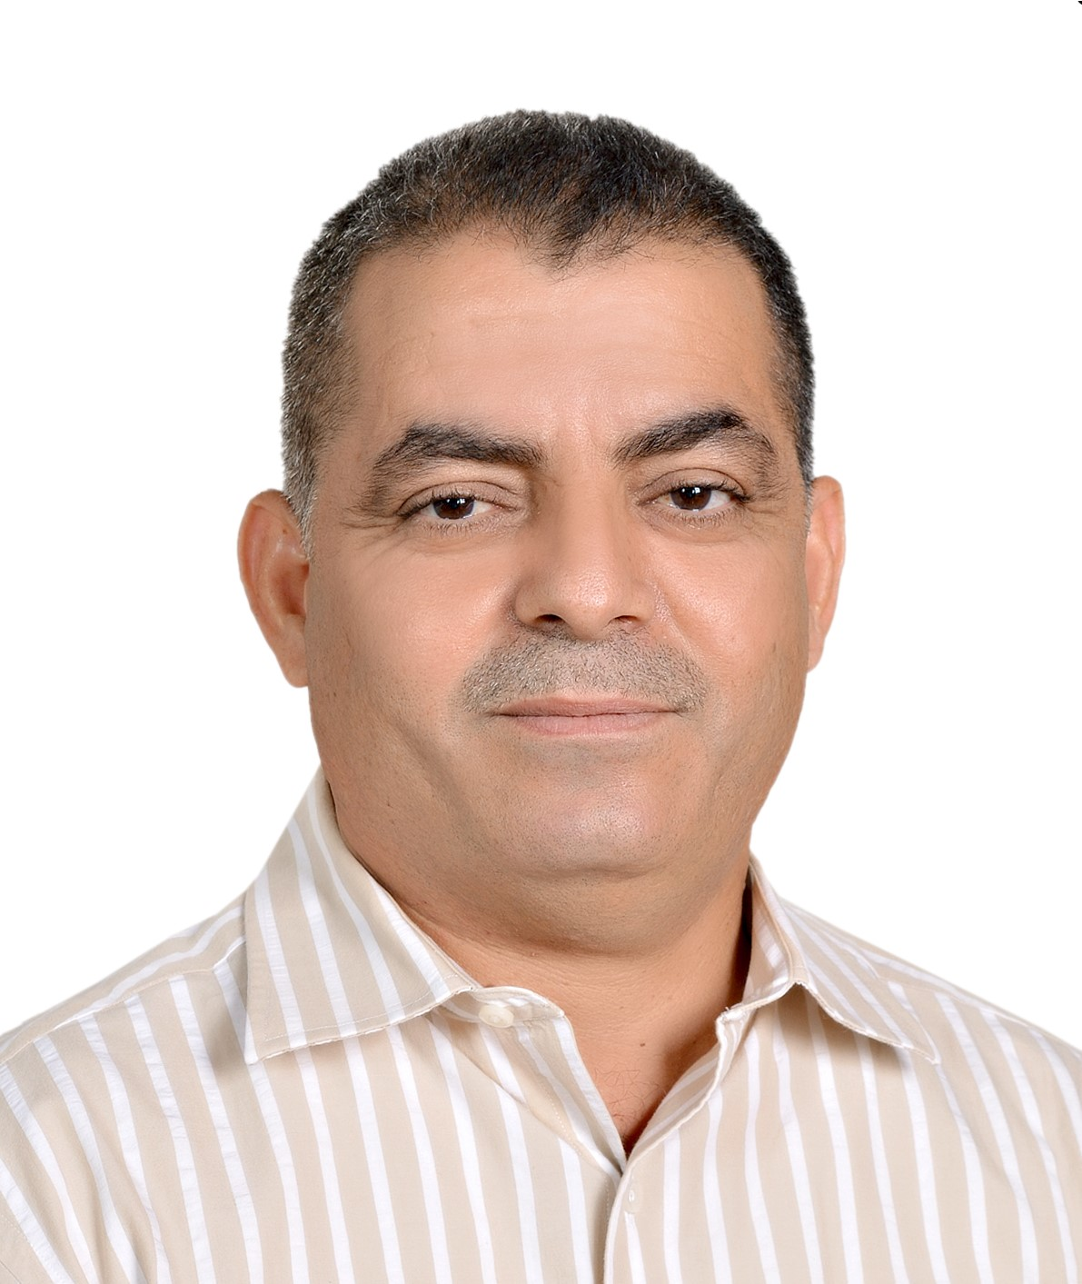
Khaleel Al Khasawneh
E-mail: krkhasawneh@just.edu.jo
Address: Mechanical Engineering Department
Faculty of Engineering
Jordan University of Science and Technology

- SCOPUS ID number: 59249031000

https://www.scopus.com/authid/detail.uri?authorId=59249031000

- ORCID:
Khaleel Al Khasawneh (0000-0003-3710-9344) - ORCID

- Google Scholar: https://scholar.google.com/citations?user=YZ_RZisAAAAJ&hl=ar&oi=ao

- Research Gate:
https://www.researchgate.net/profile/Khaleel-Al-Khasawneh?ev=hdr_xprf

EDUCATION

Ph.D., Mechanical Engineering, New Mexico State University, USA
Dissertation Title: Theoretical and Numerical Studies of Two Rarefied Gas Flow Problems.

The course included Advanced Applied Mathematics, Intermediate Heat Transfer, Gas Dynamics, Plasma dynamics, Computational Fluids Dynamics, Elasticity, Aero-elasticity, Vibrations, and Dynamics.

M.Sc., Mechanical Engineering, Jordan University of Science and Technology
Thesis Title: Thermodynamic Optimization and Entropy Generation of Transient Conjugate Pipe Flow.

The course included Advanced Applied Mathematics, Viscous Fluid Flow, Intermediate Heat Transfer, and Numerical Techniques.

B.Sc., Mechanical Engineering, Jordan University of Science and Technology

ACADEMIC EXPERIENCES

- Associate Professor: Jordan University of Science and Technology. May 2019- Till Now

Courses taught: Heat Transfer, Fluid Mechanics, Advance heat transfer, Advance fluid mechanics. Thermo- fluids Lab. Thermodynamics.
- Assistant Professor: Jordan University of Science and Technology. Feb 2015- May 2019.

Courses taught: Numerical Analysis, Heat Transfer, Fluid Mechanics, Intermediate heat transfer, Intermediate Fluid Mechanics. Thermo- fluids Lab. Thermodynamics.

- Assistant Professor: Hashemite University Sep. 2012 - Feb 2015
Courses taught: Numerical Analysis, Heat Transfer, Fluid Mechanics,
Strength of Material, Dynamic, Thermo- fluids, Strength of Material Lab,
and Thermo- fluids Lab.

- Assistant Professor: Al Balqa Applied University Sep. 2011- Sep. 2012
Courses taught: Mechanical Vibrations, Dynamics, Numerical Analysis,
Heat Transfer, Thermodynamics, Strength of Material, Strength of Material Lab.,
Heat Transfer Lab and Engineering Drawing.

- Teaching Assistant/ Lecturer: New Mexico State University Jan. 2011- May 2011

- Research Assistant: New Mexico State University Jan. 2009 -Jan.2011

- Teaching Assistant: New Mexico State University Jan. 2008 -Jan. 2009

- Teaching Assistant: Jordan University of Science and Technology Jan. 2004- Jan. 2007

OTHER EXPERIENCE

- Mechanical Engineer: Jordan 2001 - Dec. 2007
Superintend and design for mechanical systems.

- Chief Engineer: Staff head for mechanical systems maintenance, Jordan Armed Force, Jordan 1995-2001
Coordinated a group of consultants to construct the factory main mechanical systems; Responsible for setting up all the machine in the group floor with their mechanical connection; maintenance of a rubber laboratory procedures and all engineering requirements for the production of solid wheels and moulds maintenance; a variety of machines/units handled: chemical cleaning units, painting units, rubber mixers, steam presses, boilers, compressors, ventilation units, rubber testing machines, sand blast units, and cooling towers. Training with AVON technical services limited (1995), United Kingdom.

- Chief Engineer: Staff head for mechanical system maintenance, Jordan Armed Force, Jordan 1991-1995
Responsible to maintain the following machines and systems: cooling, heating and steam generation systems; cranes and lift systems; air compressors and their networks; ventilation and heating ventilation units; cooling tower systems; electroplating and chemical cleaning system; water and chemical waste treatment systems.

RESEARCH INTERESTS

- Gasdynamics, Computational methods for fluid mechanics, Rarefied gas flows, Gaskinetic CFD methods, Slip flow in microchannels.

PRIVIOUS PROJECTS

Previously participated in the following projects:
- 01/2009-01/2010, Multi-scale Gaskinetic/Particle (MGP) Simulation for Rocket Plume/Lunar Dust Impingement, NASA-STTR Phase I project.
- 01/2009-01/2010, A Unified Multi-Dimensional Gaskinetic Hybrid BGK-DSMC Method for Non-equilibrium and Chemically Reacting Flows, NASA-SBIR Phase I project.
- 08/2009-07/2012: Gaskinetic Schemes for Micro-Scale Flows with Heat Transfer, National Science Foundation, Fluid Dynamics section, NSF-CBET-0854411.

SELECTED UNDER-GRADUATE PROJECTS:
- (2022-2023) Cooling of Lithium-ion Batteries Using nano Phase-Change Materials and Liquid Cooling in Wavy Porous Pipes.
- (2022-2023) Effect of Electromagnetic Field on Water-Fe₃O₄ Nanofluid Flowing in a Two-Dimensional Rectangular Microchannel
- (2021-2022) Thermodynamic analysis and technoeconomic assessment of integrated solar combined cycle power plant in Jordan (Rehab) using parabolic trough collectors.
- (2021-2022) Integrated Fuel Cell -Brayton Cycle with Particles Based Thermal Energy Storage System for Variable Electricity Production.

- (2021-2022) Waste Heat Recovery by a Stirling Engine for a Combined Brayton-Organic Rankine Cycle Powered by a Fuel Cell.

- (2020-2021) Improvement of coefficient of performance of refrigeration cycle
by improvement the cooling process of the condenser.
- (2020-2021) Improved Model of Integrating Transparent and Conventional Solar Cells
- (2020-2021) Integrated Solid Oxide Fuel Cell (SOFC) with Absorption Refrigerating Cycle and Heat Storage
- (2019-2020) Design of an Automatic Feeding and Cleaning System for the Fireplace
- (2019-2020) Integration of a Solid Oxide Fuel Cell in a Split System of Charging and Discharging Compressed Natural Gas.
- (2019-2020) Design a Dual Preheating-Cooling System Using Geothermal Energy with Underground Air Flowing Tunnel.
- (2019-2020) Combined Evacuated Tube and parabolic Trough Solar Collector to Drive an Absorption chiller for Cooling Systems.
- (2018-2019) Performance and Parametric investigation of a flash-steam plant with organic Rankine cycle and solar pond.
- (2016-2017) Design a system for Extraction of Freshwater from Atmosphere.
- (2015-2016) Portable Cooler using TEG.
- (2015-2016) A Refrigeration System Design with Pre-cooling Using Absorption Cycle with Alternative Energy for Fruits and Vegetables at Al-Mafraq -Jordan.
- (2015-2016) Environmental Performance of Insulation at Residential Building in Jordan

SUPERVISING GRADUATE STUDENTS:
    - Member of the examining committees of graduate M.Sc.
    - Master’s Thesis Supervised:

Entropy Generation Analysis for Low Magnetic Reynolds Number Compressible Gas Flow Inside Two Dimensional Rectangular Microchannel, Mechanical Engineering Dept. Jordan University of Science and Technology, 2018. Dua Kharouf.

Analytical Study of Gaseous Slip Flow and Heat transfer in Horizontal Rectangular Microchannel with Second Order Boundary Conditions Effected by Inclined Magnetic Field, Mechanical Engineering Dept. Jordan University of Science and Technology, 2019. Amani A. AlWardat.

Analytical Study of the Impact Forces and Stagnation Point Properties on an Inclined Plate Surface for Rarefied Jet Impingement Issuing from Planner Exit, Mechanical Engineering Dept. Jordan University of Science and Technology, 2020. Yazan AL Samamah.

Performance analysis of novel Stirling engine- double effect absorption chiller hybrid system for waste heat utilization from Gas Turbine Modular Helium Reactor. Mechanical Engineering Dept. Jordan University of Science and Technology, 2020. Alaa Al Tubeshat.

5)
Experimental investigation of a novel solar cooker design with linear Fresnel reflectors, 2023, Ahmad Dudol.

REFREED PUBLICATIONS:
Research Gate: https://www.researchgate.net/profile/Khaleel-Al-Khasawneh?ev=hdr_xprf

- Cai, C., Khasawneh, K.R., Liu, H., and Wei, M., Collisionless Gas Flows Over a Cylindrical or a Spherical Object, Journal of Spacecraft and Rockets, Vol.46, No.6, November-December, pp. 1124-1131, 2009.

- Cai, C. and Khasawneh, K., Collisionless Gas Flow over a Flat Cryogenic Pump Plate, Journal of Vacuum Sciences and Technology (A), Vol.27, No.4, pp.601-610, 2009.

- Cai, C. and Khasawneh, K., Two-Dimensional Micro-Hartmann Flows, ICCS 2009, Baton Rouge, Louisiana, May 25-27. Allen G. et al (Eds.), ICCS 2009, LNCS Vol. 5544, PART I, pp.655-664, Springer Publisher.

- Khaleel Khasawneh, Hongli Liu and C. Cai, Highly Rarefied Two-dimensional Jet Impingement on a Flat Plate, Physics of Fluids, 22,10, pp.1-6 DOI: 10.1063/ 1.3490409, 2010.

- Khaleel Khasawneh, Liu, H. and Cai, C., Surface Properties of Rarefied Round Jet Impingement on a Flat Plate, Physics of Fluids, 23, 1. DOI: 10.1063/1.3549934, 2011.
- Khaleel Khasawneh and Cai, C., Higher Order Slip Boundary Solutions for Gaseous Flow in a Uniform Rectangular Microchannel, Journal of Fluids and Thermal Sciences, Volume 1, Issue 1, 11 April 2012, pp. 71-83.
- M. Tarawneh , A. Alshqirate , Khaleel Khasawneh and M. Hammad, Experimental study on the Effect of Porous Medium on Performance of single tube Heat Exchanger: CO2 case study, Heat Transfer-Asian Research ( ISSN: 1099-2871) , DOI: 10.1002/htj.21059 , 42 (6), pages 473–484 , 2013.
- Khaleel Khasawneh and M. Tarawneh, Asymptotic Solutions of Pressure and Heat Flux of Highly Rarefied Gas Flows in Vacuum Packaged Micro-electro-mechanical System Devices, international review of mechanical engineering, Vol. 7, No. 6, pp. 1087- 1093, 2013.
- M. Tarawneh, A. Alshqirat, and Khaleel Khasawneh, Experimental Analysis and CFD Simulation of Pressure Drop of Carbon Dioxide in Horizontal Micro Tube Heat Exchangers, International Journal of Natural and Engineering Sciences, 8 (2): 15-20, 2014.
- Khaleel Khasawneh, C. Cai, and M. Tarawneh, Comprehensive Analytical Study of Rarefied Jet Flow of Annular Exit Impingement at Vertical Flat Plate, International Journal of Fluid Mechanics Research, Vol. 42, No. (5), pp. 404-417, 2015, DOI: 10.1615/InterJFluidMechRes.v42. i5.30.
- Khaleel Khasawneh, Duaa Kharouf, Analytical Study of Non-Continuum Flow Impingement onto a Flat Plate with an Arbitrary Angle, International Journal of Fluid Mechanics Research, submitted 13, 10, 2016, accepted 31, 7, 2017, Vol. 45, no 2, pp. 153-162, DOI:10.1615/InterJFluidMechRes.2018019025.
- Khaleel Khasawneh, Irreversibility Analysis of a Compressible Gas Flow inside a Two- Dimensional Uniform Microchannel, Int. J. Exergy, submitted, 26/11/2017, accepted 2/2/2018, Vol. 27, No. 1, 2018, pp. 1-20.
- Khaleel Khasawneh, Duaa Kharouf, Entropy generation and irreversibility analysis for two-dimensional microhartamann gas flows, Int. J. Exergy, submitted, 13/5/2018, Vol. 27, No. 4, pp.460 – 480, 2018, DOI: 10.1504/IJEX.2018.096012.
- Khaleel Khasawneh, The Impact Force Acting on a Normal Flat Plate Due to a Non- Continuum Flow Issuing from Planner Exit with Different Speed Ratio, International Review of Aerospace Engineering, Vol. 12, No. 4, pp. 187- 194, 2019.
- Kharouf D M, Al-Khasawneh K, Tarawneh M. Effect of Inclined and Low Magnetic Field in Gaseous Slip Flow in Two-Dimensional Rectangular Microchannel, Heat Transfer. 2020; 49:2887-2905, https://doi.org/10.1002/htj.21751.
- Khaleel Khasawneh, Amani A. Alwardat, Saud A. Khashan. Gaseous Slip Flow in Two-Dimensional Uniform Rectangular Microchannel using Second Order Boundary Conditions Affected by Inclined Magnetic Field. Heat Transfer. DOI: 10.1002/htj.21645, 2020; 49: 909–931.
- Moh’d A. Al-Nimr, Abdallah Milhem, Basel Al-Bishawi, Khaleel Al Khasawneh. Integrating Transparent and Conventional Solar Cells TSC/SC, Sustainability 2020, 12, 18, 7483; doi:10.3390/su12187483.
- Abdullah E. Alali, Ala’a Al Tubeshat, Khaleel Al Khasawneh, Performance analysis of stirling engine double-effect absorption chiller hybrid system for waste heat utilization from gas turbine modular helium reactor, Energy Conversion and Management, Jan 2022, Vol. 251. DOI:10.1016/j.enconman.2021.114976
- Khaleel Al Khasawneh, Issa Ashour Zahedah , Marwan Obaid Abu Saileek, Gaseous Slip Flow in a Porous Two Dimensional Rectangular Microchannel Subjected to Inclined Magnetic Field, Results in Engineering , 1/12/2022. Vol: 16. https://doi.org/10.1016/j.rineng.2022.100720
- Khaleel Al Khasawneh, Yazan M. AL-Samama`h, Analytical study of the impact forces acting on an incline flat plate due to impingement of rarefied flow, International Review of Aerospace Engineering, Vol 15, No 5 (2022). https://doi.org/10.15866/irease.v15i5.22475
- Ahmad Bani Yaseen, Mohammad Tarawneh , H. N. Dalgamoni,
Khaleel Al-Khasawneh, Performance study of sub-cooled CO2 trans-critical air conditioning cycle: The combined effect of vapor quality and compressor efficiency, Journal of Thermal Engineering, Vol. 6. (2024).

- Khaleel Al Khasawneh, Issa Ashour Zahedah , Marwan Obaid Abu Saileek , Analysis of Entropy Generation and Irreversibility of Gaseous Slip Flow in Microporous Rectangular Channel with Electromagnetic Field, international journal of exergy, 12/2024.

PAPERS UNDER CONSIDERATION:
- Khaleel Al Khasawneh, Ahmad Mousa Al Da’doul, Experimental Investigation of a Novel Solar Cooker Design with Linear Fresnel Reflectors, Solar Energy, submitted.

- Khaleel Al Khasawneh, Aman Al Khatib, Hybrid Cooling System for Lithium-Ion Batteries Using Phase-Change Materials and Liquid Cooling in Star-Shaped Channels, Energy Storages, submitted. 7/2024,
- Khaleel Al Khasawneh, Gaseous Slip Flow in Porous Circular Microchannel Adjacent to Radial Magnetic Field, International Review of Mechanical Engineering, submitted, 8/2024.

CONFERENCE PAPERS:

  - Cai, C. Khasawneh, K., Liu, H. and Wei, M., Collisionless Gas Flows over Cylinder and Sphere, AIAA paper 2009-3603, 41st AIAA Thermo physics Conference, San Antonio, 22-25 June 2009.

  - Cai, C., Khasawneh, K., Yang, S. and Liu, D.D., A Gaskinetic BGK Scheme for Chemically Reacting Planar Shock Wave Flow Computation, AIAA Paper 2009-0140, 47th AIAA Aerospace Sciences Meetings, Orlando, 5-8 Jan. 2009.

  - Cai, C., Khasawneh, K. and Kecman, M., Exact Solutions for Internal and External Collisionless Gas Flows, AIAA paper 2009-0264, 47th AIAA Aerospace Sciences Meetings, Orlando, 5-8 Jan. 2009.

  - K. Khasawneh, C. Cai, M. Wei, and S., Yang, Rarefied Compressible Two-dimensional Jet Flows, AIAA Paper 2010-0986, Orlando, FL, 2010.
  - K. Khasawneh, H. Liu and C. Cai, Gaseous Slip Flow in Three-Dimensional Uniform Rectangular Microchannel, 27th International Symposium on Rarefied Gas Dynamics, Pacific Grove, California, (USA), 10-14 July 2010, ID: 206.

  - K. Khasawneh, C. Cai, Hongli Liu and Shuchi Yang, Highly Rarefied Planar Jet Impingement on a Flat Plate, 27th International Symposium on Rarefied Gas Dynamics, Pacific Grove, California, (USA), 10-14 July 2010, ID: 205.

  - Khasawneh, K., Liu, H. and Cai, C., Asymptotic Solutions for Gaseous Three-Dimensional Microchannel Flows, AIAA paper 2011-0181, 49th AIAA Aerospace Sciences Meetings, Orlando, Jan. 2011.

  - Khasawneh, K., Liu, H. and Cai, C., Rarefied Jet Plume Impingement on a Flat Plate, AIAA paper 2011-0761, 49th AIAA Aerospace Sciences Meetings, Orlando, Jan. 2011.

  - Khasawneh, K., Analytical Study of Stagnation Properties of Rarefied Jet Flow of Annular Exit impinge on a diffused flat plate with Different Knudsen numbers, 3rd Thermal and Fluids Engineering Conference, March 4-7, 2018, Fort Lauderdale, FL, USA, pp. 1197-1205, DOI. 10.1615/TFEC2018.fnd.024345,

PRESENTATION

- Khasawneh, K. and Cai, C., Low Magnetic Reynolds Number Micro-Hartmann Gas Flows Inside a Two-Dimensional Channel, AIAA Southwest New Mexico Annual Symposium, 16, April 2009.

- Khasawneh, K. and Cai, C., Highly Rarefied Plume Jet Impingement onto a Flat Plate, AIAA Southwest New Mexico Annual Symposium, 15, April 2010.

- Hongli Liu, Khasawneh, K. and Cai, C., Multiscale gas kinetics/Particle simulation for Rocket Plume/Lunar Dust Interactions, AIAA Southwest New Mexico Annual Symposium, 15, April 2010.

SUBJECTS (CAN BE TAUGHT)
- Fluid mechanics, Heat transfer, Thermodynamics, Refrigeration and air conditioning, Internal combustion engines, Thermo-fluids, Intermediate heat transfer, intermediate fluid mechanics.
- Vibrations, Dynamics, Static, Strength of materials.
- Applied Math., Advanced Math, Numerical methods for engineers.
- Gas Dynamics.

A STATEMENT OF RESEARCH INTERESTS

My research interests concern computer simulation of rarefied, non-equilibrium thermodynamics gas flow using particle methods and various new gaskinetic CFD schemes. This work covers all aspects of simulation: development of physical models, development of numerical algorithms, and applications to real engineering problems, such as the complex flows associated with electronic cooling.
Non-equilibrium gas flows occur from low fluid density or when the characteristic length scale of the flow is extremely small. For such flows, the traditional Navier-Stokes equations are not applicable due to their lack of higher gradient terms and the breakdown of the constitutive stress/strain relation, and the Fourier’s law of heat conduction. As such, to simulate these flows both accurately and efficiently, we need more advanced simulation methods and techniques. One example of an appropriate numerical technique is the direct simulation Monte Carlo (DSMC) method. DSMC employs simulated particles that move through physical space while undergoing statistically modeled intermolecular collisions. Other useful schemes include gaskinetic CFD schemes based on molecular velocity distribution functions and the Boltzmann Equation / Bhatnagar-Gross-Krook (BGK) model. Two of these approaches are the Lattice Boltzmann Method (LBM) and the BGK-Xu scheme.
The research projects currently I am involved focus on development of state-of-art gaskinetic CFD schemes for rarefied gasdynamics. More specifically, they include:

- Development of Gaskinetic CFD Schemes to Simulate Rarefied Gas Flows with Multi-Scale and Multi-Physics
There are many multi-scale and multi-physics flow problems with flow regimes ranging from continuum to free molecular. Examples for those problems include gas flows through a dust mask with very thin fibers; rocket-plume, crater and lunar dust interactions on the Moon and Mars; and gas dynamic spray inside vacuum chambers. These flow problems call for the development of new gaskinetic CFD schemes. The development includes extending the LBM to more rarefied gas flows, and development of various hybrid gaskinetic CFD schemes.

- Theoretical and Numerical Studies on Rarefied Gas Dynamics
The major goal of this research task is to address a large need by providing an efficient and effective way to simulate low-density gas flows. Examples of such flows include a missile rocket plume with the ambient atmosphere. NASA is interested in validated aero-braking and aero-capture simulations for planetary exploration. Another concern is about accurate modeling of flows in Micro-Electrical-Mechanical Systems (MEMS). In contrast to most other DSMC applications, MEMS flows are characterized by low-speed and high-pressure effects at very small characteristic length scales with electric and magnetic fields, e.g., a micro-Hartmann flow. MEMS simulations require DSMC development to reduce convergence times and statistical scatter. I am also interested in MEMS applications involving chemical processes such as very small rockets or micro-thrusters to be used for control of small satellites.

