Curriculum vitae
Personal information:
- Name: Mustafa Ahmad Al-Shehabat
- D.O.B: 8/4/1970
- Address: Jordan
- Marital status: married/ 4 kids
- Mobile: 00962-772454272
- E-mail: mashehabat@just.edu.jo
- 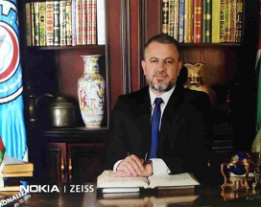

Present Job
Doctor of physiology and Biochemistry for the eleventh year at the department of Physiology & Biochemistry/ faculty of medicine/Jordan University of Science and Technology.
Qualifications:
- Bachelor degree of nursing (RN)/ Jordan University of Science & Technology.
- Bachelor degree of medicine/ Russia
- Master degree of physiology/ Jordan University of Science & Technology.
- PhD of Biochemistry /University of Jordan.

Teaching Experience:
- A full-time lecturer /Department of physiology/ faculty of medicine/ Global colleges/KSA for three years.
- A full-time lecturer /faculty of medicine/ department of physiology and biochemistry/Jordan University of Science & Technology since 2011 till now.

Research & Teaching Interests
- Fifteen articles have been published in refereed journals (Research gate).
- Broad medical experience in teaching hospitals.
- Long experience in teaching the following courses:
- Physiology for medical and paramedical students.
- Pathophysiology for dental and paramedical students.
- Biochemistry for medical students.
- Physiology and pathophysiology for postgraduate students.

Referees:
- Prof. Abdelrahim Al-Hunaiti, Professor of biochemistry, University of Jordan
Email: hunaiti2001@gmail.com
Mobile: 0777228880

- Prof. Nabil Albashir, Professor of biochemistry, JUST
Email:nbashir@just.edu.jo
Mobile: 0795545602

- Prof. Nayef Garraibeh, Professor of physiology, JUST
Email; Nayef@just.edu.jo
Mobile: 0798009018

