Samer Abedallah Masoud Al-Said
Professor
Permanent Address:  UM-Alsimak & Khalda  P. O. Box 482  Amman-Jordan 118-21  Tel :(962)(6) 5342516  Mobile :(962) 790479796  e-mail: masoud@just.edu.jo | Work Address  Mechanical Eng. Dept.  Jordan University of Science & Technology  P.O. Box 3030,  Irbid –Jordan 22110  Tel: (962)(2)7201000 - 22549  e-mail:  masoud@just.edu.jo; masoudsa2003@yahoo.com | 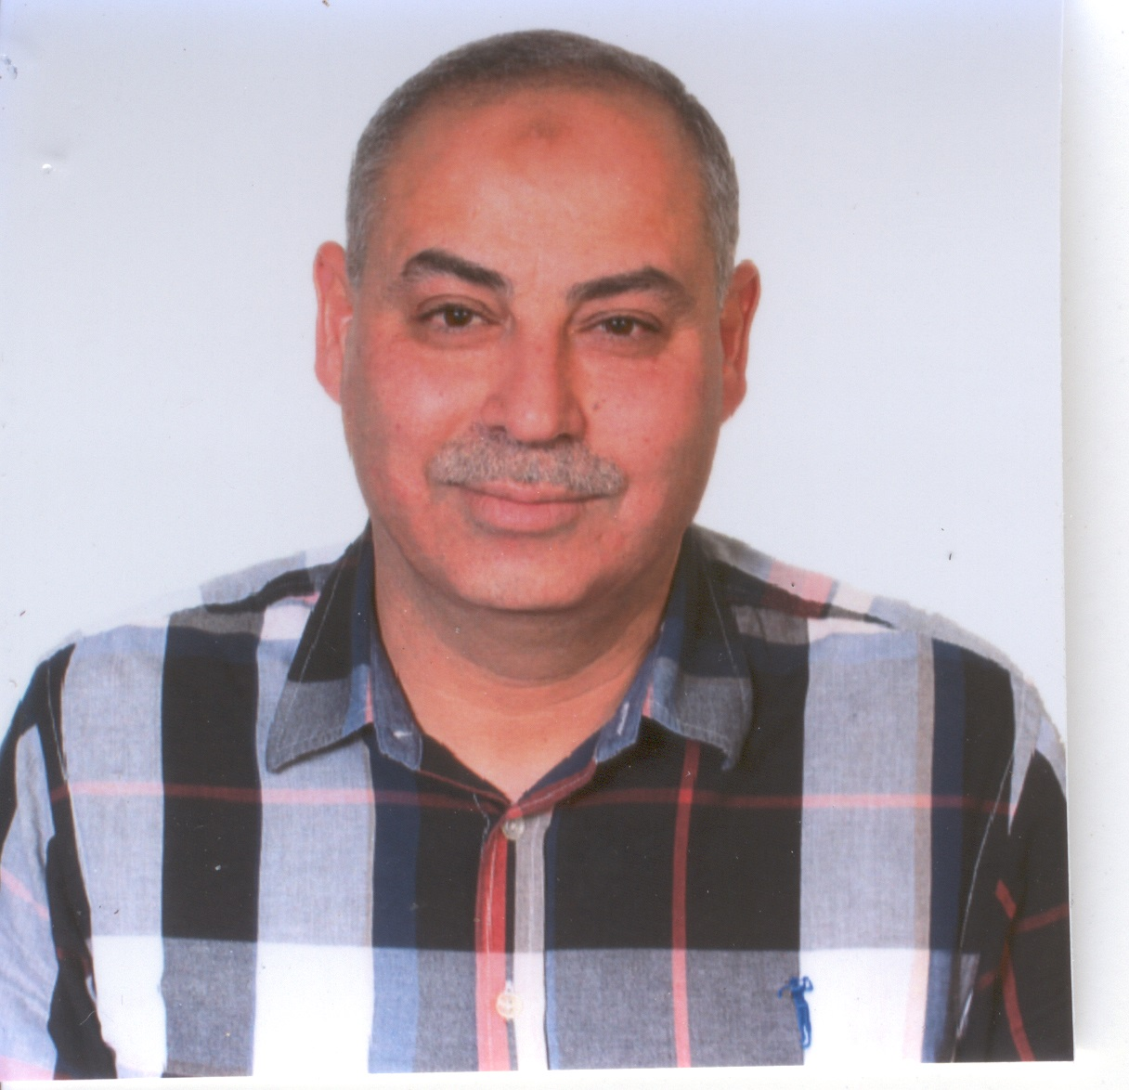

EDUCATION  Sep.91-Dec.94  Feb.87-Jan.90  Sep.83-Jan.87 | Ph.D. in Mechanical Engineering (Design & stress analysis/Dynamics & vibration) at the University of Cincinnati (Cincinnati, Ohio). The Ph.D. dissertation utilized new methods to improve the surface contact and bending fatigue stresses in spur- gear. G.P.A. is 3.9 out of 4.  M.Sc. in Mechanical Engineering (Applied Mechanics) at Jordan University of Science and Technology, Irbid/Jordan. The M.Sc. thesis tackles the mistuning in gas turbine engine fans and its effect on the engine's structural dynamics. I graduated top of the class with a G.P.A. of 85.2%.  B.Sc. in Mechanical Engineering (Aerospace) from Yarmouk University Irbid/Jordan. Graduated in the top 2% of the class with G.P.A. of 84.2% (rating of excellent).
RESEARCH  Stress Analysis  & Design  Dynamics  & Vibration  Applied Mechanics | A research concerned with improving the spur-gears performance. New methods to reduce the fillet stresses as well as the contact stresses were proposed. Design and analysis are carried out using the Finite Element, and the results were enhanced using Boundary Element Method. Moreover, a new stress/deflection computation approach is proposed, where The Assumed Mode method is used to calculate stresses/Deflections in beam like structures subjected to side pressure wave.  The structural dynamics of a tuned and mistuned bladed-disk in a gas turbine was studied using modal analysis. The work was extended to investigate the effect of support flexibility and asymmetry on the system characteristic and stability.  The effect of a crack depth on system characteristic for prestressed column is investigated; theoretical analyses and experimental work are carried out. The work is extended for cracked rotating Timoshenko beam.  Utilizing vibration, crack identification algorithms were proposed to identify crack in beam like structures (like: stepped beam carrying rigid disks and rotating cracked beam). The algorithms are verified experimentally and/or using FEA.  Crack identification using vibration-induced heat “Vibrothermography”  Participated in two different areas of research, fluid mechanics, and path planning

EXPERIENCE
Aug 2015-Aug 2016

Sep. 2011-Sep 2012

Jan. 2008-Cur.
Sep. 2003-2007
Sep. 2002-2003
Feb.2000-Jan.2008
Feb.95-Feb 2000

Dec. 93-Jul. 94

Oct. 91-Feb. 92

Sep. 89-Apr. 91

Jan. 87-Jun. 89

GRANTS
Jun. 2008

Jun. 2006-Oct. 2007

May .2006-Mar. 2007

Aug. 2004- Dec. 2005

Sep. 1996-1997

Dec. 1993-1994

REVIEWER for

- Visiting professor in Mechanical Engineering Department at American University of Sharjah, Sharjah, United Arab Emirate.
- Professor in Mechanical Engineering Department at University of Hail, Hail/ Saudi Arabia. (Sabbatical year)
- Professor in Mechanical Engineering Department at Jordan University of Science and Technology Irbid/Jordan.
- Visiting Associate Professor in Mechanical Engineering Department at King
Saud University, Riyadh-Saudi Arabia
- Head of the Mechanical Engineering Department, Jordan University of Science
& Technology, Irbid-Jordan.
- Associate Professor in Mechanical Engineering Department at Jordan University of Science and Technology Irbid/Jordan.
- Assistant Professor in Mechanical Engineering Department at Jordan University of Science and Technology Irbid/Jordan.
Taught the following courses:
Graduate courses:
Perturbation Techniques, Analytical Vibration Methods, Continuum Mechanics, Applied Engineering Mathematics
Supervised five master thesis
Under Graduate Courses
Mechanics of Machine, Mechanical Vibrations, Mechanical Engineering Design (I
& II), Computer Aided Design, Finite Element, Vibration lab, Mechanics of Material, Instrumentation (Course & its lab), Engineering Mechanics (Statics & Dynamics), Engineering Drawing, Mechanical Drawing, Introduction to Applied Engineering, Numerical Methods in Engineering
Supervised several senior design projects.

Research Assistant in Mechanical Engineering Department at Univ. of Cincinnati. Ohio-USA

Research Assistant in Aerospace Engineering Department at Univ. of Cincinnati. Ohio-USA

Research Assistant in Mechanical Engineering Department at Jordan University of
Science and Technology (J.U.S.T) Irbid/Jordan.

Teaching Assistant in Mechanical Engineering Department at J.U.S.T.

• Stress Analysis for Sama aircraft wing using Finite Element. Jordan Aerospace
Industry (JAI), Amman, Jordan.
• Dynamic Characteristics of Two Elastically Coupled Cracked Beams. Saudi
Basic Industrial Corporation (SABIC). Riyadh-Saudi Arabia.
• New Algorithm for Crack Localization in Rotating Timoshenko Beam. College of Engineer Research Center, King Saud University, Riyadh-Saudi Arabia
• Crack identification in stepped beam carrying concentrated masses. Saudi Basic
Industrial Corporation (SABIC). Riyadh-Saudi Arabia
• Stress analysis of concrete pan mixer structure, using Finite Element. Technical
Industrial Group Company, Amman - Jordan
• Improving Spur Gear performance. USA Department Of Defense/Central State
Univ. Xenia, Ohio-USA
- Journal of The Franklin Institute
- JORDAN JOURNAL OF MECHANICAL AND INDUSTRIAL ENGINEERING
- NED University Journal of Research
• Meccanica
- Journal of Vibration and Control

- International Journal of Mechanical Sciences
- Journal of Mechanical Design, Transactions of ASME
- Session Chair for Sensor & Measurement THE 3rd INTERNATIONAL CONFERENCE ON MECHATRONICS (ICOM'08), Kuala Lumpur, Malaysia 18-20 December, 2008
• 2010 IEEE/ASME International Conference on Advanced Intelligent
Mechatronics.
• Journal of Mechanical Engineering Science, Proceedings of the Institution of
Mechanical Engineers Part C
• International Journal on Advanced Steel Construction
• Mechanics Research Communications
• International Journal of Applied Engineering Research
• Mu’tah Journal for Research & Studies (MJRS)
• 13th Mediterranean Conference on Control and Automation (2005 ISIC-MED)
• ASME, International Gas Turbine and Aeroengine Congress and Exposition
(IGT), Jun, 2003. Atlanta, Georgia.
• Session Chair for Modelling and Simulation Methods I, at the IASTED
international conference on Applied Simulation and Modelling, June 25-28,
2002, Crete, Greece
• IEEE Transaction on System, Man and Cybernetics
• Journal Finite Elements in Analysis and Design
• Yarmouk Research Journal
AWARDS  & HONORS  Jan.92-Dec.94  Sep.94-Dec.94  Sep.93-Jun.94  Sep.91-Aug.93 | Scholarship from Jordan University of Science and Technology. University Graduate Scholarship ( University of Cincinnati ) Doctoral University Scholarship ( University of Cincinnati ) University Graduate Scholarship ( University of Cincinnati ) Honor list (B.Sc. at Yarmouk University Irbid/Jordan)  Member of Jordan Engineers Association
COMPUTER EXPERIENCE | FORTRAN, MATLAB.
FINITE ELEMENT SOFTWARE | ANSYS 10, COSMOS/M ver. 2.5, I-DEAS 6
Work under progress  Submitted | • Crack Location Identification in Beam Carrying Rigid Disk Using Trial Mass  • Crack identification using vibration-induced heat "Vibrothermography"  - Bassam A. Abu-Nabah, Samer M. Al-Said, Rim Gouia-Zarrad "SONIC IR CRACK SIZE ESTIMATION USING 2D HEAT DIFFUSION MODEL OF FRICTIONAL HEATING", submitted to Inverse Problems and Imaging  - Mohammad Alkam , Samer M. Al-Said, “Failure Prediction of Beam Like Structure Subjected to Side Pressure Wave Using Assumed Mode Method”, submitted to International Journal of Protective Structures
PUBLISHED WORK  Refereed Journals | 1. Samer A. M. Al-Said "Crack Influence on the Dynamic Characteristics of Elastically Coupled Beams", Applied Mechanics and Materials Vols. 110-116 (2012) pp 328-336  2. Ahmad A. Masoud and Samer Al-Said "A New Algorithm for Crack Localization in a Rotating Timoshenko Beam", Journal of Vibration and Control, 15(10): 1541–1561, 2009  3. Samer Masoud Al-Said, “Crack Detection in Stepped Beam Carrying Slowly  Moving Mass”. Journal of Vibration and Control 14 (12) 1903-1920, 2008  4. S.A.M. AL-Said and A.A. AL-Qaisia, “Influence Of Crack Depth And Attached Masses On Beam Natural Frequencies”. International Journal of Modelling and Simulation, Vol. 28, No. 3, 2008  5. Samer Masoud Al-Said, “Crack Identification in a stepped Beam carrying a rigid disk”. Journal of Sound and Vibration, 300 (2007) pp. 863-876  6. Samer Masoud Al-said, Mohammad Qasim,”Tooth Stress Redistribution to Improve Bending Fatigue Strength of Spur-Gear”. International Journal of Engineering Simulation. Vol. 7 No. 3, 2006  7. Samer Masoud, Malk Naji, Adnan Al-shukry, “Flexural vibration of Rotating Cracked Timoshenko Beam”. Journal of Vibration and Control, 12 (11), 2006, pp. 1271-1287  8. Samer Masoud and Naser Al-Huniti, “Effect of support flexibility on the stability of bladed disk attached to unsymmetrical continuous shaft”. International Journal of Modelling and Simulation, 205-4046 Issue 2, Vol. 25, (2005).  9. Masoud A.S.S.A. and Qasim, M. ‘Increasing spur gear durability: two-material spur gear’, international journal of Computer Applications in Technology, Vol. 24, No. 3, 2005, pp. 171–179.  10. Masoud, Samer A. Masoud, Ahmad A. “Motion planning in the presence of directional and regional avoidance constraints using nonlinear, anisotropic, harmonic potential fields: A physical metaphor" IEEE Transactions on Systems, Man, and Cybernetics Part A: Systems and Humans., v 32, n 6, November, 2002, p 705-723  11. M. Al-Nimr, A. M. Hassan and Samer Masoud, “Diffusion bonding in multi- layers systems”, Heat and Mass Transfer Volume 37 Issue 2/3 (2001) pp 271- 273  12. Samer A. Masoud and Ahmad A. Masoud , "Constrained Motion Control Using Vector Potential Fields", IEEE IEEE Transactions on Systems, Man, and Cybernetics Part A: Systems and Humans, v. 30, n. 3, MAY 2000 251-272  13. Samer Masoud, A. M. Hassan and M. Al-Nimr, “Mass diffusion into Two-layer media” Heat and Mass Transfer, Volume 36 Issue 2 (2000) pp 173-176  14. S. A. Masoud, M. A. Al-Nimr and M. K. Alkam “Transient Film Condensation on a Vertical Plate Imbedded in Porous Medium” Transport in Porous Media, Sept. 2000, Vol. 40, Issue 3, pp. 345-354.  15. M. Naji, M. Al-Nimr, S. Masoud "Transient thermal behavior of a cylindrical brake system," Heat and Mass Transfer 36 (2000) pp 45-49  16. Samer Masoud, Mohammed Al-Jarrah, Majed Al-Maamory, "Effect of Crack Depth on The Natural Frequency of a Prestressed Fixed-Fixed Beam", 1998, Journal of Sound And Vibration, 214(2), pp201-212.  17. M. A. Al-Nimr, S. Masoud, "Unsteady free convection flow over a vertical flat plate immersed in a porous medium", 1998, Fluid Dynamics Research (23)  pp153-160.  18. Mohammed Al-Nimr, Samer Masoud, "Nonequilibrium Laser Heating of Metal  Films", Journal of Heat Transfer ASME, vol. 119, February 1997 pp. 188-190.  19. Naim Khader, Samer Masoud, "Vibration of Mistuned Bladed Disks Supported by Flexible Continuous Shafts", 1991, Journal of Sound and Vibration, 149(3), pp 471-488.

Refereed
Conference

- Jin-Hyuk Lee, Samer Masoud Al-Said, “Flow-Induced Vibration Analysis of Supported Pipes with a Crack”, COMSOL CONFERNCE 2016 MUNICH, October 12-14, The Westin Grand München, munich Germany
- Samer A. M. Al-Said "Crack Influence on the Dynamic Characteristics of Elastically Coupled Beams" 2nd International Conference on Mechanical, Industrial, and Manufacturing Technologies MIMT 2011, Singapore 26-28 Feb. 2011
22. Samer Masoud Alsaid and Max Brown "Strengthening Spur Gears by Altering Stress Distribution" THE 3rd INTERNATIONAL CONFERENCE ON MECHATRONICS (ICOM'08), Kuala Lumpur, Malaysia 18-20 December, 2008
23. Ahmad A. Masoud, Samer A. Masoud, "A Modified, Hybrid, PDE-ODE Controller with Integrated directional and Region Avoidance Constraints,” IEEE Conference on Decision and Control, Tampa, Florida, USA, 1998.
24. Ahmad A. Masoud, Samer A. Masoud, "A Self-Organizing, Hybrid, PDE- ODE Structure for Motion Control in Informationally-deprived Situations,” IEEE Conference on Decision and Control, Tampa, Florida , USA , 1998.
25 Ahmad A. Masoud, Samer A. Masoud, "Evolutionary Action Maps for Navigating a Robot in an Unknown Multidimensional, Stationary Environment, Part II: Implementation and Results", 1997, IEEE International Conference on Robotics and Automation, April 21-27 Albuquerque, New Mexico, USA
26 Samer Masoud, Naim Khader, "Stability Analysis for Unsymmetrical Shaft With Flexible Bladed-Disk", presented at the gas turbine and aeroengine congress and exposition June 2-5, 1997 Orlando, Florida USA, ASME Paper No. 97-GT-201.
27 Ahmad Masoud, Samer Masoud, Mohamed Bayoume, "Robot Navigation Using a Pressure Generated Mechanical Stress Field: The Biharmonic Potential Approach", 1994 IEEE International Conference on Robotics and Automation, May 8-13, San Diego, California.
28 Naim Khader, Samer Masoud, "The Assumed Mode Method in Structural Dynamic of Bladed Disk Shaft Systems", presented at the gas turbine and aeroengine congress and exposition June 11-14, 1990 Brussels Belgium, ASME Paper NO. 90-GT-315

References

Professor Hazem S. Zibdeh, Mechanical Engineering Department
Jordan University of Science and Technology
Email: hazem@just.edu.jo; hazemz@batelco.jo

Professor Bassam Abu-Hijleh
Atkins Chair
Head of the Sustainable Design of the Built Environment Programme (SDBE) Fellow, Cardiff University (UK)
The British University in Dubai (BUiD) PO Box 502216 Dubai – UAE
e-mail: Bassam.Abuhijleh@buid.ac.ae

Dr. Mohammad Alkam.
Department of mechanical engineering.
Jordan University of Science and Technology
P.O. Box 3030
Irbid – Jordan
Email alkam@just.edu.jo
Tel: +962795028871

Dear Sir

I have a Ph. D. in mechanical engineering from university of Cincinnati (Cincinnati Ohio), with emphasis on design/stress analysis and vibration/rotor dynamic. I am a professor in the mechanical engineering department at Jordan University of Science and Technology Irbid/ Jordan (JUST), also, I worked as visiting professor at King Saud University (Riyadh/Saudi Arabia), Hail University (Hail/Saudi Arabia) and American University of Sharjah, Sharjah (UAE).

As teaching experience, I taught some graduate and undergraduate courses. For undergraduate courses I teach the following topics:
General engineering courses:
• Strength of material (course and lab) •Statics
• Engineering Mechanics (combined Static & Dynamics) •Dynamics
• Instrumentation (Course & its lab)
• Engineering Drawing

For senior undergraduate courses
• Finite Element Analyses • Mechanical Drawing.
• Mechanics of Machines • Mechanical Vibration
• Numerical Method for Engineering
- Vibration lab, where a demonstration for basic vibration problems were carried out, and some advanced experiment, as static and dynamic balancing for a shaft, forced lateral vibration response for a beam, ..etc were done.
- Machine Element Design (I & II), failure theories for static and dynamic (fatigue) loading and designing some basic mechanical parts were introduced.

I supervised many senior design projects. In these project students are asked to use the basic knowledge they learned to construct and develop a gadget or a methodology to solve an engineering problem, using modern computer tools.
One of these projects was a joint senior project with Purdue University (USA), where JUST team worked with Purdue team, on a domestic wind energy system, the JUST team developed an idea to eliminate the tower needed to carry a small size wind turban. They suggested a frame and a mechanism that can be mounted on building roof.

The graduate courses were:
  - Advanced Dynamics and vibration course it involves modal analyses and some numerical techniques to find system frequencies and mode shapes, as well as an introduction to analytical dynamics.
- Perturbation course, where techniques to solve nonlinear ordinary deferential equations are represented.
• Advance Engineering Mathematics
Also I can teach more graduate courses in the field of applied mechanics as “but not limited” :
• Advanced strength of material • Continuum mechanics
• Elasticity • Nonlinear vibration,

Also, I supervised five master theses, four theses were related to dynamic modeling and vibration and one thesis was related to gear design.

As far as research is concerned, I am mainly involved in the following areas; Design/Stress Analysis. Crack Identification, Rotor Dynamics/Structural Modal Analysis.

In the first research area, I developed a new Design method to improve the surface contact and bending fatigue strengths in spur gear. The design and the analysis are carried out using Finite Element, and the results were enhanced as Boundary Element is used. Also, I am working on development of a new stress calculation method in beam like structures utilizing modal analysis which is widely used in structural modal analysis.

Experimental, theoretical modeling and finite element work has been carried out in the second area. The effect of initial stresses on the natural frequency of a cracked beam was investigated. This work was extended to find the effect of the centrifugal force on the natural frequencies of rotating cracked Timoshenko beam. Also, using vibration, new crack identification algorithms are developed to identify crack in stepped beam carrying rigid disks and in rotating thick beams.

Now I am working in developing crack detection algorithm in a pipe containing running fluid utilizing pipe vibration, and, a second algorithm to detect surface crack using vibration-induced heat "Vibrothermography".

In the final area, a mathematical model for bladed-disk in gas turbine is developed, and computer codes to simulate the model are written. I extend this model to account for blade mistuning and support flexibility and asymmetry, to see the effect of these two parameters on rotor stability. Also I am involved in several research areas which is related to my experience, as control (path planning), fluid mechanics.

As community service, I did a consultation for a Jordanian company called Technical Industrial Group; Stress analysis of concrete pan mixer structure was carried out, using Finite Element. Also I did a consultation for the Jordan Aerospace Industry (JAI), where Stress Analysis for Sama aircraft wing using Finite Element was carried out.
Also I had grants from Saudi Basic Industrial Corporation (SABIC) Riyadh-Saudi Arabia and from College of Engineer Research Center in King Saud University, to develop algorithms to identify crack in beams.

For more information please see my attached C.V. and if further documents are needed, please contact me at my current address, or at my e-mail

Sincerely

Dr. Samer Masoud Alsaid
e-mail: masoud@just.edu.jo; masoudsa2003@yahoo.com

UM Alsimak & Khalda
P. O. Box 482 Amman -JORDAN 118-21
Mobile: (962)790479796

