Team Alpha Progress

1. Introduction
During the first phase of the ReTour project, Team Alpha focused on building the AI core responsible for generating personalized tourism packages. Our objective was to establish a complete end-to-end workflow that connects the user interface with the AI engine while providing a scalable architecture that can support future integration with external knowledge sources.
The main achievement of this phase was successfully transforming structured user requests into structured tourism packages through an AI-driven pipeline. At this stage, package generation relies solely on the language model's internal knowledge, while the retrieval layer (RAG) will be integrated in the next phase.
2. System Architecture
The overall ReTour platform follows a layered architecture where responsibilities are clearly separated between Team Alpha and Team Beta.

Figure 1. Overall ReTour Architecture
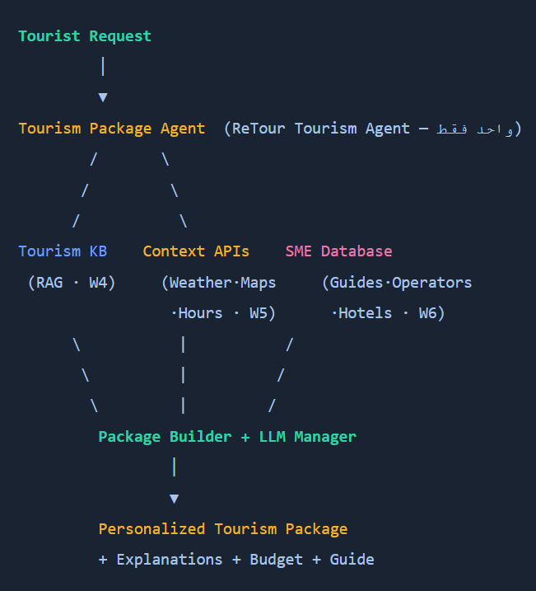
Our responsibility focused on designing and implementing the AI Brain, which acts as the decision-making component of the platform.
Instead of embedding all logic inside the API layer, we separated responsibilities into multiple components, allowing every module to evolve independently.
3. Backend Development
During this phase, we implemented the complete backend pipeline responsible for generating tourism packages.
The processing flow is illustrated below.

Figure 2. Package Generation Pipeline

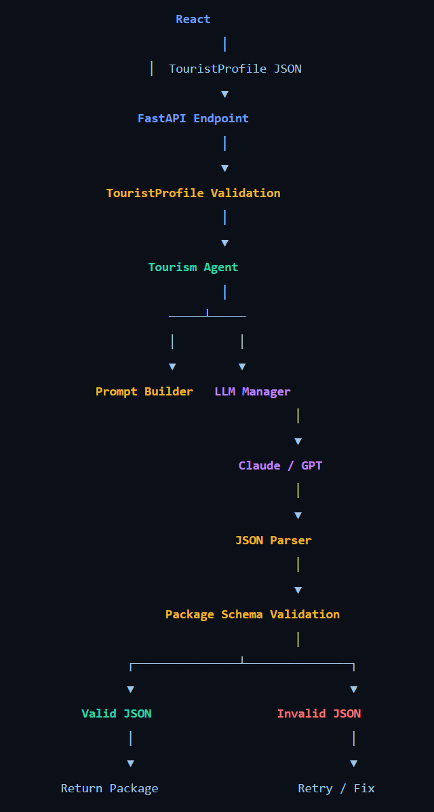
One of the most important achievements was integrating the frontend developed by Team Beta with our backend API. We connected the “Generate My Package” button directly to our FastAPI endpoint and implemented a mapping layer that converts the frontend wizard fields into the JSON schema expected by our AI service.
This integration allowed the frontend to communicate seamlessly with the AI Brain while keeping the interface independent from the internal implementation.
1
Pathway Explained Simply
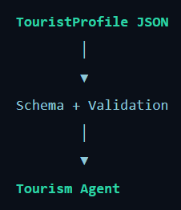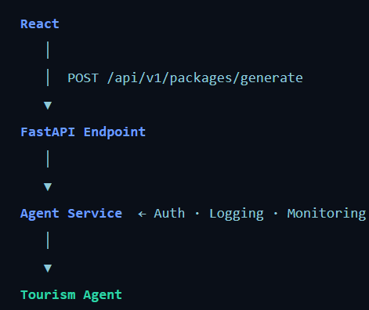
2

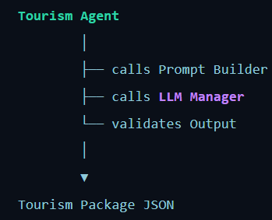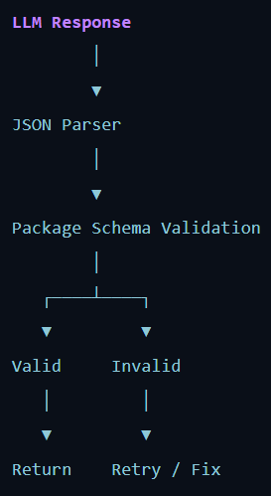
3
4. Prompt Engineering
Initially, our AI relied on a single prompt file containing the agent role, formatting instructions, schema description, and request.
Although functional, this design quickly became difficult to maintain. Any modification affected unrelated sections and increased hallucination because the prompt became unnecessarily large.
To solve this problem, we redesigned the prompt architecture by splitting it into five specialized prompt files:
• Role
“””
You are **ReTour AI Brain**, an expert Jordan tourism consultant with deep knowledge of destinations, logistics, culture, and realistic trip planning across Jordan.
Your sole task is to generate a **personalized tourism package** as **valid JSON only**.
“””
• Output Rules
“””
1. Return **ONLY** a single JSON object — no markdown, no code fences, no prose before or after.
2. Do **NOT** use thinking mode or reasoning traces — output the JSON directly.
3. The JSON must match the exact structure defined in the schema section below.
4. All monetary values are in **Jordanian Dinars (JOD)**.
5. Respect the user's **budget**, **duration**, **traveler profile**, and **preferences**.
6. Create a **realistic, coherent itinerary** — no impossible schedules or duplicate activities.
7. Avoid hallucinating specific business names you are uncertain about; use plausible, well-known Jordan establishments when possible.
8. Consider **accessibility needs**, **special occasions**, **must-visit** sites, and **places to avoid**.
9. Honor the **mode** field:
- `build`: Create a custom package from scratch tailored to the request.
- `browse`: Filter and adapt recommendations as if selecting from existing packages (still output full package JSON).
10.
“””
• JSON Schema
• Quality Guidelines
“””
- **Personalization**: Reference specific interests, group type, language, and occasion.
- **Pace**: Relaxed trips have fewer activities; fast-paced trips pack more (within reason).
- **Activity level**: Easy = minimal walking/strenuous activity; Active = hiking/adventure OK.
- **Budget**: If budget is tight, prioritize value; if comfortable, suggest upgrades.
- **AI Priority**: When `aiPriority` is set, use it to break ties between equally good options.
- **SME Preferences**: Favor family-owned, eco-friendly, or women-led businesses when requested.
- **Regions**: Prioritize `preferredRegions` and `mustVisit`; avoid `placesToAvoid`.
- **Language**: Note guide/language considerations for `preferredLanguage`.
- **Children/Seniors**: Adjust activity intensity and timing accordingly.
“””
• User Request
Before every inference, the Prompt Service dynamically combines these files into a single prompt.
This modular design improved maintainability, simplified future updates, and reduced hallucination by separating responsibilities between prompt components.

5. LLM Evaluation
Selecting the appropriate language model was one of the most important decisions during Phase 1.
We evaluated two Ollama models:
- Qwen3
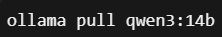

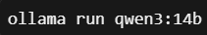
- Llama 3 (Same Steps)
To ensure fairness, both models received identical user requests from the wizard interface.
Multiple experiments showed that Qwen3 consistently produced better travel packages with:
- better organization
- more consistent outputs
- fewer hallucinations
- better JSON formatting
However, hallucination still exists because the current implementation depends entirely on the model's pretrained knowledge.
Without external knowledge grounding (RAG), the model may still generate hotels, attractions, or recommendations that are not supported by real data.
For this reason, Qwen3:14B was selected as the default model for Phase 1.
We implemented a production-ready REST API using FastAPI.
6.API Development
The main endpoint
POST /api/v1/packages/generate
accepts a validated PackageRequest object and returns a structured TourismPackage response.
Additionally, we implemented:
- request validation
- automatic JSON validation
- retry mechanisms
- unified exception handling
- CORS support
- health monitoring endpoint
This API now serves as the communication contract between Team Alpha and Team Beta.

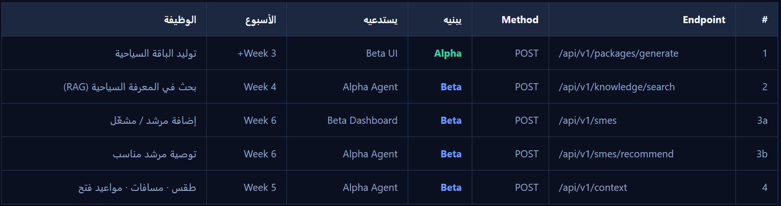
APIs Agreed Upon with Team Beta

7. Testing and Documentation
To ensure software quality, we implemented comprehensive automated testing.
Our current implementation includes:
- 25 unit and integration tests
- Validation tests | - API tests | - Prompt Service tests | - LLM Manager tests

- 100% successful execution
Documentation has also been prepared, including:
- README
- Architecture documentation
- API Agreement
- Swagger Documentation
- Phase 1 Documentation
8. Current Status and Future Work
Phase 1 successfully demonstrated the complete workflow from user input to AI-generated tourism packages.
The backend architecture, prompt engineering framework, API layer, and frontend integration are now complete.
The next development stage will focus on integrating the Knowledge API and ChromaDB retrieval system, allowing the AI to generate responses grounded in verified tourism information. This enhancement is expected to further reduce hallucination and significantly improve the accuracy of generated travel packages.
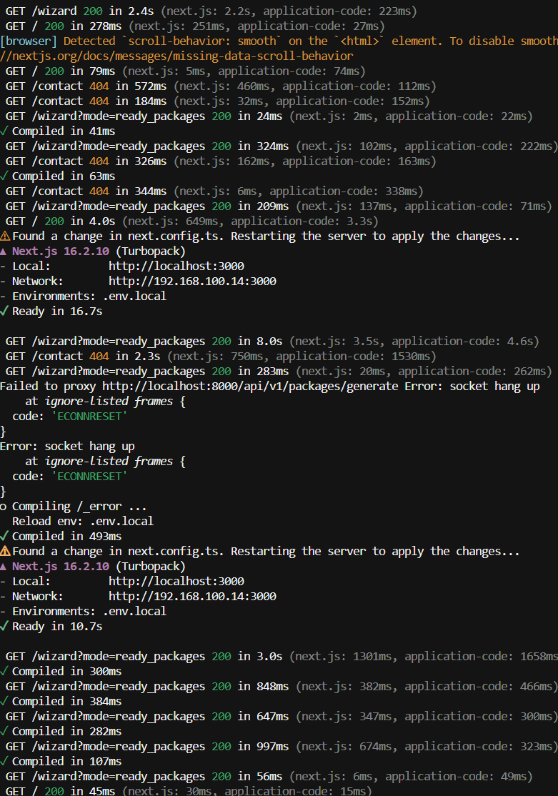
Work Progress Screenshots

The above section demonstrates that both the backend and frontend are functioning correctly
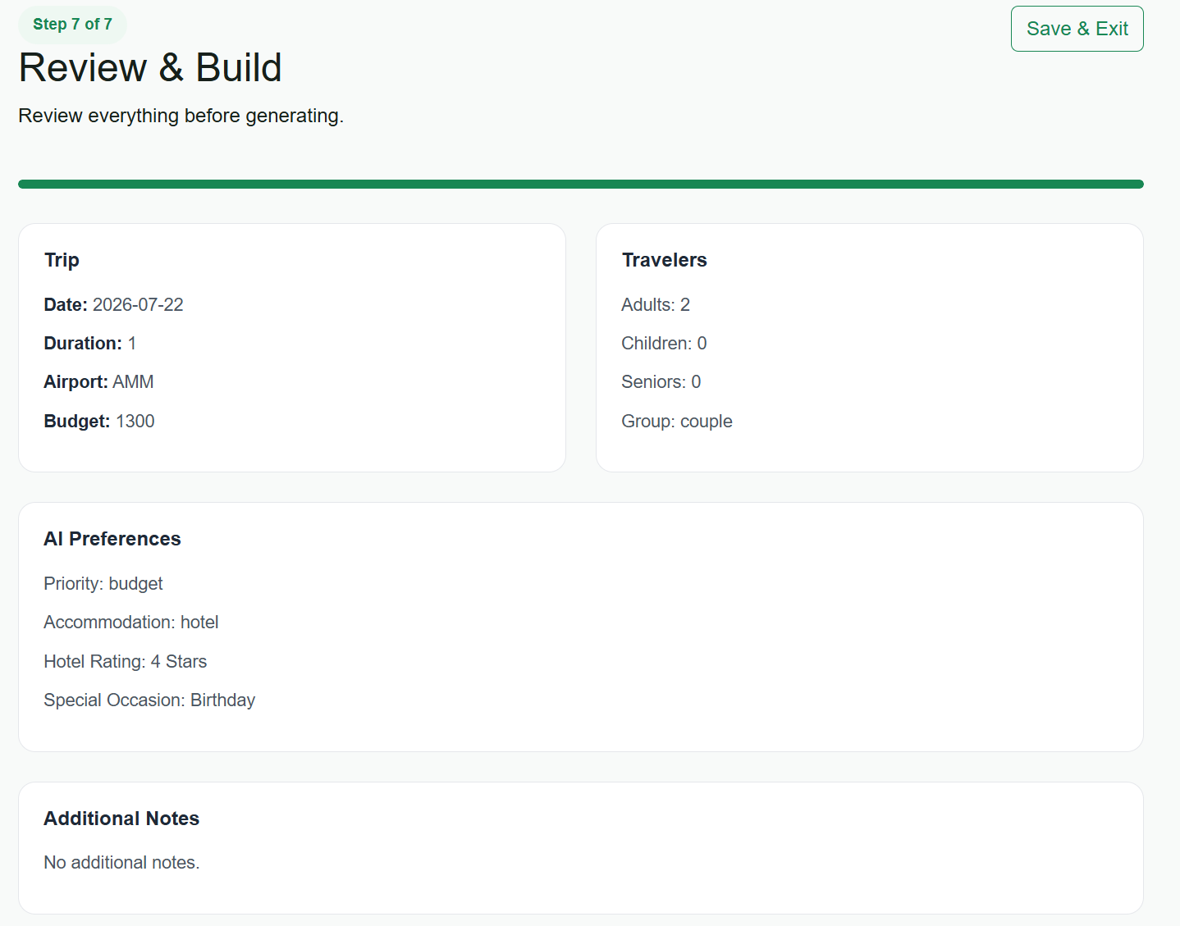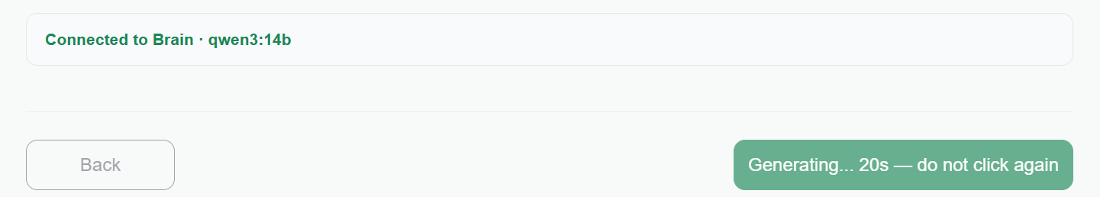

Note: The output schema will undergo significant changes in next stage.

{
"success": true,
"package": {
"summary": "A relaxed, budget-friendly one-day trip to Aqaba, focusing on nature and adventure with limited walking and a special birthday celebration.",
"tripOverview": {
"title": "Aqaba Adventure for a Birthday",
"durationDays": 1,
"regions": [
"Aqaba"
],
"groupDescription": "A couple seeking a relaxed, nature-focused trip with a special occasion",
"highlights": [
"Aqaba’s coral reefs",
"Birthday celebration at a local restaurant"
],
"bestSeasonNote": "July is a great time for diving and snorkeling in Aqaba."
},
"dailyPlan": [
{
"day": 1,
"date": "2026-07-22",
"theme": "Nature and Adventure",
"activities": [
{
"time": "09:00",
"title": "Snorkeling in Aqaba’s Marine Park",
"location": "Aqaba",
"description": "Explore the vibrant coral reefs with minimal walking, perfect for a relaxed adventure.",
"durationHours": 3,
"estimatedCostJOD": 50,
"category": "adventure"
},
{
"time": "13:00",
"title": "Birthday Celebration at Al Muntaha Restaurant",
"location": "Aqaba",
"description": "Enjoy a special birthday meal with a view of the Gulf of Aqaba, featuring local Jordanian cuisine.",
"durationHours": 2,
"estimatedCostJOD": 60,
"category": "food"
}
],
"notes": "Ensure to book the snorkeling activity in advance and confirm the restaurant’s availability for the birthday celebration."
}
],
"hotelRecommendation": {
"name": "Al Aqaba Resort",
"location": "Aqaba",
"type": "resort",
"rating": "4 star",
"nightlyRateJOD": 100,
"totalNights": 1,
"totalCostJOD": 100,
"whyRecommended": "Offers easy access to Aqaba’s main attractions and features eco-friendly amenities.",
"amenities": [
"WiFi",
"Breakfast"
]
},
"restaurants": [
{
"name": "Al Muntaha Restaurant",
"location": "Aqaba",
"cuisine": "Local Jordanian",
"mealType": "dinner",
"estimatedCostPerPersonJOD": 30,
"whyRecommended": "Provides a unique dining experience with a view of the Gulf of Aqaba, ideal for a birthday celebration."
}
],
"transportation": {
"primaryMode": "taxi",
"summary": "Use of taxi services for short distances within Aqaba to accommodate limited walking needs.",
"segments": [
"Arrival at Aqaba airport to hotel",
"Hotel to snorkeling spot and restaurant"
],
"estimatedTotalCostJOD": 40
},
"estimatedCosts": {
"accommodation": 100,
"activities": 110,
"dining": 60,
"transportation": 40,
"guideAndExtras": 0,
"total": 310,
"withinBudget": true,
"budgetRemainingJOD": 990
},
"tips": [
"Book the snorkeling activity in advance to secure a spot.",
"Check the restaurant’s birthday package options for a memorable celebration."
],
"reasoning": "The trip is tailored for a couple with limited walking needs, focusing on a relaxed pace and nature-based activities. The budget is prioritized to ensure a comfortable and memorable birthday celebration in Aqaba.",
"confidence": 0.9
},
"metadata": {
"model": "qwen3:14b",
"provider": "ollama",
"mode": "build",
"latencyMs": 404578.72,
"retries": 1
}
}

