Curriculum Vitae

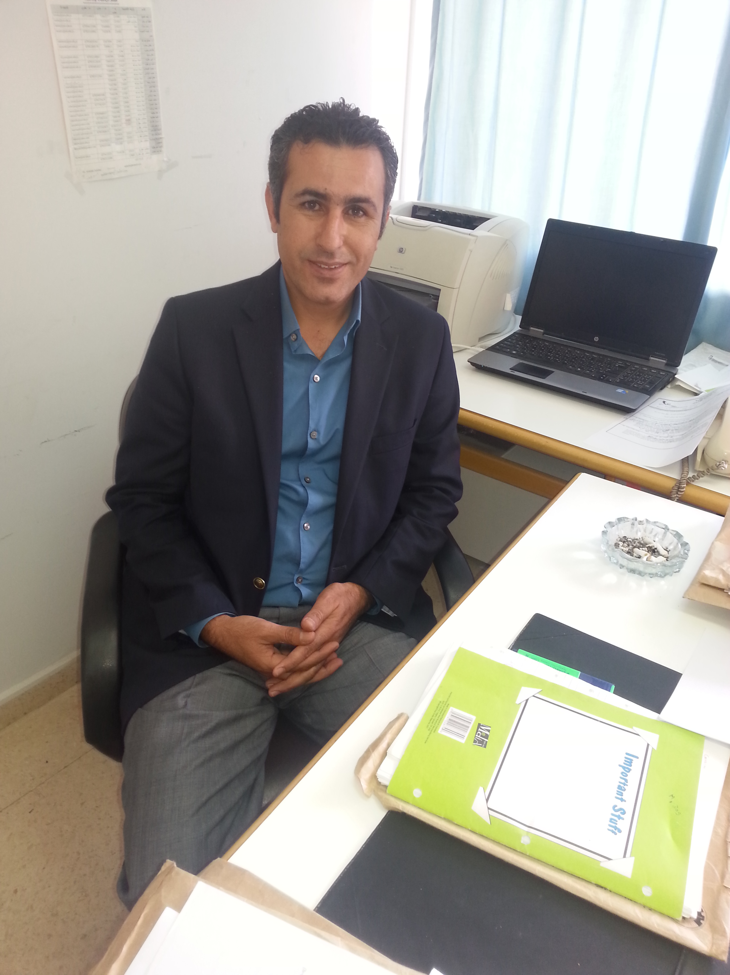
Malik Sami Bataineh
Department of Mathematics
Jordan University of Science and Technology
P.O. 13030- Irbid-22110- Jordan
 Mobile: +962 776252414
 msbataineh@just.edu.jo

Education

O B.S.C. in Mathematics, Andhera University, visakhapatnam/India, 1996
Major: Mathematics, Physics and Computer Science.
O B.A. in Mathematics, University of Iowa, Iowa City/Iowa, USA, December, 2001
Major: Mathematics.
O M.S. in Pure Mathematics, University of Iowa, Iowa City/Iowa, USA, May 2003.

o Ph.D. in Mathematics, Abstract Algebra, University of Iowa, Iowa City/Iowa, USA, July,
2006
o Doctoral Dissertation: "Generalizations of Prime Ideals"

o Doctoral Advisor: Professor D. D. Anderson , University of Iowa.

Experience

o High school teacher: Jordan Ministry of Education schools, 1996-1998.
o Teaching assistant: College of Liberal Arts/Mathematics, University of Iowa/USA, 2001-2005

O Research assistant: College of Liberal Arts/Mathematics, University of Iowa/USA, 2000-2001
O Instructor : College of Liberal Arts/Mathematics, University of Iowa, 2005-2006.
o Assistant Professor: Department of Mathematics, Al hashemite University/Jordan, 2006-2009
o Assistant Professor: Department of Mathematics, Jordan University of Science and
Technology/Jordan , 2009-till present
o Computer skills: Microsoft Office 2010, Scientific Workplace 5.0 , Wolfram Mathematica,
Maple and Latex. Computer languages (FORTRAN, COBOL, and C).
o Courses taught:

o Graduate Courses
• Abstract Algebra (Dummit and Foote).

O Undergraduate Courses

- Pre-Calculus
• Calculus I
• Calculus for business
• Calculus II
• Elementary Linear Algebra
• Discrete Mathematics
• Ordinary Differential Equations
• Basic Algebra I
• Linear Algebra I
• Linear Algebra II
• Abstract Algebra I
• Abstract Algebra II
• Number Theory

Research Interests

o Commutative rings
o Ideal Theory
o Graded Rings
o Computational Applied Mathematics

Theses Supervised

o Generalizations of Primary Ideals and Submoduels.
o Generalizations of Almost Graded Prime Ideals and Graded Submoduels
o Generalizations of Almost Primal Ideals over Commutative Semirings.
o Generalizations of Ideal-Based Zero-divisor Graphs of Commutative Rings.
o Generalizations of Prime Submodules.
o On Fuzzy Almost Prime Ideals.(08/2014).
o On 2-absorbing Almost Primary Ideals.(08/2015).
o Generalization of Prime Ideals.(08/2015).
o Covering Linear Spaces and Other Algebraic Structures By Finitely Many Substructures
(08/2015).
o Zero-Divisor Graphs with Respect to Almost Prime Ideals. (12/2015)

External/Eternal Examiner

o Generalizing sum results on the normality of Monomial Ideals.
o An infinite family of Ragliff –Rush Ideals.
o A study of Generalizations on prime Submodules.
o Minimality matrix Representations of Turkowiski's Six-Dimentional Lie Algebras.

o Grobner Basis For Certain Monomial Curves Under The Degree Reverse
Lexicogarphical Ordering.
o Modified Algorithm For The Clenshaw-Curtis Method.
o Approximated Solutions To Nonlinear Partial Differential Equations Using Differential Transform Method And Adomian Decomposition Method.
o Properties of Graded Weakly Prime Submodules.(08/2014)
o On Properties of Graded Classical Prime Submodules. (08/2014)
o Chains of Ideals and Ratliff-Rush Closure. (10/2014)
o Normality of Certain Monomial Ideal. (10/2014).
o On the Union of Graded Prime Submodules (05/2015).
o A study on Some Properties of Graded Comultiplication Modules (12/2015)

Mathematics services

o Reviewer at the American Mathematical Society (AMS).
o Editorial Board Member for Journal of Advances in Mathematics (JAM).
o Editorial Manager for Journal of Modern Methods in Numerical Mathematics.
o Editorial Board Member for Universal Journal of Applied Mathematics.
o Reviewer for Thai Journal of Mathematics.
o Reviewer for the Journal Advanced Research in Pure Mathematics (JARPM).
o Reviewer for Communications in Algebra.
o Reviewer for Indian Journal of Pure and Applied Mathematics (Springer).
o Reviewer for Utilatis Mathematica.
o Reviewer for Journal of Algebraic Systems.
o Reviewer for MATEMATICKI VESNIK.
o Reviewer for Turkish Journal of Mathematics.

Books

Graded Prime Submodules, LAP Lambert Academic Publishing, 2012.

Research activity

- Anderson, D., Bataineh, M. (2008). Generalization of Prime ideals. Communication
Algebra, 36,686-696.

- Khassan, H., Jaber, A., and Bataineh, M, (2009). Graded rings in which every proper
ideal is almost GR-Prime. Journal of Mathematical Science advanced applications, 3,41-
58.

(3) Jaber, A., Bataineh, M. and Khassan, H., (2009). Almost graded prime ideals, Journal
of Mathematics and Statistics, 4, 231-235.

(4) Zead M, Wafi Sh, Bataineh, M. (2009). Existence of Fixed point results in G-metric
spaces. Int. J. Math. Math. Sci. (2009), Art. ID 283028, 10 pp.

(5) Bataineh, M. Ala' Khazaa'leh, Jaber, A., (2011). Graded Almost Prime Submodules.
International Journal Of Algebra. 5, 189-198.

(6) Bataineh, M. and Safa' Kuhail., (2011). Generalizations of Primary ideals and
Submodules. Int. J. Contemp. Math. Sciences. 6, 811-824.

(7) Bataineh, M. and Ala' Khazaa'leh., (2011). Graded Almost Prime Submodules.
International Journal of Algebra. 5(4), 189-198.

(8) Bataineh, M. and Ala' Khazaa'leh., (2011). Graded Almost Prime Submodules Under
Localizations. International Mathematical Forum. 6, 2217-2224.

(9) Bataineh, M. and Ala' Khazaa'leh., (2012). Graded Prime Submodules Over
Multiplication Modules. International journal of Pure and Applied Mathematics. 76,
241-250.

- Rashid Abu-Dawwas, Khaldoun Al-Zoubi and Bataineh. M., (2012). Prime
Submodules of Graded Modules. Proyecciones Journal of Mathematics (PJM). 31, 4,
(355- 361).

- Bataineh, M. and Ruba Malas., (2014). Generalizations of primal ideals over
commutative Semirings. Matematički vesnik. 2, 66, (133-139).

(12) Bataineh, M. and Ruba Malas., (2014). Primal and Weakly primal Subsemimodules.
American International Journal of Contemporary Research. 4, 1.

- Bataineh, M. and Anderson, D., (2014). Idealization and Polynomials. Glasnik
Matematicki. 49 (69), 47-51.

- Rashid Abu-Dawwas., Bataineh, M., (2015). Graded Weakly Semiprime Ideals that are
not Graded Semiprime. Global Journal of Pure and Applied mathematics. 11, (6),
(4527-4532).

(15) Bataineh, M. and Ala' Khazaa'leh. Graded Almost Primary Submodules Over
Multiplication Modules. (Submited).

- Bataineh, M., Khaled Badarneh . On Almost Strongly Prime
Submodule. (Submitted).

- Bataineh, M., Obydah Al-Nuserat., (2016). On Almost (2)-absorbing Primary Ideals
In Commutative Rings. 38 (2), (In Press).

- Bataineh, M., Akram Al Areqi. On Almost Fuzzy Prime Ideals and Submodules.
(Submited).

- Bataineh, M., Khaled Badarneh. On Almost 2-absorbing Submodules. (Submitted).

- Bataineh, M., Rashid Abu-Dawwas. Graded Almost 2-absorbing
Structures.(Submitted).

- Batineh, M., Rawan Abdel-Aziz. Zero-divisor Graph with Respect to Almost Prime
Ideals. (Accepted).

Conferences and Seminars

- BLAST 2011 Conference. June 1-5, 2011, The University of Kansas-Lawrence-KA-USA. The
talk entitled ” General types of Connected Spaces”.
- AMS Sectional Meeting. April 27-28, 2013, Iowa State University- USA. The talk entitled “ Graded Primary Submodules Over Multiplication Modules”.
- AMS (Spring Western Sectional Meeting). April 18-19, 2015, University of Nevada- USA. The talk entitled “ On Almost 2-absorbing Submodules”.

Workshops and Programs

o Training Workshop for Mathematics teachers- Ministry of Education –Jordan, Spring 1995.
o Research Assistant at University of Iowa, 2000-2001
o Teaching Assistant at University of Iowa, 2001-2005
o Outstanding Teaching Assistant Award, University of Iowa (2006)
o Social activities Representative at Hashemite university, (2006-2008).
o Jordan university of Science and Technology, mathematics department Representative (2011-
2012).
o Jordan university of Science and Technology, College of Science and Art ( Dean Assistant) (2015-Present).

Academic Awards

o A thanks letter from “Thank a Teacher” Program at the center of teaching of University of Iowa
(2003).
o Teaching Assistant Award ($1000)-University of Iowa (2006).

References

Professor / Department Chair
Dr. D. D. Anderson (Doctoral advisor)
University of Iowa
Department of Mathematics
Iowa city, 14A MLH
 Phone: (319) 335-0714
 dan-anderson@uiowa.edu

Dr. Hamed Mohd Obiedat
Department of Mathematics
Hashemite University
P.O. 150459, Zarqa, Jordan
 Mobile: +962 776056102
 hobiedat@hu.edu.jo

Dr. Qutaibah T. Khatatbeh
Jordan University of Science and Technology
Department of Mathematics and Statistics
P.O.Box 3030 – Irbid - 22110
 Phone: (962-2)7201000
 qutaibeh@just.edu.jo

