Curriculum Vitae

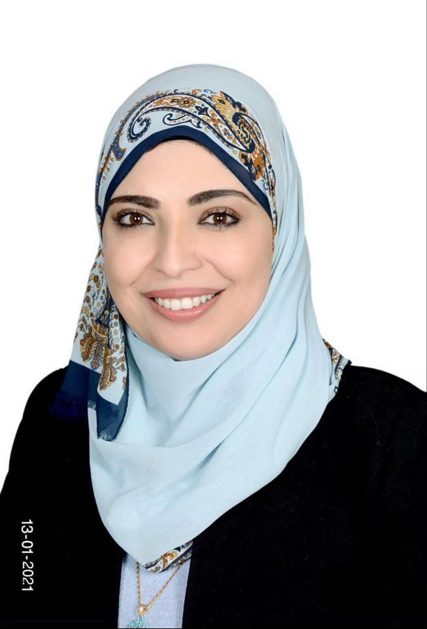

Noor M. Alqudah M.D

Current position
- Assistant Professor of Ophthalmology ,Faculty of Medicine, Jordan University of Science and Technology, Irbid, Jordan

- Consultant in Cornea and Refractive Surgery at King Abdullah University Hospital , Irbid , Jordan

- Head of Ophthalmology division, Special surgery department, Faculty of medicine, Jordan University of Science and Technology, Irbid, Jordan.

Current Address
Jordan University of Science and Technology
Faculty of Medicine, Department of special Surgery, Division of Ophthalmology Division
P.O Box 3030, Irbid 22110, Jordan

Personal Information
Gender Female
Date of Birth 6th October 1981
Citizenship Jordanian
Email address nmalqudah5@just.edu.jo
qudahnoor@gmail.com
Phone Number 00962798510010
Languages Arabic, English, German

Education and positions:
1999-2005 University of Science and Technology (Irbid, Jordan)
Bachelor Degree in Medicine and Surgery
2005-2006 Internship at Princess Basma Teaching Hospital (Irbid, Jordan)
2006-2010 Residency Training in Ophthalmology at King Abdullah University Hospital (KAUH), Jordan University of Science and Technology

2010-2012 Research and Teaching assistant at Jordan University of Science and Technology

2012-2014 Clinical fellowship in Cornea and Refractive Surgery , Rhur University, Bochum, Germany.

2014 till now: Assistant Professor at Jordan University of Science and Technology, Faculty of Medicine, Department of Ophthalmology.
Consultant in Cornea and Refractive Surgery at King Abdullah University Hospital, Irbid, Jordan

2019 -2021 Assistant Dean at Faculty of Medicine, Jordan University of Science and Technology (JUST)

2021 till now : Head of ophthalmology division, special surgery department, Faculty of medicine, JUST

Certifications

2005 Bachelor Degree in Medicine and Surgery

2006 USMLE Part 2

2010 high specialization in Ophthalmology

2010 Board certified Ophthalmologist (Jordan Medical Board)

2012 German medical license (Approbation)

2014 Fellowship training in Cornea and Refractive surgery, Germany

Research Experience/Publications

- Hatamleh, M.M., Alnazzawi, A.A., Abbariki, M., Alqudah, N., Cook, A.E., 2017. Survey of Ocular Prosthetics Rehabilitation in the United Kingdom, Part 2: Anophthalmic Patients’ Satisfaction and Acceptance. Journal of Craniofacial Surgery 28, 1297–1301.

- Hatamleh, M.M., Abbariki, M., Alqudah, N., Cook, A.E., 2017. Survey of Ocular Prosthetics Rehabilitation in the United Kingdom, Part 1: Anophthalmic Patients’ Aetiology, Opinions, and Attitudes. Journal of Craniofacial Surgery 28, 1293–1296.

- Shihadeh, W.A., Jammal, H.M., Alkhatib, S.Q., Okour, F.M., Gharaibeh, A.M., Alqudah, N.M., Alqudah, A.A., 2012. Prevalence of Exfoliation Syndrome in Patients Scheduled for Cataract Surgery: A Hospital-based Study in Northern Jordan. Jordan Medical Journal.

- Jammal HM, Alqudah NM, Khader Y. Awareness, Perceptions, and Attitude Regarding Coronavirus Disease 2019 (COVID-19) Among Ophthalmologists in Jordan: Cross-Sectional Online Survey. Clin Ophthalmol. 2020 Aug 3;14:2195–202.

- Saleh OA, Jammal H, Alqudah N, Alqudah A, Abu-Yaghi N. Clinical Experience in the Administration of Intravitreal Injection Therapy at a Tertiary University Hospital in Jordan During the COVID-19 Lockdown. Clin Ophthalmol. 2020 Aug 24;14:2473–80.

- Alqudah AA, Al Dwairi RA, Alqudah NM, Abumurad SK. COVID-19 Lockdown and Eye Injury: A Case Series from Jordan. Int Med Case Rep J. 2020 Oct 9;13:493–501.

- Jammal H, Abu Ameera M, Al Qudah N, Aldalaykeh M, Abukahel A, Al Amer A, et al. Characteristics of Patients with Pseudoexfoliation Syndrome at a Tertiary Eye Care Center in Jordan: A Retrospective Chart Review. Ophthalmol Therapy.

- Alqudah NM, Jammal HM, Saleh O, Khader Y, Obeidat N, Alqudah J. Perception and experience of academic Jordanian ophthalmologists with E-Learning for undergraduate course during the COVID-19 pandemic. Annals of Medicine and Surgery. 2020 Nov 1; 59:44–7.

- Noor M Alqudah, Hisham M Jammal , Infective keratitis following iontophoresis-assisted corneal crosslinking (I-CXL): A case report , The Open Ophthalmology Journal.

- Noor M Alqudah, Hisham M Jammal, Yousef Khader, Wedad Al-dolat , Sarah Alshamarti , Zaki Shannak, Characteristics of Keratoconus patients in Jordan: Hospital-based population , Clinical Ophthalmology Journal.

Membership:
- Member of the Jordan Eye Bank Committee (King Abdullah University Hospital Representative)
- Jordan Medical Association
- Jordanian ophthalmological society
- American Society of cataract and Refractive Surgery (ASCRS)
- European Society of Cataract and Refractive Surgery (ESCRS).

Volunteer Working /other activities
- Active participant in community free medical days held in the villages located in Irbid province, affiliated by King Abdullah University Hospital , and providing eye care for children in underserved poor areas, orphanages, etc.
- Volunteer at Syrian American Medical Society (SAMS) campaigns in Jordan
- Girl Scout of Jordan (1995 -1999)
- Youth camp & Sport, El- Hassan Youth Award , bronze stage 1998

Conferences and meetings attended
1. Jordanian Ophthalmology Conference, 2007
2. Glaucoma and Refractive surgery Conference in collaboration with Eye Subspecialty Center(Egypt) , 2008
3. The "Rheinische-westfalischerAugenartzte" ophthalmology meeting, 1st -2nd February 2013, Bochum
4. The ophthalmological Acadmy Of Germany (AugenArztlicheAkademie ,Deutschland,Dusseldorf 26.2 -2.3.2013
5. American Society of Cataract and Refractive Surgery (ASCRS),San Fransico,2013
6. Deutsche OphthalmologischeGesellschaft( DOG) meeting , 19-22.9.2013
7. European Society of Cataract & Refractive Surgeons (ESCRS) meeting, Amsterdam, 5-9.10.2013
8. Deutschsprachige GesellschaftfürIntraokularlinsen -Implantation, interventionelle und refractive Chirugie ( DGII) meetings, Bochum 6-8.3.2014
9. World Ophthalmology Congress (WOC), Tokyo, 2-6.4.2014
10. American Society of Cataract and Refractive Surgery (ASCRS) annual meeting, San Diego, 2014
11. American Academy of Ophthalmology (AAO) annual meeting, Chicago, 2016
12. American Academy of Ophthalmology (AAO) annual meeting, New Orleans, 2017
13. European Society of Cataract & Refractive Surgeons (ESCRS) congress, Lisbon, Portugal, 2017.
14. 18th EURORETINA congress, Vienna, 2018
15. American Academy of Ophthalmology (AAO) annual meeting, San Francisco, 2019

WET LABS:
- Stitching course (Nahtkurs) + wet lab , The "Rheinische-westfalischerAugenartzte" ophthalmology meeting,Bochum,2013
- Lasik and PRK wet lab, the ophthalmological Academy Of Germany,2013
- Femtosecond laser cataract wet lab, ESRCS ,Amsterdam, 2013
- Ferrara Rings wet lab, ESCRS, Amsterdam 2013
- Lamellar keratoplasty wet lab, DGII, Bochum, 2014
- Smile procedure wet lab, Visumax Carl Zeiss , WOC, Tokyo, 2014

