Dr. Rasheed IbdaH  Associate Professor  Department of Internal Medicine, Faculty of Medicine  Jordan University of Science and Technology (JUSTP.O.Box , 3030, Irbid, 22110 JORDAN | 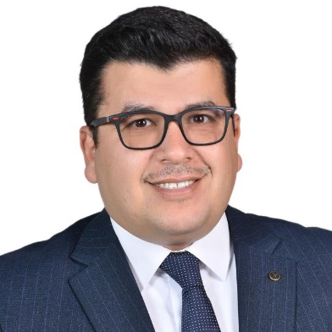
Phones: 009620790124465 Email : rkibdah@just.edu.jo
- Vice Dean Faculty of graduate Studies /Jordan University of Science and Technology,
Irbid, Jordan since 2022
- Associate Professor of Medicine /Jordan University for Science and Technology since 2020
- Consultant of Interventional Cardiology/King Abdallah University Hospital since 2014
- Assistant Professor of Medicine /Jordan University for Science and Technology 2014-2020
- Assistant Dean /Faculty of Medicine/ JUST 2019- 2021
- Head of Cardiology Department at King Abdallah University Hospital 2019_2022
- Cardiology Fellowship, University of Tubingen.Tuebingen, Germany, 2010-2013.
- Teaching assistant, Faculty of Medicine, Jordan University for Science and Technology, Irbid, Jordan, 2009-2010
- Internal Medicine Residency, Jordan University for Science and Technology, Irbid, Jordan, 2005-2009
- Member of Board of Directors of Jordanian Medical Association since 2022
- Head of Scientific Committee at Jordanian Medical Association since 2022
- Jordanian Board of Cardiology 2019
- Fellow of German Cardiac Society 2013
- Fellow of American College of Cardiology 2022
- Jordanian Board of Medicine 2009

