**WORK EXPERIENCE**

**OBJECTIVES**

* Design, and conduct research that has real academic weight.

* Develop substantive knowledge in academic research through innovative and high-quality work.

*Become leader in academic research in oral health field as independent scientists**.**

**Tamadur M Falah**

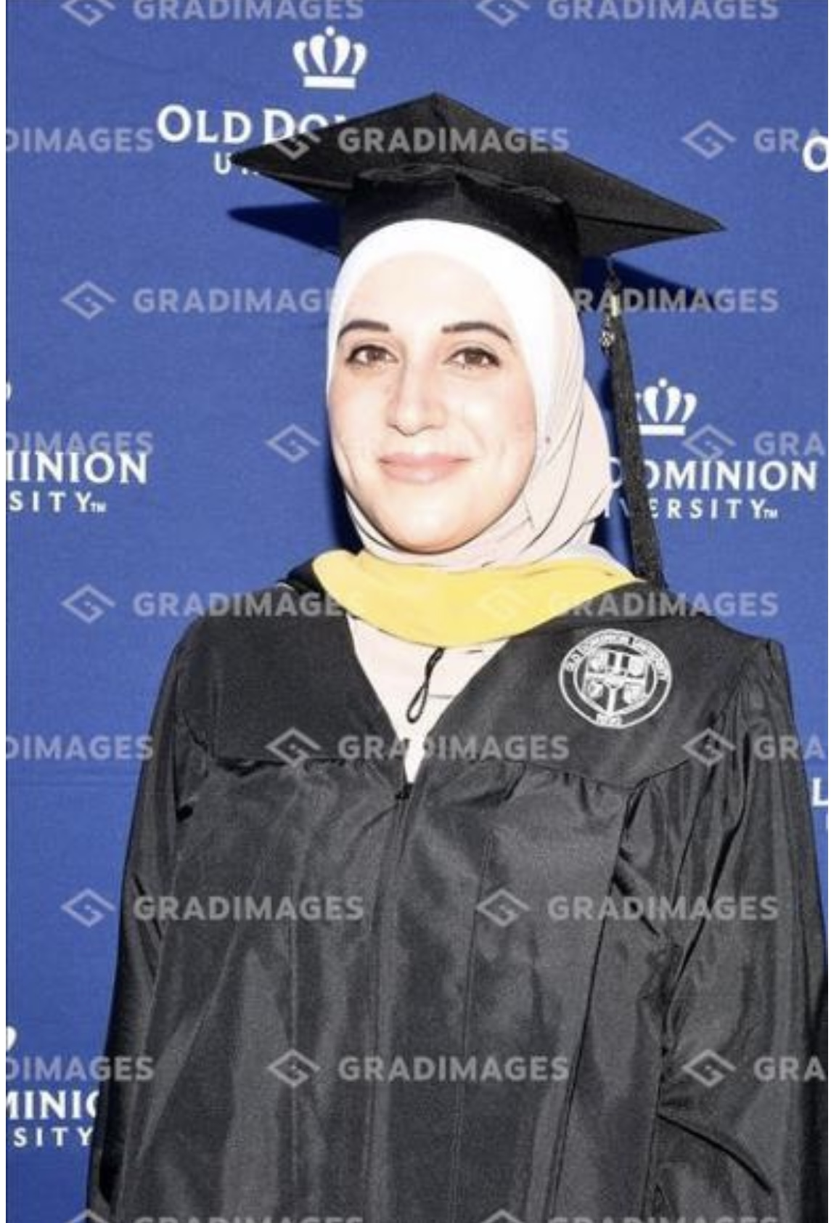

Full time University Lecturer. Jordan University of Science and Technology(JUST). Department of Allied Dental Science. Faculty of Applied Medical Science.

**CONTACTS**

Jerash City, Jordan

* (+962) 796556456

[tmfalah@just.edu.jo](mailto:tmfalah@just.edu.jo)

[tishreenflowers@yahoo.com](mailto:tishreenflowers@yahoo.com)

* Dh.Tamadhor Nawasrah

**Teaching and Research Assistant at JUST at Department of Allied Dental Sciences (2016-2018):**

* Teaching assistant in several practical courses; Oral Radiology, Prosthodontics, Clinical Dental Hygiene, Clinical Allied Dental Sciences, Community Oral Health, Dental Morphology and Occlusion, Oral Epidemiology, and Periodontology course.
* Coordinated with research colleague team to write and submit research proposals.
* Proofread and edited research proposals.
* Demonstrated effective written and verbal communication skills.
* Conducted systematic data collection and performed a detailed analysis.

**Dental Assistant at Kool Smile Dental Office (Virginia- Janaf. USA) (May 2019- May 2020):**

* Taking intra and extra oral radiograpgh (X-ray machine)
* Dental Sterilization Unit
* Medical Record Unit
* Taking and pouring impression
* Dental Assistant (Four handed Dentistry).

**OBJECTIVE**

* **Full time lecturer at JUST at Allied Dental Science Department (2021-now)**
* Teaching experience in the following courses ( Oral Histology, Oral Radiology, Community oral health course, Clinical Oral hygiene course, Oral health science course, Allied Dental Sciences, Research Project Course).
* Excellent written and verbal communication
* Time management and organizational skills.
* Conduct lectures, seminars, and tutorials.
* Creating teaching materials (Visual Aids).
* Arrange free medical and educational days for our local community through the objectives of Community oral Health course

**Dental Hygienist**

* Screen patients and assess oral health status.
* Provide routine cleaning and teeth polishing procedures during regular dental checkup visits.
* Mentor and counsel dental hygiene patients on the importance of proper oral hygiene maintenance.

**Publications**

* Oral Health Consequences of Khat Use; Dimensions of Dental Hygiene Journal 2021
* Assess Pharmacists’ Knowledge, Attitude, and Practice towards Oral Health Care; F1000 Journal. 2024.

**Volunteer Opportunities**

* Participant in local community service committee.
* Volunteer in oral health community days at SOS in Irbid City, Jordan.
* Volunteer in free medical days for local community.
* Develop mobile phone application “ Just Smile” (free download on Android) about oral health education topics.

**AWARDS**

**\*** Full sponsored scholarship in master degree

*Full Sponsored Scholarship to Complete PhD

**Research Interest/Experience**

* Management of dental office
* Dental Assisting
* Offered the academic and personal support to guide students through the course selection process and academic policies.
* Assisted the students with clarifying values and goals; counselled students regarding educational options and requirements
* Provide health promotion responsibilities as a Dental Hygienist
* Dental Hygiene
* Dental Sterilization
* Dental Radiology
* General Office management
* Familiarity with online learning and Internet technology.
* Thorough knowledge of open-ended questioning, non-verbal communication and active listening.
* Amazing ability to work in a changing environment.
* Outstanding ability to work independently and in a team and effectively and work collaboratively with other departments.
* Communication Skills Course
* Course in leadership (we are a community leadership)
* Internship courses in community & Environmental health (master's degree)

**Completion**: 2016

**Relevant Coursework**: Periodontics, Dental Hygiene Procedures, Advanced Oral Hygiene, Pharmacology, Dental Materials, Oral Histology, Oral Radiology, Oral Pathology, Community Oral Health. Epidemiology, Prevention, Oral Surgery, Anatomy & Physiology.

* **Master Degree in Dental Hygiene Program.**

Old Dominion University (ODU).Virginia. USA

**Completion**: 2021

**Relevant Coursework**: Principles of Dental Hygiene, Educational concepts, Clinical Teaching, Research methods, public health courses, internship in environmental and public health, Biostatistics.

* **Bachelor of Science in Dental Hygiene.** Jordan University of Science and Technology (JUST). Irbid City. Jordan.

* Community oral health field
* Published paper in Dimensions of Dental Hygiene Journal titled Oral Health Consequence of Khat in 2021.
* Ongoing work with faculty colleagues in community oral health field; first research about Teledentistry in Jordan; (Case study and survey-based research). The second work about the pharmacists' knowledge of oral health disease in Jordan (survey-based study).

**EDUCATION**

**PROFESSIONAL SKILLS**