Curriculum Vitae
Name: Mohammad Ahmad Al-Salah 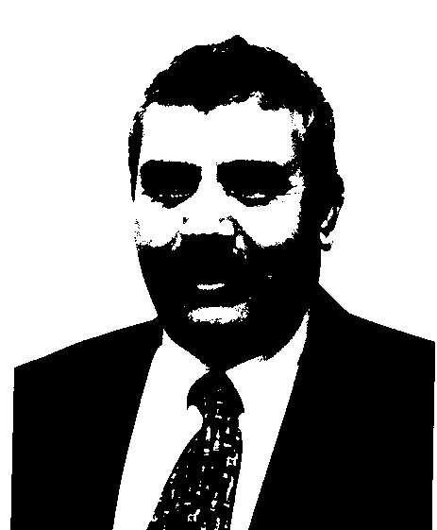
Nationality: Jordanian
Place of Birth: Deir Abi Said/ Jordan
Date of Birth: May 12th, 1955
Marital Status: Married
Tel. +96227242343
Mobile: +962796252060
Work Tel: +96227201000 Ext. 22635
Fax: +96227201076
Email: youniss@just.edu.jo
Mail Address (permanent):
P.O.Box 3030,
Humanities Department, Faculty of Arts and Sciences
Jordan University of Science & Technology (JUST)
Irbid, Jordan.
Education:
Certificate | Major | School | Date of Graduation
PhD | Modern History | Saint Joseph University/Lebanon | 1989
PhD | Modern History | Saint Joseph University/Lebanon | 1984
MA | Modern History | Saint Joseph University/Lebanon | 1981
BA | History | Beirut Arab University/ Lebanon | 1979

PhD Dissertation Title:
Constitutional System of Trans-Jordan: 1921-1946.
MA Thesis:
Al-Salt District between the end of 19th and Beginning of 20th Centuries.
Professional Experiences:
- Full Professor, Jordan University of Science & Technology, Sep 1st, 2004 – to-date.
- Associated Prof. Jordan University of Science & Technology, Sep 1st, 1999 to Aug 31st, 2004.
- Assistant Prof. Jordan University of Science & Technology, Sep 1st, 1994 to Aug 31st, 1999.
- Lecturer, Jordan University of Science & Technology, Aug 25th. 1990 to Aug 31st, 1994.
Training Courses:
- Workshop of Instructional Technology and Evaluation, Jordan University of Science & Technology, Jan 1992.
- Measurement and Evaluation Workshop, Jordan University of Science & Technology, Feb 1999.
- Basic Computer Skills Workshop, Jordan University of Science & Technology, Nov 2000.
- Lectures Presentation by PPT, Jordan University of Science & Technology, Jan 31st to Feb 3rd, 2005.
Conferences:
- "Hussein and Arab Unity". Apr 8th to 10th, 2002. Conference of Late King Hussein's Thought Studies, King Hussein University, Maan.
- "The Effect of Arab Revolution On Keeping Arab Identity". Feb 17th to 21st, 2000. The Third Conference of Contemporary Forum, Miknass, Morocco.
- " Effect of Natural Environment on the Development of Humayma and on the Abbasid Movement 68-132A." Jun 1995. International Conference of Studying Jordan History and Its Antiquities, General Directorate of Antiquities, Torieno, Italy.
- "Reality and Orientations of Scientific Research in Dealing with Jordan Contemporary History". Apr 1998. Conference of Crisis of Scientific Research in Humanities Sciences and Brain Immigration in the Arab World. Zaghwan, Tunisia.
- "Industrial Technology in Al-Kourah District in the First Half of 20th Century". Apr 1992. International Conference of Studying Jordan History and Its Antiquities, General Directorate of Antiquities, Jordan University of Science and Technology, Irbid, Jordan.

Professional Memberships:
- Member of Arts & Science Faculty Board. 1994-2000.
- Member of:
  - Scientific Research Committee,
  - Cultural & Social Committee,
  - Students' Control Committee,
  - Employment Committee,
  - Internet Committee,
  - Timetable Schedule Committee,
  - Scientific Day of Sciences Faculty Committee.
- Consultant of One's and the Other's View Consortium & Human Rights 1996-97.
- Consultant of the Heritage Consortium. 1995-1996.
- Member of Initiative Committee of the First Scientific Conference of the Arts & Sciences Faculty. May 23rd, 2000.
- Representative of the Initiative Committee of Jerusalem Debates. 1999-2000.
- Visitant Professor , Arts Faculty at Yarmouk University. 2001/2002.
- Visitant Professor , Arts Faculty at Hail University, Saudi Arabia, 2008-2009.

RESEARCH, PUBLICATIONS &PROFESSIONAL ACTIVITIES:
- "Development of Jordan Regime: 1921-28". 1991.Yarmouk Research Journal, Vol. 7, No. 4.
- "Financial Management in Jordan: 1921-46". 1993.Yarmouk Research Journal, Vol. 9, No. 4.
- " Jordan Government Role in Developing the Agricultural Sector: 1921-46". 1994.Yarmouk Research Journal, Vol. 10, No. 2.
- " Ottoman Management in Al-Salt District Based upon Islamic Court Documents: 1890-1921". 1995. Arab Historical Journal of Ottoman Studies, Tunisia, No. 11 and 12, p.279.
- "Development of Land Taxes System in Trans-Jordan: 1921-46". Dirassat Journal, University of Jordan, No.1, Vol. 23, p.90.
- "The Effect of the Ottoman Regulations on the Financial System in Trans-Jordan:1921-33". 1997. Arab Historical Journal of Ottoman Studies, Tunisia, No. 14 and 15, p.297.
- " Ottoman Tamattu Tax in Trans-Jordan:1921-46". 1998. Arab Journal of Sciences of Humanities. Kuwait, p.130.
- "British Administration in Trans-Jordan Pre-Regime of Ameer Abdullah: Aug 1920 to March 1921". 2002. Social and Human Sciences Journal. UAE University. No.2, Vol. 17.
- "The Effect of British Financial Aids on the Financial Circumstance in Trans-Jordan: 1921-1925". 2002. Arab Journal of Human Sciences, Kuwait University.
- "Government Role in Developing Commercial Sector in Jordan: 1921-1946." 2003. Dirassat, University of Jordan,Vol. 30, No. 1.
- "Trade Relations Between Jordan and its Neighbors: 1921-1946". 2004. Social and Human Sciences Journal. UAE University. Vol.20.
- Al-Salah, Mohammad, "Administration in Trans-Jordan Emirate: 1921-1946, 1986, Dar Al-Mallah, Irbid, Jordan (500p).

Adminstrative Work:
- Head of Humanities Department, JUST, 1996-2000.
- Director of University Staff Club, JUST, 1999-2000.
- Supervisor of Social Sciences Section, JUST, 1995-1996.

Teaching Courses:
- Islamic Civilization (3C, 3H):
Explanatory theories of the origins of civilization. Islamic civilization, its birth and characteristics, the relationship between civilizations, the economic aspects of Islamic civilization, the influence of Islamic civilization on the world, the relationship between civilization and the modern civilization.

- History of Sciences Among Arabs & Muslims (3C, 3H):
This course covers a general introduction to the establishment of sciences among nations that preceded Islam. Emphasis will be given to famous Greek scientists, Arab sciences before Islam will also be covered. Additional emphasis will be given to scientific thinking in the Arab Islamic Civilization, especially in medicine, pharmacy, chemistry, mathematics and the translation and communication process.

3- History of Jerusalem (3C, 3H)

